Design and Construction of a High-Speed BDM Pod for ColdFire CPUs

W. Mohat wdm@ameritech.net 26MAR00 CFPOD.DOC

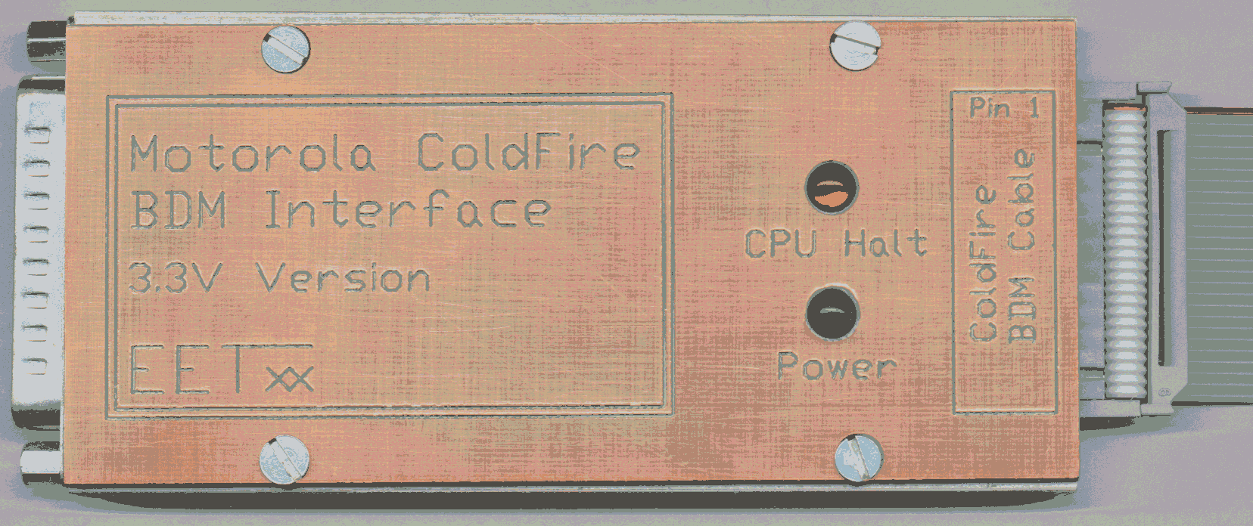

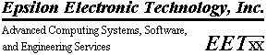
Table of Contents

Item Page

Introduction 3
The P&E BDM Pod: Reference Documentation 3
Analysis and Recommendations for P&E BDM Pods 6
Design Goals for a new, High-Speed BDM Pod 10
New Design: Electrical Schematic and Xilinx Details 10
Construction Details, and Final Notes 13

Introduction

There were several reasons why this document was created. The first was simply to collect together some knowledge I have found about high-speed BDM pods for the Motorola ColdFire family of CPUs. Secondly, it will document a few “weaknesses” found in the commercially available BDM pod from P&E (and how to fix some of them.) And, the last purpose is to document my own design for a high-speed ColdFire BDM pod.

My BDM pod design is intended for serious engineering teams only. If you don’t have considerable experience with constructing high-speed prototype modules, you will be far better off just purchasing a commercial unit and applying the “fixes” I recommend if you have troubles with it. However, experienced designers that demand “bulletproof” reliability from their design tools may consider building my reference design. If built carefully it will be as reliable as an anvil, even on 54 MHz. ColdFire busses.

The “commercial unit” documented here is the BDM pod sold by P&E. This unit was included in the box with many (all?) of Motorola’s ColdFire evaluation modules, so it is probably the most popular BDM pod in terms of quantities installed in the field. Many people have them, and I believe that all of the software debugging tools for ColdFire CPUs support this BDM pod.

It is not my intention to cause any harm to P&E or the excellent reputation that they have. However, the simple fact is that their pod was designed back in the 5 volt 25 MHz. CPU days. While they modified the pod to support 3.3V processors, the design simply was not built for CPU speeds much faster than 25 MHz. Judging from the high volume of messages on the ColdFire discussion groups about BDM pod problems, I am clearly not the only engineer that has run into some of these difficulties. Here, then, are a few solutions.

The P&E BDM Pod: Reference Documentation

The next two pages of this document include the schematic diagram of the P&E BDM pod design, and the GAL source code for the Lattice GAL16LV8C used in their design. The schematic is also available from P&E directly. ( It can be downloaded from their web site at: http://www.pemicro.com/products/coldfire/cablecf/cablecf.pdf )

The GAL source code was obtained from Rolf Fiedler. Apparently he has switched his Internet service provider, because I was unable to locate his home page when I produced this report. However, his GAL source is known to be correct, and can be used to program a new GAL if one is accidentally destroyed. (Thanks to Rolf Fiedler for his effort here.)
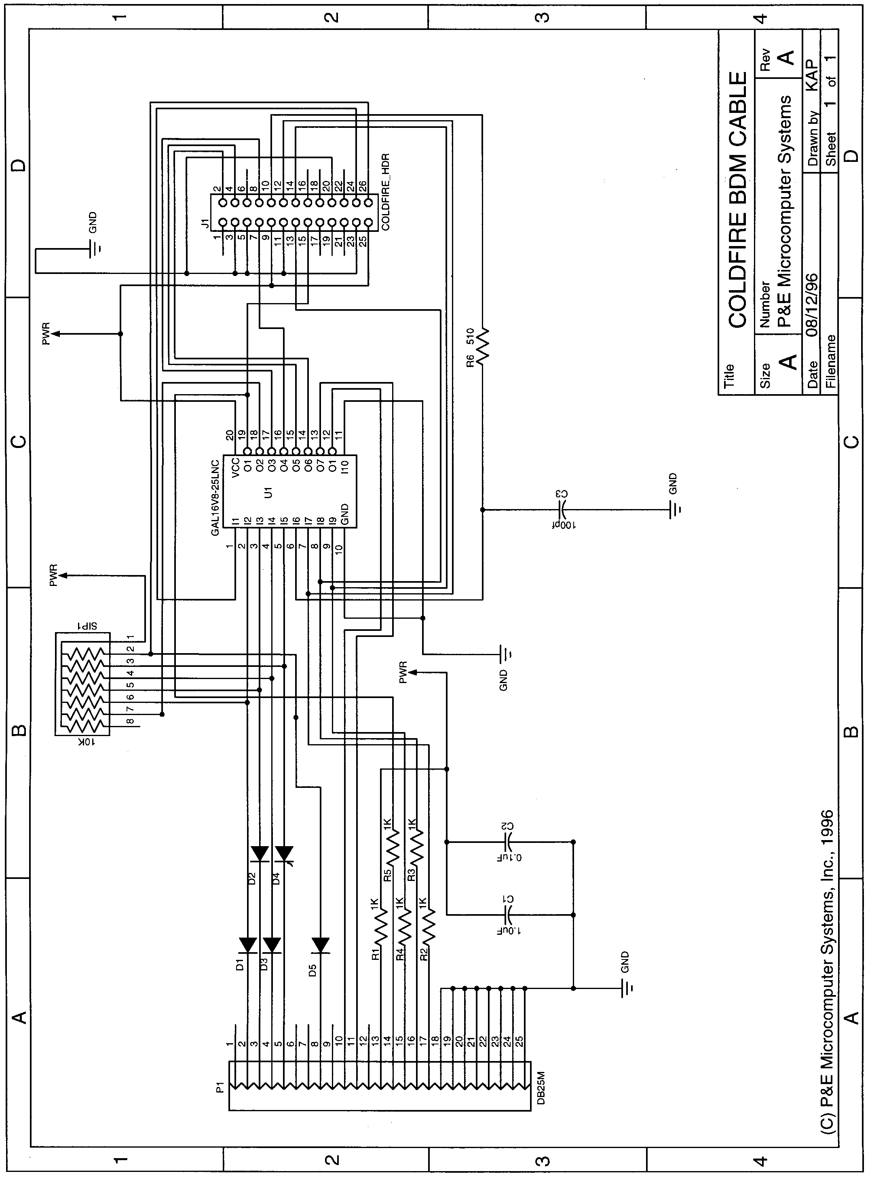
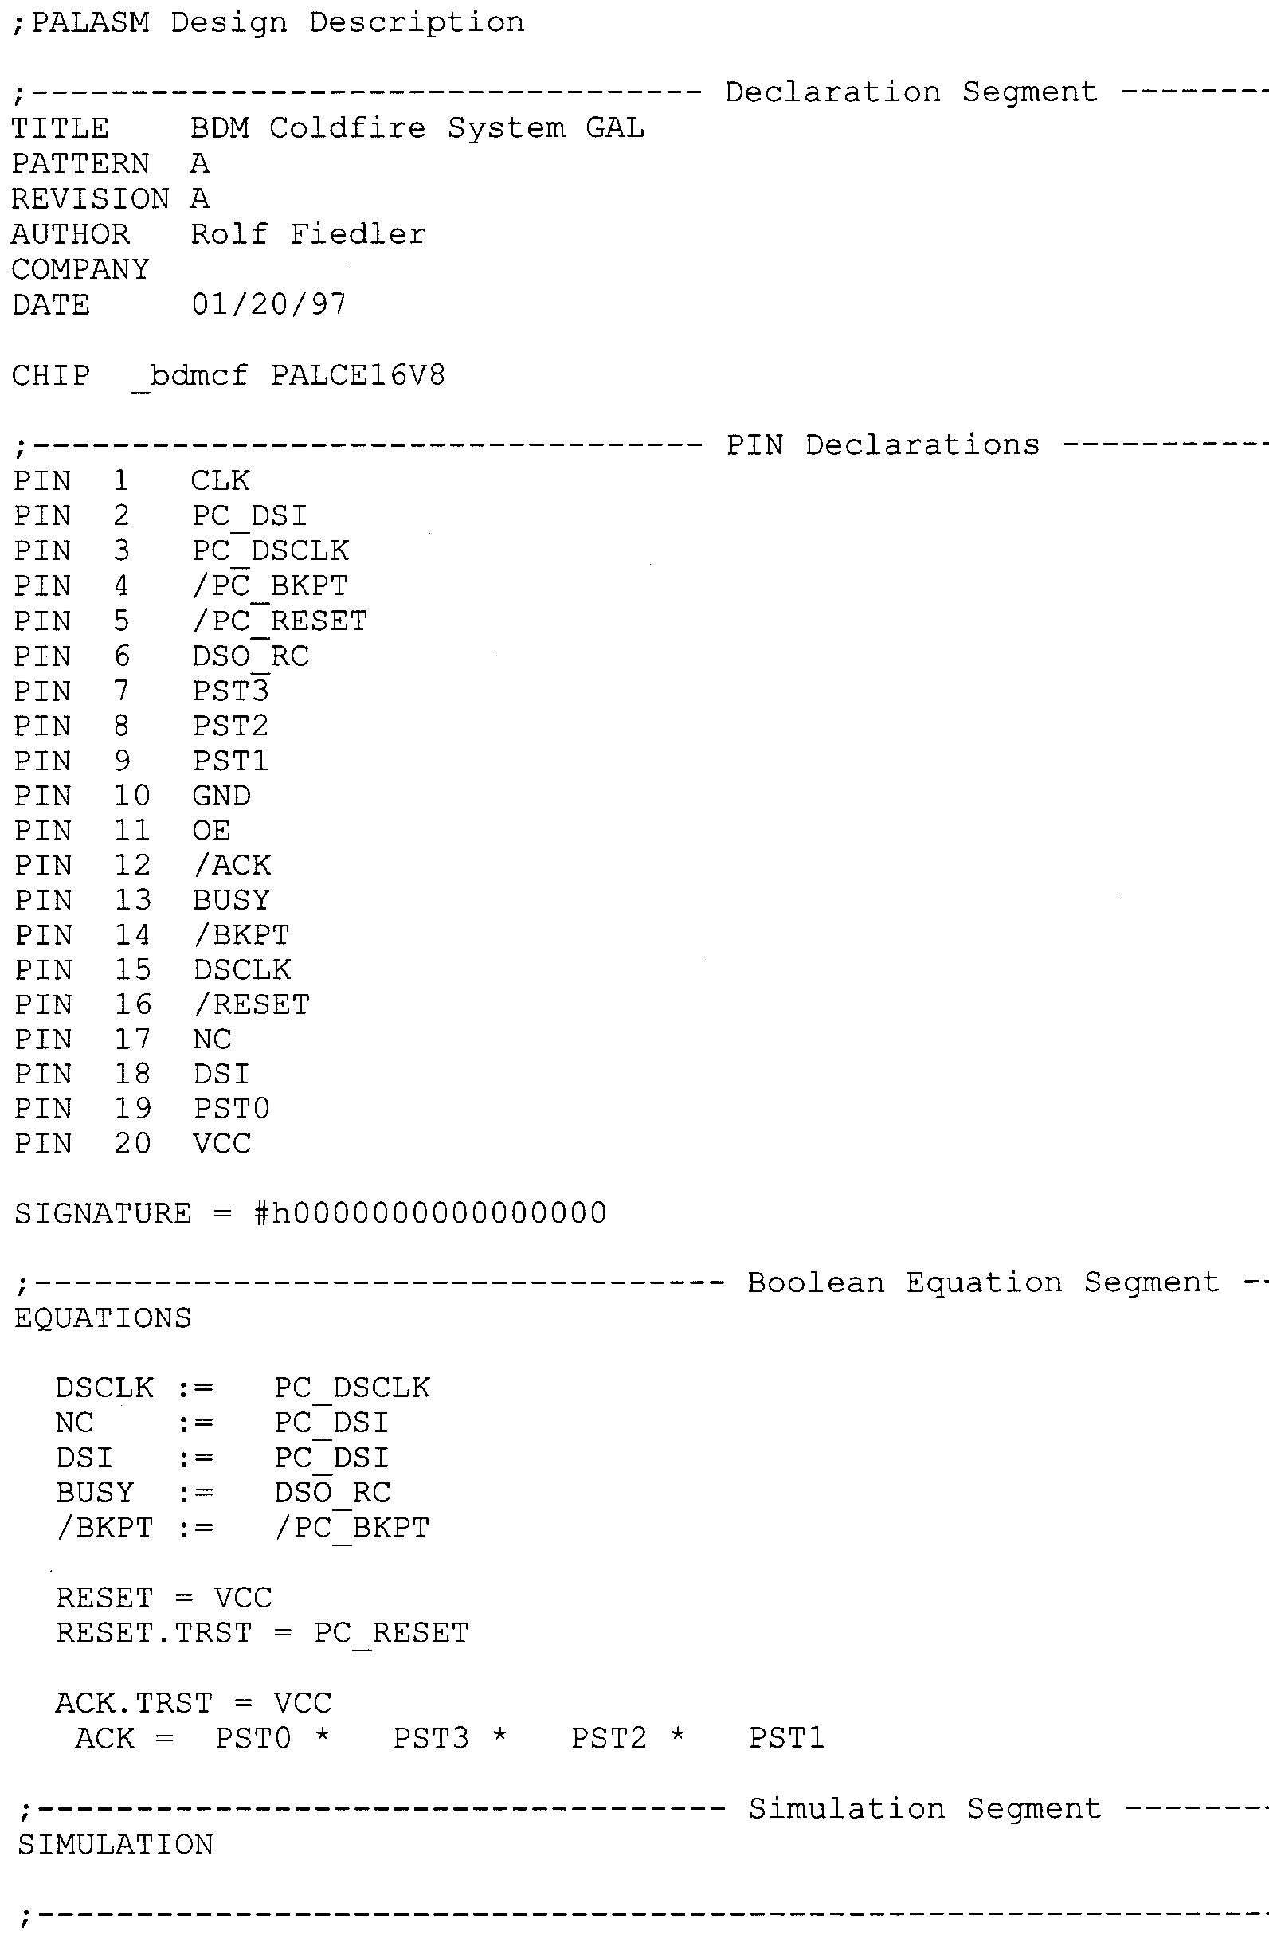
There are apparently two errors in the P&E schematic (at least, between the schematic and the P&E pods that I own). Fist, R6 is 220 ohms, not 510 like the schematic shows. Secondly, the GAL used currently is a 15 nSec. device, not a 25 nSec. part as the schematic shows.

Analysis and Recommendations for P&E BDM Pods

First, a 25 nSec. GAL will barely handle a 25 MHz. CPU. 15 nSec. GALs will not operate much above 40 MHz. On 54 MHz. 5206e designs, they will sometimes fail at random intervals. A quick timing analysis shows why:

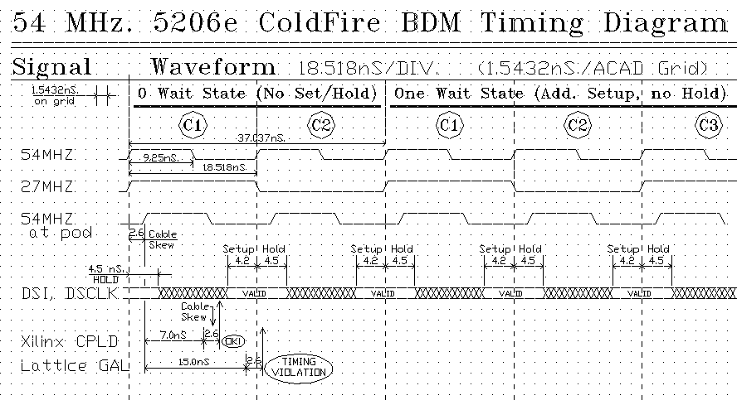

The ColdFire CPUs require that the BDM signals “DSI” and “DSCLK” be synchronized to the CPU’s clock, with certain “setup” and “hold” time requirements. A 54 MHz. ColdFire CPU has 18.5 nSec. between clock edges, with a 4.2 nSec “setup” time. This leaves 14.3 nSec worth of time for any external device to drive these signals into the CPU. (This include the devices internal propagation delay, plus signal propagation delays between the device and the CPU …. shown as “skew” on the diagram above.) Even with no propagation delays at all, a 15 nSec. device is simply too slow. It will probably work most of the time. However, when the signal propagations delays are included, it becomes clear that a 15 nSec. device is simply too slow, and a 7 nSec. device is required.

RECOMMENDATION: Replace the 15 nSec. GAL with a 7 nSec. device. This will cure many problems with P&E pods.
The signal “skew” on the diagram is the timing shift between the clock signal as seen by the ColdFire CPU on the target design, and the clock signal seen by the GAL on the P&E pod. This timing delay is caused by the signal traveling through the ribbon cable up to the BDM pod, the poor electrical characteristics of the ribbon cable, and the lack of any “termination” on the P&E circuit board. A high-speed digital oscilloscope shows this timing shift and signal distortion clearly:

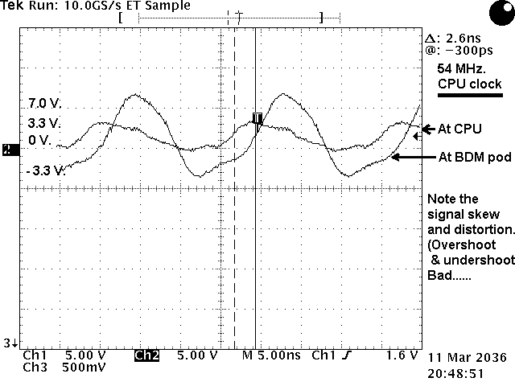

As the oscilloscope shows, the clock signal has a 3.3V amplitude at the CPU, but it gets severely distorted and phase shifted due to the ribbon cable and lack of termination. The phase shift appears to be about 2.6 nSec. with the standard ribbon cable length. (That’s from the CPU to the GAL.) Remember that the signals from the GAL back to the CPU have to go through the same ribbon cable, and that’s another 2.6 nSec. timing loss. (For a total of 5.2 nSec. Add that to the 4.2 nSec. “setup” time, and you have 9.1 nSec. in the timing budget left. A 7 nSec. GAL device fits the bill here, a 15 nSec device is clearly too slow.)

Recommendation: Cut the ribbon cable length back to about 4” to 6”. This will lower the propagation delay, and reduce some of the signal distortion as well. Note, there does not appear to be a good way to add “terminators” to the P&E design. The board is a simple 2-layer board, lacking solid ground and power planes. Without solid power planes, signal terminators are useless.
Next item: the input signals from the PC to the BDM pod go through signal diodes with pullup resistors behind them. (D1 through D5, and SIP1). The purpose of these components is to shift the 5V logic level from the PC’s parallel port to 3.3V for the GAL device. These components do not provide any significant filtering action for any electrical “noise” picked up by the parallel port cable, or any “crosstalk” created between signal lines in the cable itself. (See the oscilloscope picture below for details.)

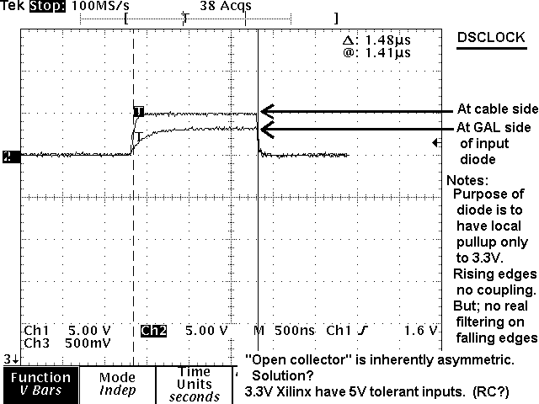

Also, note that there is a dramatic difference between parallel port modules. Some have output filters that cause the board to generate fairly clean output signals. Other (less expensive) parallel port modules have no output filters, and create significant electrical “noise” and “crosstalk” as a result. Also, older parallel port modules had slow, “open-collector” outputs. The high-speed “totem-pole” outputs of some ECP / EPP modules create much sharper signal edges, and consequently much more “noise”.

Recommendations: As stated before, there is no point in trying to add filtering components to this module. However, the input noise can be significantly reduced two ways. First, select a parallel port module that has output filtering components between the ASIC on the board and the 25-pin parallel port connector. Secondly, use only a short (6 foot or less) parallel port cable that is IEEE 1284 rated. (These have much better internal shielding and isolation between signal lines than older parallel port cables.)

Next item: the filter on the “DSO” signal from the CPU to the BDM pod is perhaps excessive. (See the oscilloscope picture below for details):
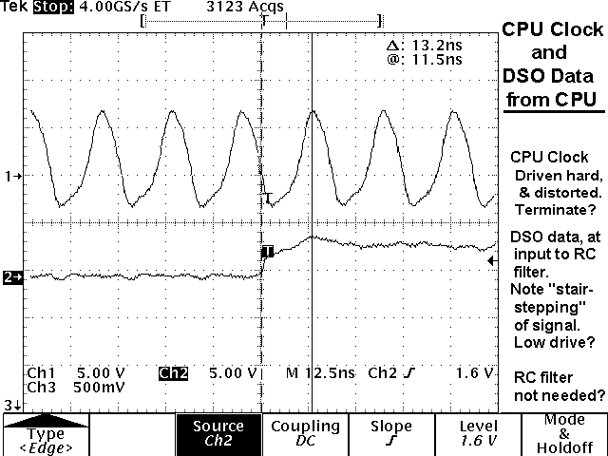

As the oscilloscope shows, the DSO signal from the CPU is not driven very hard at all. Consequently, the RC filter on the BDM pod doesn’t appear to be needed. The fact that P&E lowered the resistor in this filter from 510 to 220 ohms gives some indication of this, and further implies that 220 ohms may still be too much.

Recommendation: Drop R6 from 220 ohms to 100 ohms.

Last item: there are no filtering components on the outputs of the GAL that go to the CPU, or to the host PC. Series damping resistors would be helpful, on the order of 10 to 50 ohms.

Recommendations: Realistically, none here. Adding these components would be difficult, and the other “fixes” listed in this report should clean up almost all problems that most users would ever encounter.

Design Goals for a new, High-Speed BDM Pod

- Build the pod with a solid ground plane so that filtering components will have something to “push against”.
- Replace the GAL with a different device that is inherently more robust; that can tolerate 5V on input signal lines even with it’s local power voltages absent. (Recommendation: a Xilinx 95xx series CPLD.) 7nSec device minimum.
- Add filters on all signal lines, both into and out of the BDM pod, to both the target ColdFire CPU and to the host PC system.
- Add some status LEDs to aid in system debugging. “Power ON” and “CPU Halted” as a minimum.
- Follow the recommendations listed in the P&E analysis. (Selection of good, clean parallel port module for the host PC, short “IEEE 1284” parallel cable and short ribbon cable.)

New Design: Electrical Schematic and Xilinx Details

( Refer to the next two pages for the schematic diagram, and the Xilinx CPLD schematic diagram. → )

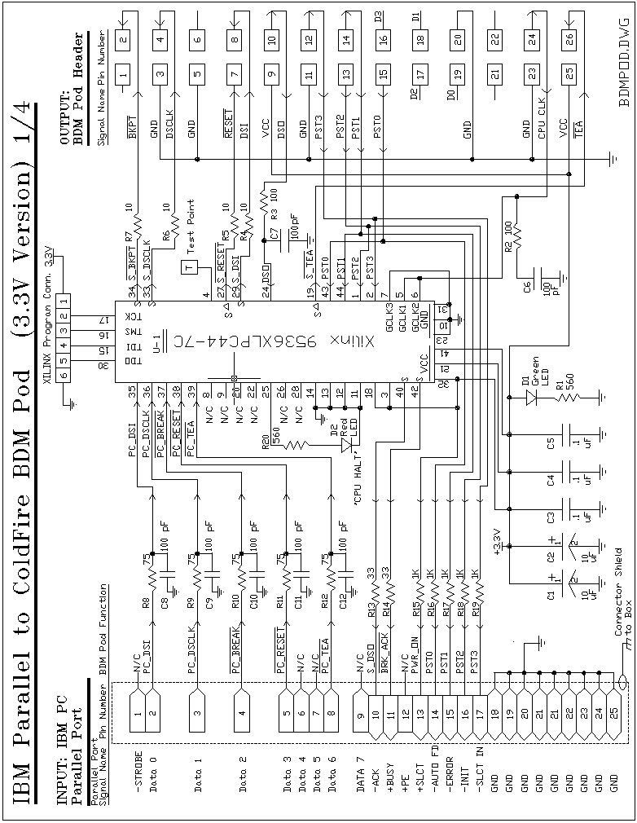
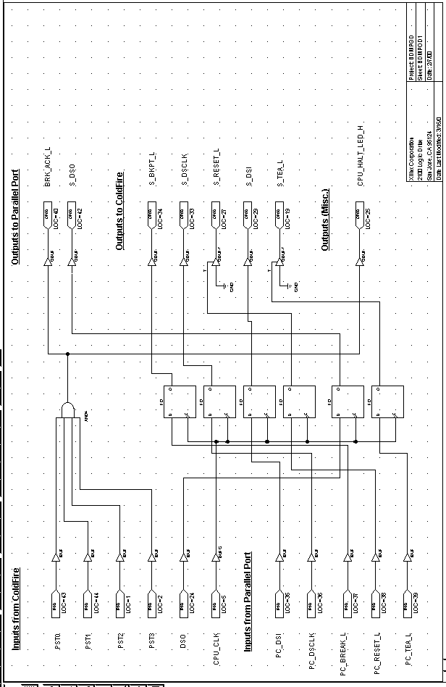

Construction Details, and Final Notes

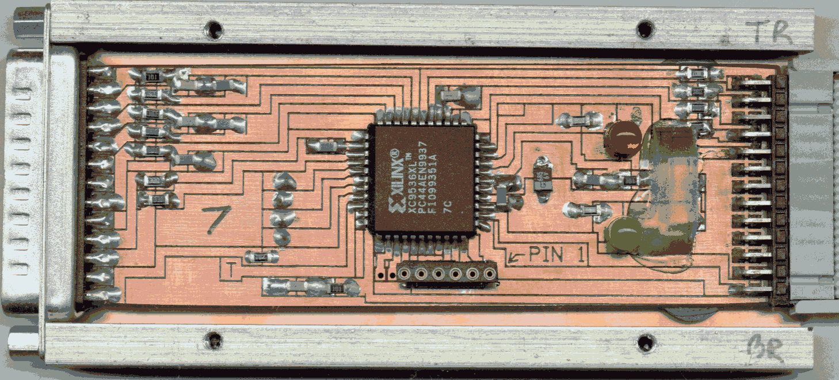

As the picture above illustrates, the prototypes of this BDM pod were produced with a circuit board milling machine. (This leaves a fairly large “ground plane” under the board.) If produced in quantity, a 4-layer board is absolutely necessary.

If anyone tries to produce this design in wire-wrap (which can be done), please observe the following rules:

- Use a good prototype board with good power planes on both sides. (example, Vector 4617-4 or similar, cut down to the required size.)
- The Xilinx part chosen is a 44-pin PLCC package. If you cannot find a wire-wrap PLCC socket, you can use a standard PLCC socket, and plug it into a 44-pin PGA wire-wrap socket.
- Keep power and ground lines to the socket VERY, VERY short. Add the power decoupling capacitors to within .1” of where the power and ground lines from the PLCC socket connect to the power and ground planes.
- It wouldn’t be a bad idea to double the number of decoupling capacitors shown in the schematic, and put these extra capacitors near the signal filters.
- Keep wire-wrap wires extremely short, and connect them directly “point-to-point”. Do NOT “bundle” any of the signal lines together.

One final note. There are 1K ohm termination resistors between the pod and pins 14,15,16 and 17 on the parallel port connector. If you check with an oscilloscope, you will discover that they are far too high in value, and that a logic “0” winds up at about 1.5V, which simply shouldn’t work at all. (Yet, the P&E pods work just fine, and so does this design. Very odd.) It appears that these lines simply are not used by any of the software debuggers. As a result, these lines could probably be simply omitted.

