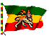

HOME PAGE



DAILY NEWS WORLD NEWS

- Ethiopian Newspaper in Amharic. CNN WORLD
Http://www.cnn.com/world/
http://pfr.ethiozena.net/
- AFRICAN NEWS. BBC DWORL
http:/news.bbc.co.uk/
http://www.africanews.org/
- BBC ARICAN NEWS.
http://news.bbc.co.uk/hi/english
- MSN-ETHIO NEWS
http://encarta.msn.com/find/Concise.asp?ti=05784000

RADIOS
- GERMAN RADIO
http://www.dwelle.de/amharic/audio.html
- VOICE OF AMERICA
http://www.voanews.com/

Her geography is unique. Covering well over a million square kilometers, Ethiopia is about twice as large as Kenya or Texas, or about five times as large as the United Kingdom. Its magnificent landscape ranges from desert areas to forested highlands. At 4,620 meters, Mount Ras Deshen is Ethiopia's highest peak, and Africa's fourth highest, but twenty mountains rise to more than 4,000 meters. The waters of the Abay River, or Blue Nile, feed Lake Tana and flow into the Nile. Most of the Nile's waters originate in Ethiopia.

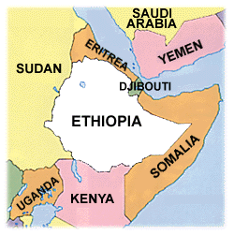
Ethiopia is generally considered

Africa's oldest continuously identifiable nation, though Egypt's written history is older and more complete. Ethiopia is landlocked today. Eritrea (independent since 1993), Djibouti and parts of Somalia, share much of their ancient, medieval and modern histories with Abyssinia, as Ethiopia was formerly known. Yemen is nearby. Across the Red Sea is the mountainous Asir Province of Saudi Arabia. Asir, which lies in Asia, has a rugged topography not unlike that of Ethiopia's uplands, and Ethiopians are one of the province's larger ethnic minorities. In times past, Ethiopia bordered Egypt, encompassing parts of what is now Sudan.
Ethiopia is home to the lion, leopard and cheetah, but to many other species as well. A short list would include the giraffe, elephant, rhinoceros, bushpig, warthog, and various varieties of ibex (including the rare walia), duiker, antelope, gazelle, zebra, buffalo, monkey, baboon, hyena, jackal and wolf. Some of these creatures exist in larger populations in neighboring Kenya, but Ethiopia probably boasts more wild mammal species than any other country in the world. Many are dwarfed by the ostrich, one of Ethiopia's 800 bird species. Some of these animals are unique to Ethiopia. Ethiopia's plant life is equally diverse.
The first Ethiopians had names like Lucy Australopithecus Afarensis, Australopithecus Africanus and Homo Habilis. They were the predecessors of homo sapiens, our species. Ethiopia's Great Rift Valley and other regions have yielded finds which indicate that this nation may well be the birthplace of the human race.
There are two possible origins of the name Ethiopia. Tradition says it derives from the name of Etiopik, descendant of the Biblical Noah. Linguists believe it comes from the Greek expression for "sunburned faces." Abyssinia, another ancient name for this land, probably comes to us from the Arabic habishat, which in this context refers to the country's "mixed" population.
Early History
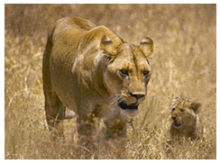
There is no doubt that humans have inhabited Ethiopia since the dawn of recorded history, as indicated in early cave drawings. The more modern Ethiopians are not a single racial or ethnic group, a fact reflected in the diversity of their languages. Despite some twentieth-century European attempts to present them as dark Caucasians, Ethiopians are predominantly Negroid.
Some Ethiopian peoples, such as the Surma, were clearly tribal and semi-nomadic, while others were more reliant on agriculture. It's difficult to generalize about such a complex ethnic mix of peoples.
Top of Page
Yet, Ethiopia is the only sub-Saharan African nation with clear historical and cultural ties to the ancient cultures of the Mediterranean. Perhaps based on their naval explorations of "Punt" (probably a coastal city on the Red Sea), the Egyptians themselves believed that their forebears were Ethiopian, and an Ethiopian dynasty was established in Egypt in 720 BC (BCE). Various inscriptions and other records indicate that the earliest Egyptians clearly knew of Ethiopia's existence, but at that time the latter was little more than a loosely allied network of kingdoms.
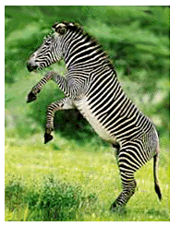
The Old Testament makes no fewer than thirty references to Ethiopia ("Cush" to the Hebrews). Moses wed an "Ethiopian" woman (Numbers 12:1). According to tradition, the Ethiopian nation was founded by Etiopik, great grandson of Noah, and Axum (Aksum) was founded by Etiopik's son, Aksumai. Queen Makeda of Sabea (Sheba) would have been a member of this dynasty; she ruled a vast area that included Yemen, and in her reign Ethiopians traded with peoples as far as Palestine and India. Makeda ventured to Jerusalem to visit King Solomon, by whom she bore a son, Menelik (from Ibn-al-Malik, Son of the King). Thus was established the Solomonic dynasty, which tradition identifies with various lines amalgamated into the dynasty that ruled until 1974. It is believed that Menelik visited his father in Jerusalem for three years as a young adult, learning the Mosaic law, and returned to Ethiopia with the Ark of the Covenant. There is, however, no conclusive evidence of this, or of the Jewish Felasha peoples being descended from Jews of Solomon's time, and some scholars identify Queen Makeda with Queen Bilkis of Sabea (Yemen).
Ethiopia has existed in some form as an identifiable state since the 10th century BC. Much more recently, the ancient Greeks and Romans knew of the Ethiopians and traded with them.
Axum (Aksum), in the northern Tigray region near Adwa, was founded around 500 BC. Its economic importance, based on trade, was born during the Ptolemaic period of Egypt (330 BC) and flourished with the expansion of the Roman Empire. Roman civilization outshone Greek culture for a time, but with the rise to prominence of the Eastern (Byzantine) Empire and the arrival of Christianity, the Greeks again made their influence felt. King Ezana was famous for Christianizing Axum.
The Axumite Empire is described in the Greek chronicle Periplus of the Ancient Sea, written in the first century, and by the Persian author Manni, who two centuries later considered it one of the world's great empires, in the company of Persia, China and Rome. Axum traded with Arabia, India, Rome and Persia. The Axumites spoke a language called Ge'ez, written with the Sabaean alphabet. Their greatest architectural legacy is their distinctive monolithic granite towers.
Though Greek influences were certainly evident, Axum gradually developed into a civilization in its own right. With the support of the Patriarch of Alexandria, the Axumite emperor Caleb fought a war against Jewish traders and colonists in Yemen in AD 523 (523 CE) in response to the persecution of Christians there, imposing Ethiopian administration for a time.
By the eighth century, with Muslim influence growing, Ethiopian political influence on the Arabian Peninsula gradually diminished, though Ethiopian traders continued to reside there. The Axumite Empire itself spread southward into the Agew region and then to Lasta, and this led to squabbles with the peoples of these areas.


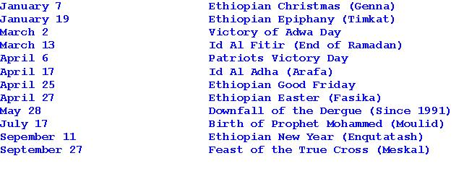

HOME PAGE



