Tabernacle Shomerim Fellowship

Topic: Overview of Genesis

A) Significant Events

- Origin of the physical universe: 1:1-2:3
- Origin of humankind: 2:3-25
- Origin of sin: 3:1-24
- Origin of death: 4:1-26
- Origin of judgment: 5:1-9:28
- The Great Flood and Noah: 6:1-9:17
- Origin of peoples and cultures: 10:1-11:32
- Revelation of purpose through Abraham: 12:1-25:8
- Revelation of purpose through Isaac: 21:3-28:6
- Revelation of purpose through Jacob: 25:26-37:1
- Revelation of purpose through Joseph: 39:1-50:26

B) Geographical Outline

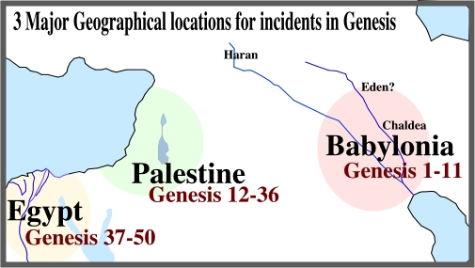

Babylonia | Gen 1-11 | Preservation of the Godly Line | Adam and Eve  Noah  Noah’s sons
Palestine | Gen 12-36 | Provision of God’s Promise | Abraham  Isaac and Ishmael  Jacob and Esau
Egypt | Gen 37-50 | Protection of God’s People | Joseph and brothers

C) Genealogical Outline

1:1-2:3 | Prologue | In the beginning God created the heavens and the earth. (Genesis 1:1).
2:4-4:26 | The generations of Heaven and Earth | This is the account of the heavens and the earth when they were created, in the day that the LORD God made earth and heaven. (Genesis 2:4).
5:1-6:8 | The generations of Adam | This is the book of the generations of Adam. In the day when God created man, He made him in the likeness of God. (Genesis 5:1).
6:9-9:29 | The generations of Noah | These are the records of the generations of Noah... (Genesis 6:9).
10:1-11:19 | The generations of the sons of Noah | Now these are the records of the generations of Shem, Ham, and Japheth, the sons of Noah; and sons were born to them after the flood. (Genesis 10:1).
11:10-26 | The generations of Shem | These are the records of the generations of Shem....(Genesis 11:10).
11:27-25:11 | The generations of Terah | Now these are the records of the generations of Terah. .... (Genesis 11:27).
25:12-18 | The generations of Ishmael | Now these are the records of the generations of Ishmael, Abraham’s son, whom Hagar the Egyptian, Sarah’s maid, bore to Abraham; (Genesis 25:12).
25:19-35:29 | The generations of Isaac | Now these are the records of the generations of Isaac, Abraham’s son: ... (Genesis 25:19).
36:1-37:1 | The generations of Esau | Now these are the records of the generations of Esau (that is, Edom). (Genesis 36:1).
37:2-50:26 | The generations of Jacob | These are the records of the generations of Jacob. Joseph, ... (Genesis 37:2).

