Proposal of using Mantis

Purpose of this document

I'd like to suggest the project teams in the company for using this issue tracking software by writing this proposal. Although there are fair number of options available in the market, I personally think that Mantis serves the purpose better in terms of features and cost after evaluating a few other softwares like Bugzilla, iTracker, JIRA and ExtraView.
Throughout this document, I'll elaborate in details what are the major problems of using a bug tracking system, does Mantis solve the problems and the hardware and software requirements of running Mantis.

Major concerns of using a bug tracking system

Despite the fact that everyone knows about the problems without using any bug tracking system in software projects, using bug tracking system could also cause many problems to the project manager, team leader, tester (or QA), developer and consultant as well. Therefore I'd like to list out the major concerns (or problems) of using a bug tracking system:
- It is too complicated – it probably doesn't justify to the user if it takes longer time or requires more tedious steps to report, track and monitor issues than using spreadsheets and emails
- It has too few features – it doesn't meet every requirement listed at section 3
- It is too difficult to configure – it might require more than just a web server and a database to work. The system might not be built with the mainstream programming languages such as Java, PHP, Perl, ASP and etc therefore it would be hard to customize and troubleshoot

The required features from different perspectives
I'm going to ignore the administrative features (relatively unimportant features) like user profile maintenance, custom fields maintenance and so on in this section. Basically below are the very fundamental features which every bug tracking system likely to have:
1) Project manager's use cases
- Add/modify project, assign resources
- Add/modify software components/modules of projects
- Create, update and monitor issues
- View regular status reports
2) QA/tester's use cases
- Create issues
- Verified resolved issues
- Put comment
3) Developer's use cases
- Update issues' statuses
- Resolve issues with resolution
4) Consultant/system analyst's use cases
- Create/update issues
But, below are those rather more important features which make a big different between great system and fair system:
- Attaching of various kind of files like images, text document, email and so on with issue
- Capability to treat defect and change request separately
- Dashboard-like page to view necessary info at a glance
- Efficient search capability
- Filtering view
- Email alert

Why Mantis?
After evaluation of some other alternatives, I find that Mantis is relatively more cost effective and it meets all the requirements which are described in section 3. Here's the reasons of using Mantis:
- It's an open source software which is still actively under development by the community. It means that we'll see more and more features being added in the future releases and we would get better support if we encounter problem.
- It covers all the requirements mentioned in section 3 and only easy steps are required to use those features.
- The UI is pretty impressive and intuitive. And it offers pretty good user experience, no user manual is needed in order to use most of the features.
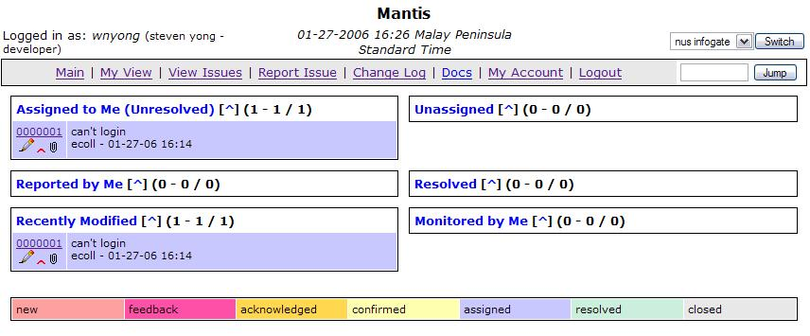
- It's easy to setup, I (who has no PHP hands-on at all) spent about only 2 hours to get it up and running.
- It requires only open source softwares which are Apache web server, MySQL database and PHP to run. And the cost of the system requirements is highly justifiable.

I'd like to tell the main reasons of NOT using the below alternatives:
1) JIRA – it has the richest features among all others and I've been using for a few past projects and I'm very satisfied with it. Unfortunately it costs thousands of dollars and it's more towards a project management system than a pure issue tracking system
- iTracker – it is lack of features and is requires a Java runtime to work. More significantly, this open source project has been terminated which means that we'll see no further fixes and supports.
- Bugzilla – Although it is a very famous open source software and it has the similar system requirements with Mantis, it isn't user-friendly enough and it's nearly impossible to use it seamlessly without some basic training.
- ExtraView – it's a free but not open source software. Actually I did not really evaluate it in details because it limits the number of users in the free version.

System requirements
Software - Mantis will literally run on Linux, Windows and Unix platform. And it requires Apache web server 2, PHP 4 and MySQL 3.23 or higher.
Hardware – There is no document specify the hardware requirement of running Mantis clearly. However, the project website claims that “Mantis has very modest software and hardware requirements. You need a computer to run the server on along with the server software. All of the required software is free for commercial or non-commercial use. The computer can be a shared public web server or a dedicated co-loc box. It can even run on an office machine. Any Pentium class computer should be adequate for moderate usage. You will need enough diskspace for the database to grow and enough memory to avoid virtual memory thrashing. Several thousand bugs will only take up a few MBs of space. This will grow proportionately with attached files.”

If you'd like to experience the system yourself, please point your browser to http://wnyong/mantis/index.php and login with user name “administrator” and password “root”. For more information about Mantis, please visit www.mantisbt.org.

