Purpose of Investigation

The aim of this environmental investigation is to discover if ‘Visitors to Oxwich bay are detrimental to the sand dunes’. To do this investigation different surveys have been used as well as other data, which is shown in the Data Presentation chapter. Page __

The location of Oxwich bay and the beauty of the area attracts visitors from miles away. There are around 250,000 visitors per year to Oxwich bay, about 8000 of these are students doing A-level, GCSE and degree level coursework. The majority of these visitors are during the summer, as this is peak season with better weather.

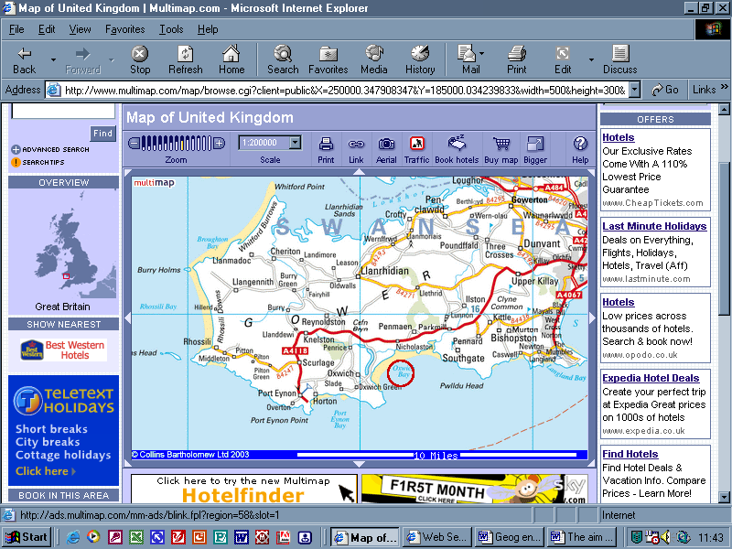
A4118 provides easy access to Oxwich bay
Due to popularity of the area people take short breaks to the area and stay in areas near Oxwich bay

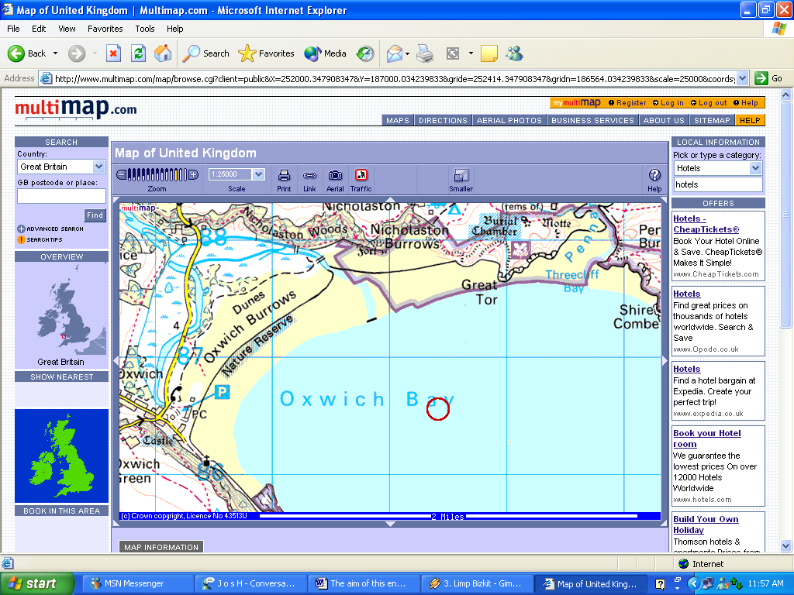
Access to Oxwich bay beach
There is fencing that runs all the way around the back of the sand dunes
Facilities

The visitors to Oxwich bay do many different activities; the purpose of this investigation is to find out if these activities are detrimental to the sand dunes.

This hypothesis was created to help to answer the aim of the investigation:

‘Visitors to Oxwich bay are detrimental to the sand dunes’

To help prove or disprove my hypothesis three key questions have been made

Key Question | Primary Data | Equipment | Secondary data + source of data
What are the sand dunes like  This will help because if there are signs of errorsion and damage caused by human activity it will show that visitors are detrimental | Pictures  Sand Dune  Transect  Vegetation surveys  Wind speed survey | Camera  Quadrat  Ranging Poles  Anemometer  Tape measure  Diluted Water  -----------------------------
How have the sand dunes been affected by the visitors and nature  The way they have been affected could show if visitors are detrimental to the sand dunes | Pictures  Sand Dune  Transect  Vegetation surveys  Wind speed survey | Camera  Quadrat  Ranging Poles  Anemometer  Tape measure  Diluted Water  -----------------------------
What are the future Implications

This helps to prove or disprove the hypothesis because from the information collected it shows that damage is going to keep occurring in the future because of human impact it proves my hypothesis. However if my results show that there is no future implications of damage occurring, that humans are not going to be detrimental to the sand dunes, however it doesn’t show if they have not already been detrimental for the sand dunes.

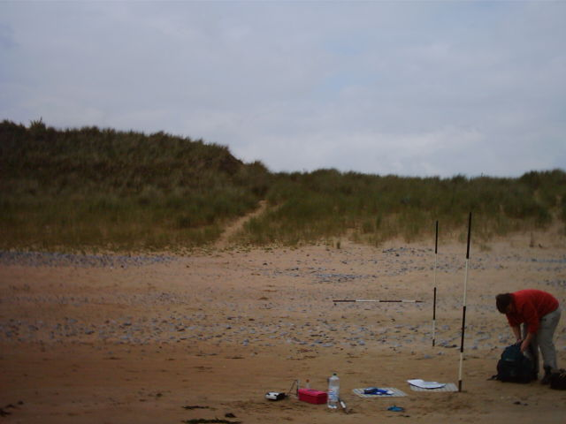
Ranging Pole
Diluted Water

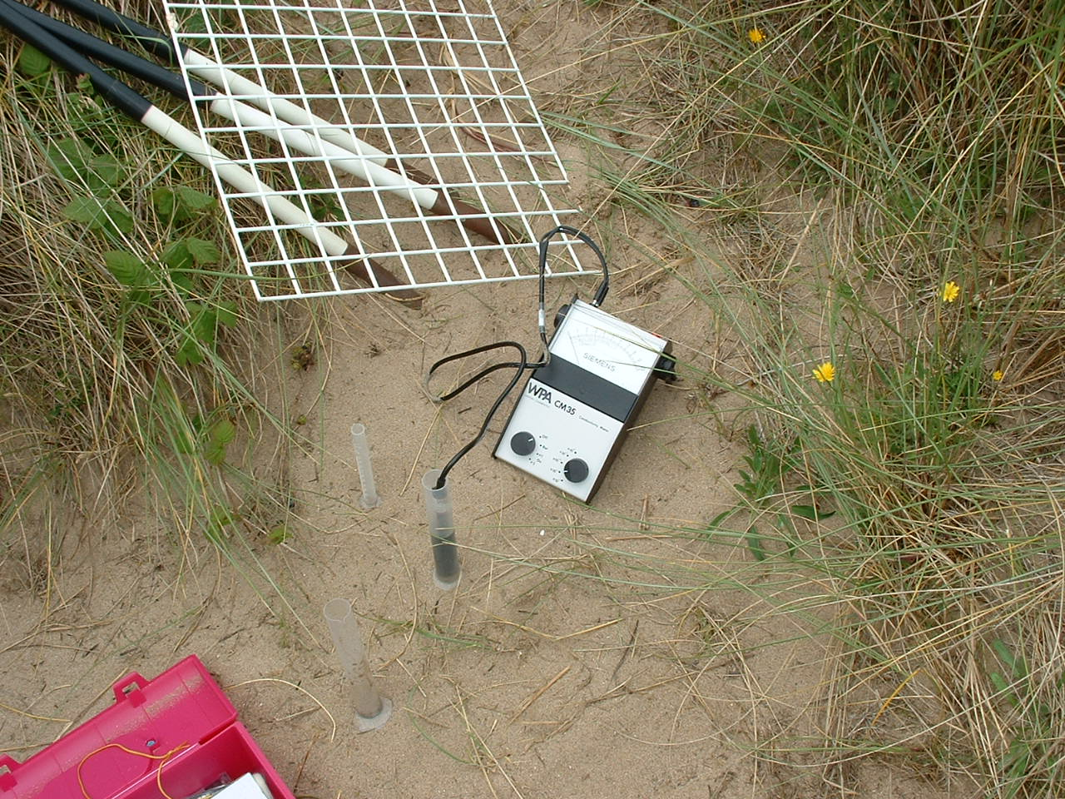
Quadrat
Test tubes

erm

Methodology of Data selection, collection and recording

I collected data on the sand dunes to help answer my key questions. The data I collected was:

Sand dune transect

The reason for the sand dune transect was to see how the sand dunes were shaped, and to see if there are any visible affects from human activities as well as weather.

The sand dune transect was done using the following equipment:

Ranging poles
Clinometer
Tape Measure
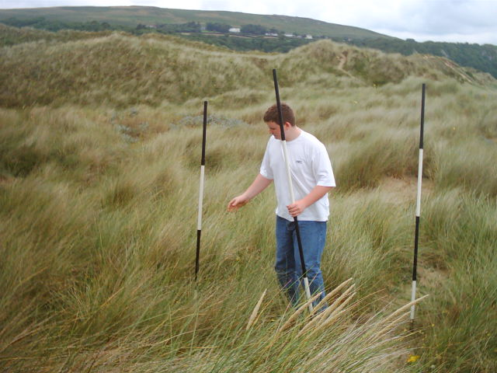

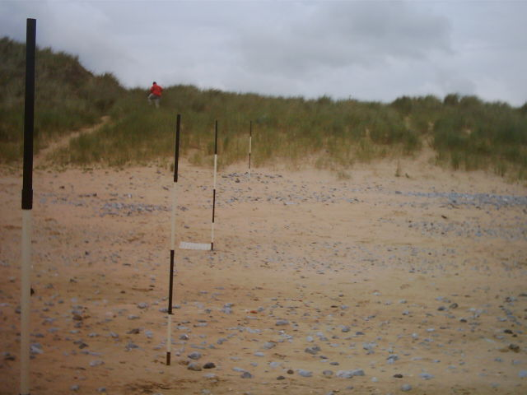
Ranging poles are put into the ground in a straight line at every area the slope starts to change

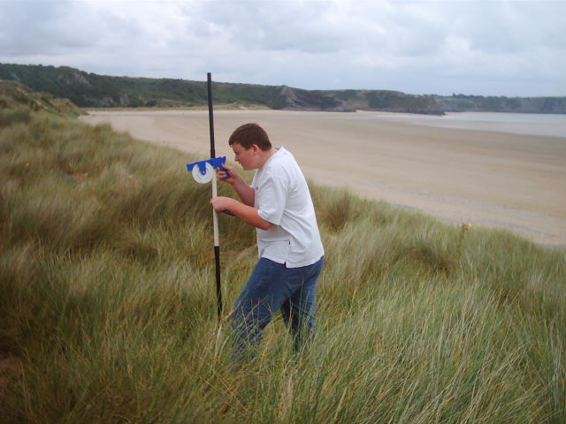

The clinometer is rested under the bottom of the top black section, and then aimed at the pole in front of it, to the same place it is resting on the pole its at.

This is then put onto grids found in: Appendix page __ Figure __

Vegetation Surveys

The reason for collecting vegetation surveys was to find out whether there is a wide variety of vegetation, whether there is lots of it, signs of trampling, and human activity affecting vegetation.

Equipment used:

Photos
Quadrats
Ranging Pole
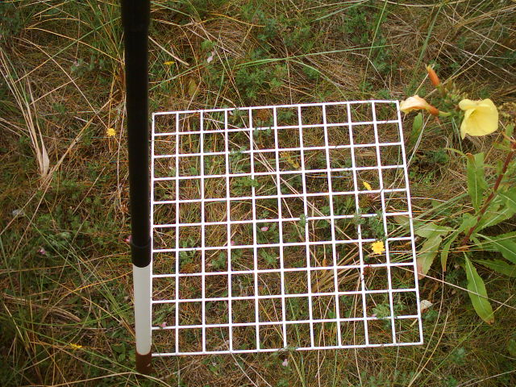

The quadrat is places by the ranging pole at random intervals.

Photos were taken so that I could research on the species of plant found.

This was then recorded onto a grid found in: Appendix page __ Figure __

Wind Speed

The reasons for collecting results on wind speed are that the weather especially the wind affects sand dunes. Blow outs can be caused and sand blown away. Collecting information on how the weather affect the sand dunes helps to find out how much the visitors have affected the dunes, because it is unrealistic to say that the only damage caused to the sand dunes is by human activities.

Equipment:

Anemometer
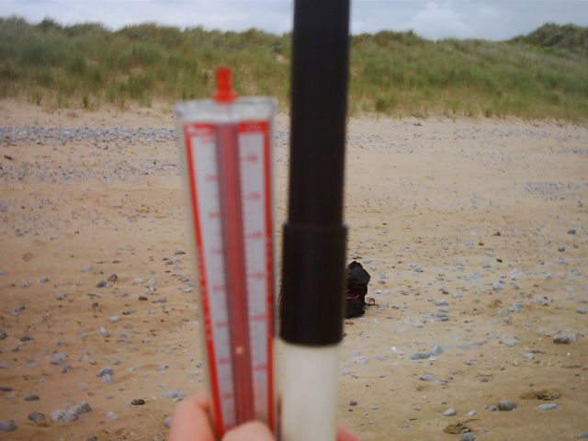
Ranging pole

Wind speed is taken at random intervals down the transect.

Anemometer is held at the same location on the ranging pole at every recording.

This was then recorded onto a grid found in: Appendix page __ Figure __

Soil Tests

Soil Tests were done

Equipment:

Distilled Water
Test tubes
That current measuring thingy
Measuring Tubes
Squirty thingy

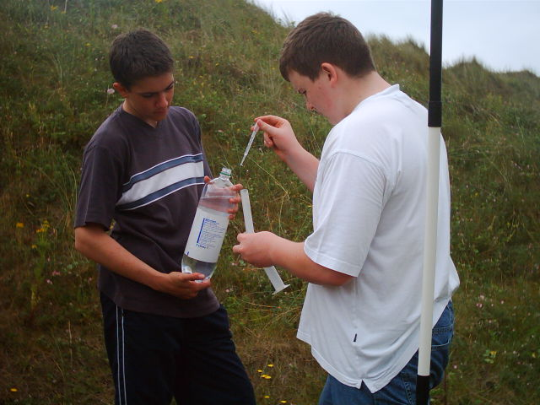
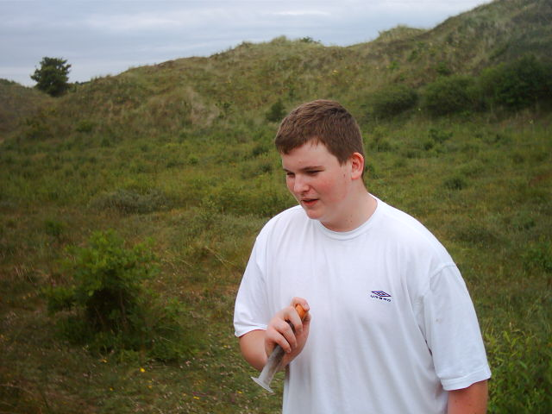
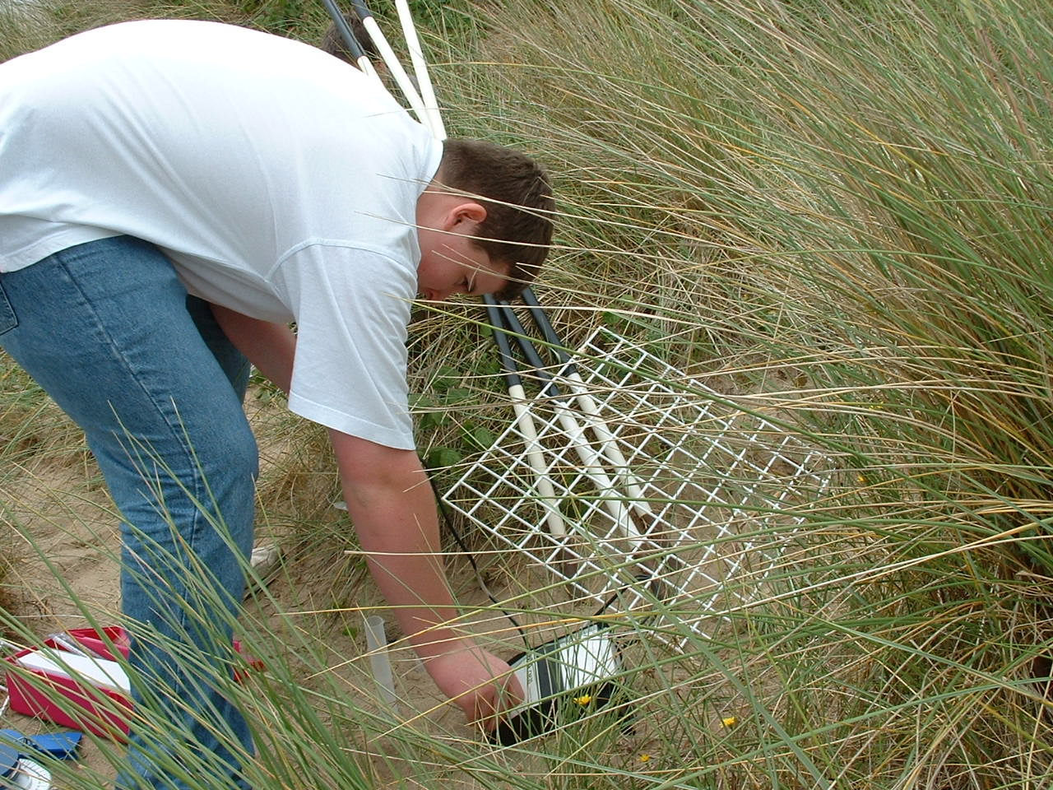
Sample of the soil is taken at stages along the transect.

Mixed with 25ml of distilled water and shaken for 1 minute. Then using the “current thingy” the resistance of the solution is measured.

There should be a decrease in resistance going away from the shoreline because there should be a decrease in the amount of salt in the water.

This was then recorded onto a grid found in: Appendix page __ Figure __

