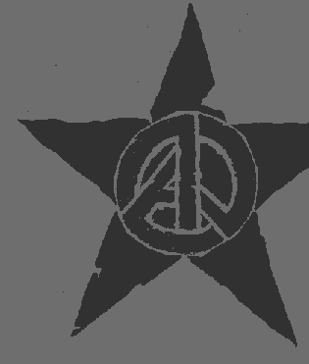
Terrorism needs you...

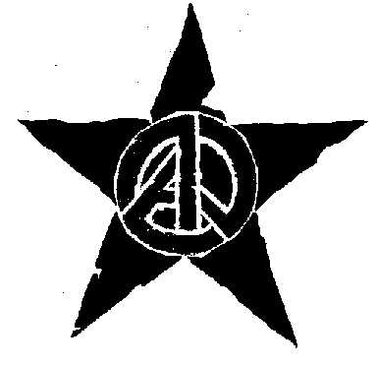
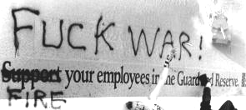
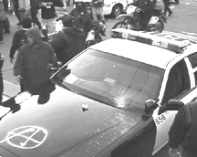
to support the latest war, so new generations of orphans can grow up hungry for revenge. Saddam Hussein, and everyone like him, especially the one who will inherit his position they too need you to support this war: a people will only obey a tyrant if they fear another enemy more. And George Bush needs you to support this war, for exactly the same reasons: he and his kind need new generations of terrorists to justify their authority to the ones the terrorists kill. Their greatest fear is that you will realize they need you more than you need them. If one nation's citizens rose up and took back power over their own lives, the citizens of other nations, knowing they had nothing to fear but their leaders, others could do the same-- and anarchy would reign. All it would take would be for a few people like you, alone or in small groups of friends,
to test your strength making visible the discontent already fermenting beneath the surface. NO MORE BUSINESS AS USUAL
- The war is in high gear, and labour is supporting it! organize a walkout from your school or workplace, or call in sick, or go on strike! Even if it's only a few of you, the others will notice. - Don’t pay taxes, don’t buy gas, stop shopping altogether-- it just encourages them. A worsening economic slump is the worst nightmare of the ones who buy and sell war. - An easy way to ease your guilt about spending money is to spruce it up a bit by writing your favourite anti-war slogan, grim statistic, etc. on the bill. - Locate corporations in your area that stand to profit from the war. Make things difficult for them, vigils, phone calls, vandalism. The same goes for US military bases like the echelon base in Waihopai, US radio base at Tangimoana (Manawatu) or Harewood (Christchurch Airport) or NZ companies such as ANZ and Fonterra. FREEDOM OF THE PRESS BELONGS TO THOSE WHO HAVE THEM- Go to concerts, public parks, cafeterias, campuses; set up a table with the cleverest, clearest free anti-war literature you can find, and start conversations. - Organize social events: concerts, dances, parties, weekly discussions, and planning sessions against war and capitalism, and in support of home-grown culture and communities based on mutual aid. - Set up an occupation downtown or on campus: be there all day and night, in rotating shifts if need be, with big signs, papers, free food to give away. - Write and distribute a press release to local news agencies for every action you do provided you trust the corporate media, that is! If you don’t, use a marker to write "LIES" across the front of every newspaper poster - Don’t stop at distrust--you can keep up with independent news coverage (www.indymedia.org.nz or www.anarchism.org.nz), or even start an Independent Media Center of your own (information at http://process.indymedia.org) to make sure other perspectives are heard.
- Organize screenings of documentaries or show the Indymedia Newsreal (www.satellite.indymedia.org). - Pull stunts that will force people to think through humour or shock where nothing else will work. For example: inundate your town with fliers announcing
that your peace group will set a dog on fire with gasoline, in protest of the war. When people show up to protest, and see you have neither dog nor
fuel, cheerfully confront them about their hypocrisy.
- Talk to your neighbours and acquaintances about the war. A good way to make your sentiments visible in your neighbourhood is to light luminaries
with various peace signs/messages written on the bags.
- Get a group and create a funeral procession--this can be done within a large march or as an independent action. Create a coffin from wood or cardboard, write statistics or paste pictures on it, and encourage people to bring flowers to place on the top.
MAKE YOUR CITY SING OPPOSITION
- Paint banners and drop them off rooftops and overpasses during rush hour. Information on how to make and deploy banners can be found at
www.crimethinc.com/cookbook - Design posters and paste them throughout your neighbourhood using wallpaper adhesive or wheat paste (boil water, adding wheat, to make a thick, sticky paste). - Go to stationary warehouse or a similar outlet and obtain a white Mean streak paint marker. Write "BUSH" or "WAR" on every stop sign, especially in the suburbs. - Cut stencils out of cardboard and spray paint messages through them all around your town. DON’T STOP AT BEING ANTI - Don’t allow any ideological faction to control anti-war organizing; organize with your friends, your own way, and seek allies rather than converts. - Don’t let your activism stop at reaction to the war. War is the way those in power flaunt their strength when they have to distract people from their weaknesses. The best way we can resist is to attack their power at its weakest points: the places where we can take control of our own lives, to build community and learn to work together. Don't let their military muscle flexing demoralize you-- there are countless others like you just waiting to join in as soon as they see resistance is possible! Every choice you make out of courage rather than fear, every dream you pursue, every day you spend doing things that are good for yourself and those around you, you are striking blows against the war machine. It runs on routine, boredom, despair, and acceptance. Quit your miserable job, start a babysitting cooperative or a band or a magazine, spend more time doing things with your friends than watching television, get in the healthy habit of fighting back when something outrages you! Living authentically is contagious and empowering. Whatever happens over the next few months, if everyone getting involved in the current anti-war movement refuses to go back to business as usual, and keeps fighting long after the soldiers have stopped--then there won't be another war, ever again.
This public service announcement is brought to you by the Anarcho Ministry of Peace (fukthe@usa.com), but don't take our word for it.

