The Aotearoa
GE Action Handbook

Content
Acclaimer
Disclaimer

I PART ONE: Preparation
The Peoples Moratorium
Campaign Strategy
Why Direct Action
Starting up your own group
Effective meetings
6.Consensus Decision Making
Affinity Groups
Dealing with Media
Legal Information

II PART TWO: The Actions
Scouting
Direct Communications
Billboards
Stencils

Banners

The Food Chain

Armchair Actvisms/Cyberactivism
Supermarket Actions
Annual General Meetings
Office Occupations
Blockades/Transport Actions

The Field Trials
Locating a Site
Ideas for Field Trial actions
Decontamination
Covert Direct Action

III Appendix
Resources
There are a thousand hacking at the branches of evil to one who is striking at the root.

-H.D Thoreau

Acclaimer
This handbook is designed to give people the tools to do what the New Zealand government failed to do: To keep Genetic Engineering out of our food and environment. After years of lobbying, marches, submissions, scientific evidence and political processes the New Zealand government has decided that New Zealand should become a GE Nation by continuing to allow GE ingredients in our food and by giving the go ahead for more field trials and conditional releases of GE field trials.
This is in disregard to the opinion of most New Zealander and in ignorance of New Zealand’s economic future as a country that strives to produce ecologically responsible high quality agricultural products. This handbook will help people to do the job that authorities like the Environmental Risk Management Authority (ERMA) and the Ministry of Agriculture and Forestry (MAF) are supposed to do. We do not take this step lightly but we feel it is our duty to protect Aotearoa and its people from a technology that has no proven benefit with the exception of generating profit for a handful of companies. Genetically engineered crops are not needed. Instead they are a biohazard to human health and to the Earth. The New Zealand Peoples Moratorium was launched in October 2003. We think that is our duty to take up a more active role in protecting our country from GE crops and GE food. This includes a range of direct actions from protests and pickets at supermarkets, the refusal to buy products that contain GE ingredients, hitting corporations where it hurts in the pocket, personally targeting those responsible for GE production in Aotearoa, to physically stopping GE organisms form being released and to safely take responsibility for their decontamination once they are released.
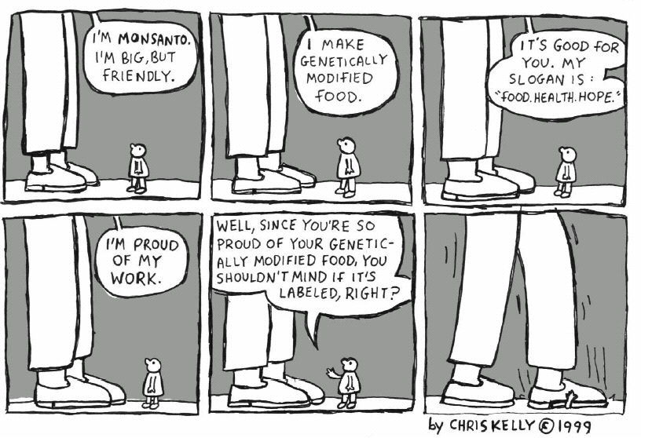
In the face of all responsibility being waived by those in a position to wield it, the responsibility falls on each one of us. We are therefore inviting people to join together to take non violent action against field trials of GE crops, GE companies and products made of GE ingredients.

In the spirit of democracy we are asking people to not only take part in actions, but to start organising them. We call on those who are opposed to genetically engineered food crops to contribute to stopping this experiment.

You may be reading this because you want to take part in an action or because you want to help support one. This handbook is an attempt to put together some of the information you'll need to organise and take part in direct actions, at whatever level you feel will make the most change. This handbook owes lots to all the wonderful people who undertake similar actions in other countries. A lot of the information herein comes from overseas, where in many countries people have successfully stopped GE crops and food from spreading. We have shamelessly copied and borrowed from other peoples' work without asking them.

Disclaimer
This handbook is written under copyleft. Reproduction and distribution is not only allowed, it is encouraged.

The information in this handbook has been gathered as a collection from other sources. The authors can take no responsibility for the actions that individuals take.

PART I: PREPERATION

“The future belongs to those who prepare for it today.”
-Malcolm X

The People’s Moratorium Declaration for a GE-Free Aotearoa/New Zealand:
In the spirit of true democracy and environmental sustainability:
We, the concerned citizens of Aotearoa New Zealand, declare that we will do what is within our power to keep our land free of genetically Engineered organisms.

Given the Government's failure to represent the will of the people and to preserve the natural environment, it is now the responsibility, indeed the duty, of the citizens of Aotearoa New Zealand to protect the environment, animals and other living organisms, and also protect and preserve our health, our food, and our democracy.

To enforce the People's Moratorium, the citizens Aotearoa New Zealand will take action when necessary. This action will be in accordance with the principles of natural justice; everyone is empowered to act according to their conscience to keep Aotearoa New Zealand free of genetically engineered organisms.

We believe that openly democratic dialogue is the preferable means to resolution; though Civil Disobedience [Civil Responsibility] may now be necessary to keep Aotearoa New Zealand free of genetically engineered organisms. When the Government is again in the position to represent the interests of the citizens of this nation and not be influenced by private corporate interests, we will support the negotiation of new legislation for a GE Free Nation.

Campaign Strategy

" They say that science is deciphering the information code of life, and that now multinational companies intend to cultivate life in their laboratories, so that it does not run around wild and unharnessed, squandering colour and gaiety with the coming of spring. But life is music. It has its own notes, and its rhythm and cadence, and its melodies. And it is a powerful and playful magic force that moves our heart and our feet, and our very soul. And life, like music, was made to spill over and flow freely, a gift to poor and to the powerful alike. There are a thousand tunes in this world, for those wanting to listen. And each tune is a little piece of the soul of people and - just like life - cannot be cultivated in the laboratory of a multinational company. For this very reason, now that capital wants to appropriate the notes that compose the diverse songs of life, we need to join efforts, and stop it."

- Indigenous People's Biodiversity Network.
We are here: Our democratic system has failed us; the government has waived its responsibility to respond to public concern and regulatory bodies are wholly inadequate. Meanwhile profit is being prioritised over the health of people and our environment. When biotechnology companies refuse to accept liability for the risks of GE; when our legal system becomes devoid of morals and ethics - then we must take responsibility.
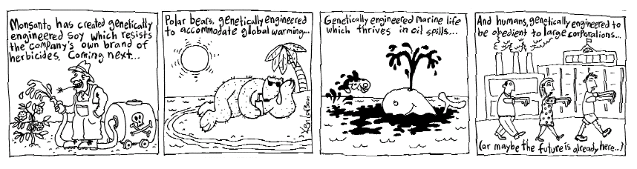
The only thing left to do for us is to take the fight to the people who force-feed us genetically engineered products and are releasing GE organisms in New Zealand. We consider this as an act of self-defence since all other paths have been denied to us. The logical next step is to target the field trial and products.
There is only one thing left for us to do: To non-violently prevent any further field trials and conditional releases. In other countries the pressure in the supermarkets, corporate offices and fields has led to governments later implementing anti GE legislation. Maybe now is the time to show the Beehive that we are serious and that we will implement our own moratorium when necessary.
Way to go! Field trials need to be prevented. ERMA claims that their field trials are “contained” because they usually have release conditions that require the removal of reproductive plant organs. Field trials cannot be contained. Field trials are releases of genetically engineered organism into our environment. It is bizarre that ERMA can approve field trials in New Zealand that have been declared too dangerous in other countries. It is also important to keep in mind that so far ERMA has approved every single field trial that was ever officially applied for in New Zealand. Some of New Zealand’s most respected scientists have spoken out against GE field trials, but ERMA has never listened. They have not listened to scientists, farmers, mothers, beekeepers, tourists and economic experts who dared to express a different opinion.
The other focus of this campaign should be the supermarkets. For several years now we have been force products that contain genetically engineered organisms. The labeling legislation is weak and will not inform you of all the GE ingredients a product might contain. The New Zealand government not only embraces the release of GE organisms, they also do not allow us to know what we are eating. While many companies selling products in New Zealand have decided to guarantee their ingredients to be GE free, there are still some of them who are happily forcing GE down our throats. We need to make a concentrated effort to stop them from selling these products to the public or even better importing these products to our shores. The best way to do this is to focus our efforts on single companies and products until they change their policy. Overseas experience shows that if all the GE groups in a country target one company, this company will soon change it’s policy. Sometimes this might take a few months or more, but we will still be stronger then if we all focus on different products and companies throughout the country.

Why direct action?

"Until one is committed there is hesitancy, the chance to draw back, always ineffectiveness. Concerning all acts of initiative there is one elementary truth the ignorance of which kills countless ideas and splendid plans: that the moment one definitely commits oneself then providence moves too .... whatever you can do or dream you can begin it. Boldness has genius, power and magic in it. Begin it now." - Goethe.

Wherever there is injustice, wherever big companies put profit before human or environmental need, there will be people to oppose them; and wherever the government introduces draconian and unjust laws, which puts its own needs above the needs of the ordinary citizen, there will be people willing to break those laws. This has always been the case. Groups of people have always come together to break the law for the common good, to actively oppose tyranny and injustice, to proclaim the rights of common humanity over the privileges of the vested interests. Direct Action has been proven a successful tool numerous times. Think about the protests In Seattle, or the struggle to save native forests in New Zealand.
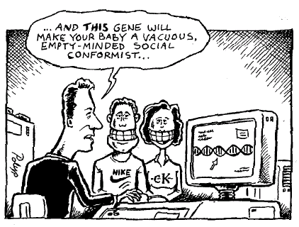
The time to engage in non-violent direct action (NVDA) against GE food and GE crops is now. We have written submissions, we have given scientific evidence, we have stripped naked in front of parliament. For more then five years have we done everything possible to make our voices heard. Direct Action is the logical next step.
‘Direct Action’ is a term, which is often misunderstood. It has the cachet of dramatic zealotry, yet in essence, it is often quieter and more powerful than this stereotype.
To act directly is to address the actual issue of your concern. If you’re working against hunger, it’s might be simply giving someone a meal. If you’re working against homelessness, it might be taking over an abandoned house and making it liveable. If you want to stop military spending, it might be refusing to pay your income taxes.
Direct action differs from symbolic protest action, which is lobbying authorities to change their policies. An advantage to direct action is that it doesn’t require the cooperation of the authority to be effective. If they intervene to stop your action, you have a dramatic story; if they ignore you, you’ve followed your conscience and can continue following it further. Since the action in itself has a direct effect, it has a power and strength. In practice, the most effective actions are both direct and symbolic, providing a clear witness to your beliefs.
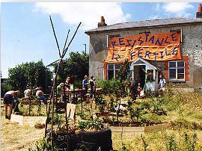
Direct action is not restricted to ages or races. Everyone can do direct action. From globalisation protesters and civil rights campaigners to local mothers and pensioners bouncing cars off of blocked pavements. Increasingly ordinary people are discovering how to bend the government's ear.
Over the last few years there has been a dramatic increase in direct action all over the world. A lot of it was connected to genetic engineering. In several European countries it was mainly direct action that forced the government to disapprove field trials and forced companies to make GE free products. This handbook will portray some of the actions that have been taken in other countries and in New Zealand. From thousands of people refusing to buy certain products to grandmothers publicly ripping up GE crops.
Let’s keep in mind that the campaign against GE in food and environment has been a tremendous success globally and in Aotearoa. In New Zealand the campaign is really just beginning.

“You may well ask: ‘Why direct action? Why sit-ins, marches and so forth? Isn't negotiation a better path?’ You are quite right in calling, for negotiation. Indeed, this is the very purpose of direct action. Nonviolent direct action seeks to create such a crisis and foster such a tension that a community which has constantly refused to negotiate is forced to confront the issue. It seeks so to dramatize the issue that it can no longer be ignored…..
I have earnestly opposed violent tension, but there is a type of constructive, nonviolent tension which is necessary for growth….
Actually, we who engage in nonviolent direct action are not the creators of tension. We merely bring to the surface the hidden tension that is already alive. We bring it out in the open, where it can be seen and dealt with. Like a boil that can never be cured so long as it is covered up but must be opened with all its ugliness to the natural medicines of air and light, injustice must be exposed, with all the tension its exposure creates, to the light of human conscience and the air of national opinion before it can be cured.” - Martin Luther King

“Usually when people are sad, they don't do anything. They just cry over their condition. But when they get angry, they bring about a change.” -Malcolm X.

Affinity Groups & Support

This is what you shall do: Love the earth and sun and animals. Stand up for the stupid and crazy. Take your hat off to no man.
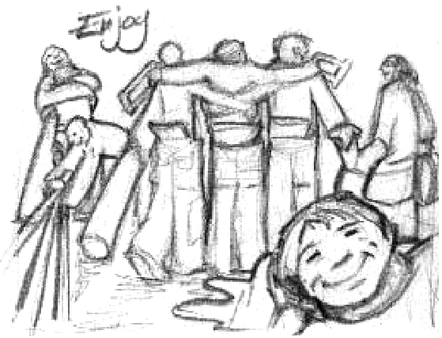
-Edward Abbey

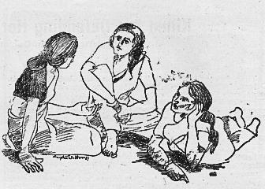
Affinity groups are self-sufficient support systems of about 5 to 15 people. A number of affinity groups may work together toward a common goal in a large action, or one affinity group might conceive of and carry out an action on its own. Sometimes, affinity groups remain together over a long period of time, existing as political support and/or study groups, and only occasionally participating in actions.
If you are planning to do civil disobedience, it is a good idea to either form an affinity group or join an already existing one. Affinity groups serve as a source of support and solidarity for their members. Feelings of being isolated or alienated from the movement, the crowd, or the world in general can be alleviated through the familiarity and trust which develops when an affinity group works and acts together. By generating this familiarity, the affinity group structure reduces the possibility of infiltration by outside provocateurs.
Every affinity group must decide for itself how it will make decisions and what it wants to do. This process starts when an affinity group forms. If a new person asks to join an affinity group, she/he should find out what the group believes in and what they plan to do, and decide if she/he can share it.
A group cannot hope to reach consensus decisions without having some base of agreement. Once a base is agreed upon, working out the details of specific issues and actions is not as difficult as one might expect, providing that there is a willingness to go along with a good idea, even if it is someone else’s. If you find that you cannot work effectively with your group, it might be better to try to find another one.
Support
The role of support in a civil disobedience action is crucial. Support people accept the responsibility of being a visible, involved contact to the outside once a member of the affinity group is arrested. They are the personal extension of the care and concern an affinity group shares among its members, an extension of the need all the participants have to see that individuals who participate in nonviolent direct action are not isolated, neglected, and overburdened because of their political statement.
It can be hard for you to decide whether to do civil disobedience or support. It is strongly encouraged that those considering doing support go through nonviolence training. In making the decision, you could consider how each role would affect your family, job, and other commitments, as well as your legal status

PART II: The Actions

"My struggle for a truth to stand within must carry into the trial itself, for the deepest, most living truth emerges through intense conflict seeking reconciliation. Truth is not a slab of concrete to rest my life upon, but a luminous force in which I stand and which I discover is sparked into more dazzling light by the conflict of challenge and response." - James Douglass.

“In 1986, after sinking half the Icelandic whaling fleet, I was approached by a former colleague in Greenpeace who said that what we had done in Iceland was criminal, despicable, and unforgivable. I answered, "So?" He said that he needed to tell me that. I said, "John, do you really think I care what you think? Do you think that I care what any human being has to say about that action? We did not sink those two killer boats for you, We sank them for the whales. Find me just one whale that disagrees with that action and I'll reconsider. Until then, I could not give a damn about your opinion on the matter. That's why I'm unpopular within the conservation movement. I do things that disturb people. I say things people don't want to hear. I'm not here to win any popularity contests. My job as a conservationist is quite simple - to piss people off. Why? Because people are the problem.”
–Capt Paul Watson of Sea Shepherd

We strongly suggest that you read the sections about legal information in this handbook before considering any of the actions below.
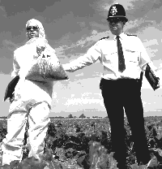

Scouting

Like much of the action development process, scouting is a combination of the artistic and mechanical. It can involve something as simple as looking over the place you want to picket, or it can be complex, involving great amounts of background research, repeated visits, or unpalatable risks. Mechanically, an activist scouts the physical qualities of the potential action site. Hazards, access, and assembly points are typical scouting objectives. They have enough of a sense of timing and proportion to judge whether the project is feasible-and what it would take. With practice, good scouts see (or research) the subtler physical qualities. Weather and lighting, useful symbols of "the other side", traffic and security patterns would fall into this category.
Artistically, experienced scouts (and action coordinators) can look at the site and almost see the action unfolding. They anticipate the reactions of other participants in the action. These include bystanders, workers, the curious, police, and media people. They have a sense of the timing and flow of the action. The artistic side of the scout can see the symbolic quality of the action and the action site as a political performance space-with an edge.
Developing scouting abilities depends on a lively discussion of technique and results.
Preparing for the scout
Before you can prepare for the scout it is prudent to revisit some of your assumptions regarding the action. Is the potential action appropriate to the campaign at this particular time? Is it proportionate to the seriousness of the issue? Will the action speak to the
problem? Will it be visible and understandable to its target audience? It is likely we will have to ask ourselves these questions several times during the scouting process.
Good scouting usually begins with good research. Good background research can reveal difficult-to-see potential. It even helps get us in the right frame of mind. Often, your potential action site is far away and you don't want to make repeated trips. So if you
haven't been to the potential action site try to visualize it. What have you heard about it? What do you know about similar sites or facilities? Do any of your colleagues have experience useful to your project? A good bit of scouting is, in effect, brainstorming
about "what-if. " Scouting is often most effective - and usually more fun - when done by a group. Who should be on the scouting team? Sometimes the team can be enhanced by friends who might not even be activists. Artists or photographers, for instance.
What to take: Don’t forget for covert actions: A.L.F. Avoid Leaving Fingerprints. Buy new gear without touching it!
Addresses: Not just of the place you are scouting but maybe your lawyer as well.
Writing address and contact numbers on your forearm in indelible ink saves having to carry bits of paper.
Covert actions require you to destroy any incrimination evidence by fire (see covert section).
Don’t bring your address books with contacts of your friends etc.
Maps: What sort of map (s) (road, cadastral, topo, aerial photo etc) you take will obviously depends on the nature of your action.

Cap: A cap can be more useful than you first think. In brushy country it can help keep stuff out of your eyes. They are also particularly useful at night when you can use the brim of the cap to screen out unwanted light allowing you to peer into those dark areas with more effectiveness.
Binoculars: Often very useful and should be part of the basic scouting kit. Binoculars are described by two numbers, 8 x 35, for example. The first number is the magnification and the second is the width of the field of view. For land-use magnifications of 8 to 10 times are good.
Camera, with correct lenses: An essential tool for most scouts. A picture can be worth a thousand words. In some cases the camera catches detail that the eye misses. It helps you remember detail. Take lots of photos. If necessary, do a sketch map of the different shots and angles. A 50mm lens together with a zoom is a good basic kit. Make sure you have extra batteries for the camera.
Carpeting/Rubber Car Mat: Nothing like a good old square of carpet thrown over the barbwire to make your fence crossing a little less difficult. Fuzzy side towards the barbs for better grip.
Communications gear: You may want to have gear to communicate with other team members or lookouts. If the action you are planning requires the use of communication gear you need to test it on-site as part of the scout. Interference from electrical equipment, distances that are too great for the equipment, and other users on your channel are more common than you think. Scout electronically as well as physically!
Compass: As an accompaniment to your map. Look for a good liquid-filled model. (The needle settles quicker) and make sure you know how to use it.
Overalls: Scouting can be a dirty, even toxic, activity. A good set of overalls can help keep your better clothes clean. And if you are spotted while scouting ditching your overalls can give you a new look quickly. In some cases, overalls can be used as a disguise. Workers might not get the attention idle individuals get.
Gloves: Your hands can take an enormous beating while scouting. Good gloves can be worth their weight in gold. Basic equipment for scouting industrial sites and a must for crossing barbed or razor wire.

Global Positioning System (GPS) Receivers: GPS has come way down in cost in recent years making it fairly affordable for activists. GPS makes back-country navigation all the easier-especially when operating off-trail. With GPS the more you pay, the greater the accuracy.
Hardhat and Clipboard: One of the universal disguises. It's amazing how people will notice, then tune out certain "normal" scenes. Hardhat and clipboard, overalls or generic uniforms all seem to have this effect.
Headlamp with extra batteries: Hand-held flashlights can be frustrating to use. A headlamp is a much better choice, and don’t use cadmium batteries because of what they do to sea turtles.
Measuring tape: How big is this pipe? How wide is that gate? The steel tape model works well.
Money: Each person in the scout team should carry a little in case they get separated or picked up.
Notepad with pencils or pens: You can also purchase waterproof paper and pens for inclement field work.
Pager: Some activists have had success using pagers as a device to warn or communicate with an on-site scouting team.
Pedometer: A device that tells you how far you have walked.
Proper Clothing: Many a scout has been cut prematurely short by wet or frozen activists. Conditions can change, be ready.
Rake or Hoe: Sometimes the easiest way past a fence is to go under rather than over it. With a rake or hoe you can lay on your belly and clear a little slither room. Particularly good if going over the fence would be too visible.
Tape Recorder: If quiet isn't a requirement speaking your notes into a tape recorder is a good, fast way to get a lot of data.
Two way Radios: Can be of invaluable help to warn scouters of approaching trouble. As with all of these tools they are also good during the action itself.

Video Camcorder:. These can be extremely useful scouting tools. One great thing about videocorders is you can record spoken notes right on the tape. They often work in lower light than cameras, although they lack the high magnification long camera lenses afford. Have extra batteries too.
Watch: Another part of the basic scouting tool kit. If it has a stopwatch, timer, and alarm all the better.
Weather Information: Get a weather forecast before each scout.

Direct Communication

"Subvertising is the Art of Cultural resistance. It is the 'writing on the wall’ the sticker on the lamppost, the brick through the window, the corrected rewording of Billboards, the spoof T-shirt. "
Billboard Subvertising
"The billboard artist's goal is to throw a well-aimed spanner into the media's gears, bringing the image factory to a shuddering halt. We work to unmask the real corporate activity behind the glamorous image. Our actions reclaim these billboards and use them as our own canvasses. After all, it's our walls that are being rented out for business propaganda."
See covert section for good activist practice for illegal activity!
Billboard Improvement: Most times it may be that you don't need any more than a tin of paint, gloves, a little humour and a quiet night to turn a multinational's expensive advertisement into your own guerrilla tapestry. This deals with the direct subversion of the billboard's message - to answer it, question it, or overturn it, all at their expense.
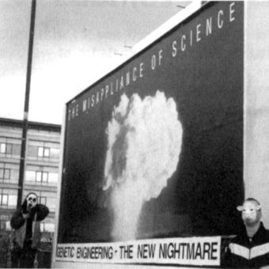
Methods: If you want to use spray cans then beware illegible scrawl and spelling mistakes. Also: like the hip-hop graffitos, get yourself a pistol grip plastic handle that fits around the can, saving on tired fingers and ensuring that the paint goes in the right direction. These are cheap and easily available at any car-shop. The most effective alterations are certainly the simplest: the addition of one or two letters, or a speech bubble; or pasting over certain words or letters with appropriately coloured paper or corflute. A skilfully reworked billboard directs the passer-by to a consideration of the original corporate strategy, in the context of a thoughtful reaction.
For lettering, paint your slogan on paper better still, find a computer and do the alphabet, one letter on each A4 printout. These are your originals - don't paste them up. When you want a slogan, take each letter in turn and blow them up on a photocopier. With a computer you should be able to find the exact typeface that is already on the billboard. Very impressive was some bright spark’s addition to Volkswagon's "We put people in front of cars" by reproducing in exact - type underneath: "And children under the front wheels."
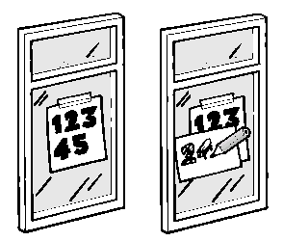
Redecorating Use wallpaper paste for, a bucket and a brush. Coat the area to be covered with lots of paste, place on the graphic and go over it again with lots of paste. A broom will get you higher - cut down the head to fit inside the bucket. Watch the billboards for when they change them - if you catch them right you can get plenty of outside studio space and time for your visual banditry. Redecorating is far more effective than just spray painting a billboard.
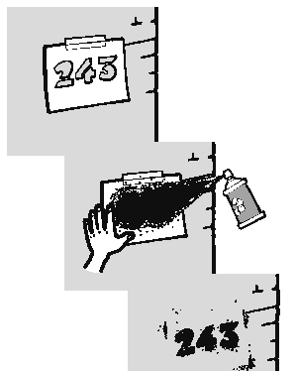
Raid the garbage bin of an advertising company or collect some big real estate sign type plastic, carefully place your new message on at home then stick up with industrial sized double sided sellotape or spray on glue!
Stencils: Stencils are a great way to get your message out. They are the activist micro-billboards. Since we do not believe that opinions should be able to be bought by money (advertising space), stencils are helping to counter the daily invasion of our minds.

What is a stencil? A stencil is a cheap and effective way of applying a graphic image or words onto almost any surface, and is basically a template that you can paint through. If you use car spray paint you can stencil wood, concrete, grip tape, t-shirts... pretty much anything. Stencils are especially effective for repeat patterns. A stencil is a simple thing to make, and requires only a sheet of thin cardboard, a sharp knife, and some paint. Road marking paint is best for footpaths, it even has an upside-down nozzle.
You will need: A sharp knife. A scalpel is the best tool for detailed stencils but for basic stencils a craft knife or a stanley knife will do.
Some thin card. Any card will do, but the cardboard cereal packets are made from is a good thickness. If you want to stencil onto material, try cutting your stencil from a sheet of acetate. A cutting mat, or a thick sheet of card, to put under your stencil while you cut out your design. The basic idea of a stencil is to cut out the design you wish to reproduce - the image you want to print needs to be removed from the card. The easiest designs to make are ones using type Note that the insides of letters such as "O" and "A" are held in place by thin strips - be careful you don't cut these off (unless you want the insides of your letters to be filled in, which can look cool to - see diagram)
You can either draw your design directly onto the card, or trace or photocopy your design onto a sheet of paper, which you then stick to the card with glue. An easy way to make a 'light box' to trace things is to tape the design you wish to trace to a window, and use the natural light shining in to trace through onto another sheet of paper.
Once you have your design, you're ready to start cutting. Cut away the areas of your design you wish to reproduce.
How to use your stencil. The two most common ways to use a stencil are to use a brush and paint, by holding the stencil flat and dabbing paint through the holes with the brush, or by spraying through the holes with a can of aerosol-powered road paint.
The road paint method is by far the quickest and easiest, the most durable, and can be applied to almost any surface.
Wear gloves so you don't leave evidence of your actions all over your fingers or fingerprints. Spray the paint lightly so as to get an even covering of paint through the holes of your stencil. Leave it for a few seconds to dry, then remove the stencil.
If you did it right, you'll have your design reproduced perfectly.
Congratulations! You're now a graffiti artist/vandal (delete as applicable)

Banner Making
Purpose: Banners can either be artistic and expressive and/or simple and effective at delivering a message. The design and construction of a banner depends upon its purpose. A banner may be disposable, made for a single event. Or, it may be made for use at multiple outdoor events. Or, it may be an indoor banner. Banners are made to communicate your message to a wide audience therefore a good location and/or media coverage can be helpful
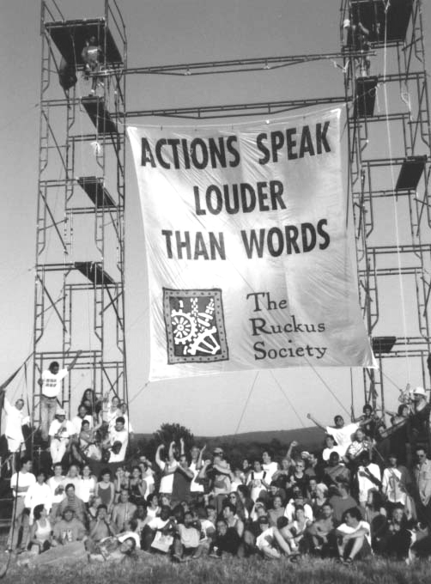
Message: The message should be simple, just a few words, and unambiguous. Of course, you might be clear about deliberately using an ambiguous message. The effectiveness of the banner also depends upon how clearly it can be seen at a distance, or in a news photo or on TV. Many banners get lost in a crowd. Their message may not reach people and not be seen in the news.
The simpler message the better if you want to reach a lot of people or inform people of your presence or your issue. The most effective banners have very few words. Banners with lots of text or graphics look nice hanging on a wall where people have time to read them.
The more time that you spend thinking about the message that you might put on a banner, the clearer it probably will be. People often make up banners spontaneously and then need to constantly explain the meaning of their message. Any banner that needs to be explained is clearly not effective. You might want to make up a list of bannerisms, ideas to consider using on banners. Painting and constructing a banner is the easy part. Web addresses make good banners too.
Styles: There are countless options: Hand carried banner, tall banner on poles, narrow banner on poles to be seen above the heads of a crowd. The style will depend on where and how the banner is used.
Layout: Make a drawing of your banner, then...
Measure, measure, measure and then measure again!
Draw guide lines on the cloth. Measure out the letters.
Draw your lines and letters with pencil. The ink from some pens will run when the banner gets wet.
Leave space between the letters so that you can highlight them. Do not crowd the letters together.
It be better to cut the cloth after you have painted it, because you may run out of space if you have not measured properly. The simpler the more effective
Use the largest font possible so that it can be seen at a distance.
Leave space, at least one-half letter high, around the borders and between lines.
Try not to leave blank space on the banner.
Put a border on the banner for holding space.
Put a one or two centimeter border in either black or white, on the banner. Photos of a borderless banner may not get posted on media because the banner could disappear against the background.
Text is easier to read at a distance or in a news photo than logos or graphics. Graphics work well in printed material or on indoor banners where people have the time to figure them out. Widely recognized logos or an extremely simple graphic can be effective. Again, highlight them with a contrasting colour.
Colours/Fonts: Using many different colours looks nice on a wall hanging but is difficult to distinguish in a crowd or in a news photo. White, although the most common background, is the easiest and most effective. Yellow bedsheets. (see materials)
Simple block letters are easiest to layout. Or, print your design and then photocopy it on to a transparency which you can buy at an office supply store. Then project it onto your banner, which you need to hang on a wall and trace the design. (Lots of work)
Highlighting with a contrasting colour makes your lettering or graphic twice as visible. If you use black lettering on a white background, pale yellow highlighting will make the letters shine in the sunlight or the glare of TV lights. Try to learn screen printing, it’ll save lots of time!
Construction: Assuming that you want to carry your banner on poles, it is important to understand that a cloth banner is not a rigid piece of plywood. The cloth banner is going to blow in the wind. If you attempt to hold it rigid and square, the wind will either blow you over or destroy the banner. Therefore, you need to allow the banner to blow in the wind, realizing, that most of the time, it will look presentable and legible.
The easiest way is to sew a sleeve on either end of the banner and put poles into those sleeves.

Vents It is necessary to cut vents in the cloth to allow the wind to pass through. The vents should be flaps, half-circles, that hang down when there is no wind.
Hanging up a banner: The four corner straps can be used to hang a banner on a wall etc. However, you need to pull the top tight to keep the banner from sagging. Or, you can sew extra straps along the top of the banner to suspend it from several points. The bottom of the banner will flap in the wind. You can hang small bags of sand (one-quarter or one-half cup) from the bottom of the banner to hold it down.

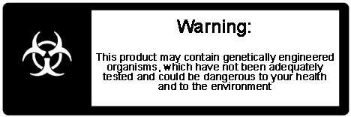
3. The Food Chain
"Those who are bent by the wind shall rise again when the wind softens." Te Whiti
The situation:
There are still companies that insist of force-feeding us products that contain GE ingredients. Also note that the labelling legislation will not result in the labelling all products that contain GE ingredients. We are currently not allowed to now whether the ingredients of or food are GE and the government has not intention of introducing a legislation that will allow us to know. That is why we must put pressure directly on the companies.
For a list of such products download the Greenpeace GE food guide at: http://greenpeace.org.nz/truefood/index.html
Note that this guide is update irregularly so it is possible that companies that are listed red (with GE ingredients) might already be green and the other way round. Write or call the companies and for their policies on GE to make sure. You will find their phone number on most of their products.

Research There are other places then the supermarkets where you can communicate with food companies: Their production facilities, distribution facilities, offices, CEO’s homes, their annual general meetings etc. Look for them in the Yellow pages (www.yellowpages.co.nz) or the White pages (www.whitepages.co.nz) or the electoral roll to find addresses. Look up their websites and look for pictures and locations of their offices, names of their CEOs and other key management. Reading their annual reports are a good way to start researching them

Armchair Activism:

Companies producing contaminated food:
em@il them Although they take longer, personal e-mails are probably more powerful then generic protest mail as they show the company that you feel that strongly about the subject. For more covert email go to an internet café and use a hackers spam program to fill their boxes with 1000’s of emails.

Call and Fax them If you are at it, why don’t you also call the company and tell them your opinion about their policy? Find their number in the phone book, the internet or on their products (but don’t buy the product). Sending a fax is just as good. Or illegally you can send a ‘black fax’ which is a black piece of paper taped onto itself that’ll overheat their machine, do this from a non-tracable number.
Bill for your time Send biotech companies and GE food producers a bill for the extra time it takes you to find non-GE food at your local supermarket.Use or modify the following template:

Company Address
Dear Sir/Madam,
I am enclosing an account for your personal attention, the showing the immense trouble, inconvenience and expense in terms of time and money, that is being inflicted on unwilling people like myself by [company name] 's unwelcome inclusion of GMOs in the world's food supply.
My monthly shopping bill has increased two and a half times due to [company name] 's unsolicited meddling with my food, and I seek compensation not only for the extra expense, but also, at modest rates, for my time employed in preparing foods by hand from carefully selected raw ingredients, as well as other demands on my time detailed in the enclosed list.
I object most vehemently to this tampering with my food, and I certainly intend to make every attempt to avoid any product containing GMOs, at the same time complaining to every supplier, manufacturer, supermarket, etc possible. I will assist in all campaigns in every possible way against inclusion of GMOs. The general public may well be complacent at the moment, but as they become more well informed, as they will do, then the companies to whom your off load these doubtful products will feel their resistance and will cease to accept them.
It is totally wrong for an organisation such as yours to force these genetically manipulated foods onto the general public in such a way that it is extremely difficult, if not vitually impossible, to avoid them. There are no benefits for the consumer by the inclusion of GMOs, only greater profits for [company name].
I insist on full recompense for the trouble and expense your company is causing me, and expect to hear from you without delay, together with your company's cheque for $[total.

Yours faithfully,
________________________________________
Extra shopping costs: year or month
Replacing bakery items with ingredients for
home-made bread, cakes etc $00.00
Purchasing organic soya milk instead of regular $00.00
Using organic soya oil for cooking $00.00
Substituting primary protein foods in place
of processed foods $00.00
Replacing breakfast cereals with organic oats $00.00

Additional costs:
Time spent cooking etc, 2 hrs/day @ $00.00/hr $00.00
Time spent travelling and shopping $00.00
Time spent reading ingredients lists $00.00
Ancillary costs:
Time spent enquiring which companies
can guarantee GMO soya free products @ $00.00/hr $00.00
Time spent on checking nutritional information to
ensure a balanced diet free of GMO soya $00.00
Time spent researching [company name] products
to maintain boycott $00.00
Time spent preparing this invoice $00.00
TOTAL $00.00

Supermarkets: Call and email the supermarkets and tell them that you are not willing to buy the products of a specific company anymore and are considering buying somewhere else altogether
Woolworths: Phone 0800-40-40-40
onlineshop@progressive.co.nz
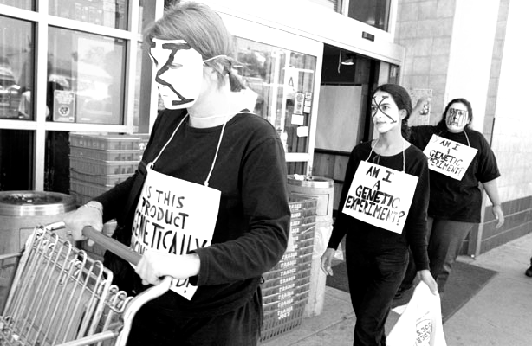
Progressive enterprises (The Countdown / Foodtown / 3 Guys chains – merged with Woolworths)
Phone: 0800 40 40 40
customerinfo@progressive.co.nz

New World (Foodstuffs)
Auckland Tel. (09) 629 1600
Wellington (04) 527 2510
Christchurch (03) 353 8700
newworld@foodstuffs-wgtn.co.nz

Pak’N Save (Foodstuffs)
paknsave@foodstuffs-wgtn.co.nz
(same phone numbers as above)

Supermarket Actions

Here are some ideas for actions you could do at a supermarket:
Label products to warn other customers. Make stickers and print them on standard labels. Then apply them to products of companies that refuse to go GE free.
Trolley runs Fill up trolleys with GE products. Bring trolleys to checkouts and go through the items demanding non-GM guarantee. Be polite to checkout staff, demand to see manager. Leaflet queue to explain the hold up.
Trolley stops Again fill trolleys with GE products. Put contaminated signs on trolley then leave around.
Creating a biohazard zone Quietly fill a number of trolleys with GE goods. Take them all to one part of the store and restock them on same shelves - a contaminated food aisle. Show shoppers where the contaminated zone is and why to avoid them.
Show people that they are part of the genetics experiment Dress as scientist and hand shoppers cards telling them they are being experimented on, with their own experimental number. Shoppers can hand an attached slip to the supermarket if they object to being experimented on.
Musical trolleys Record messages to shoppers in the form of announcements ("Ding dong! Attention all Customers “insert product name” is now contaminated with genetically engineered ingredients. We suggest don't buy it"). Play these in a loud portable tape player hidden in your trolley.
Set up a customer advice centre Provide lists of GE and non-GE goods. Offer to check through shoppers purchases. Download the current true food guide at http://www.greenpeace.org.nz/truefood/index.html

Superheroes against GE Dress up as superheroes and do some acrobatics with Arnott’s products (also works with GE mutants, suit and ties etc)
CEOs for GMOs. Dress up in a suit and pretend to be a representative of your favourite biotech company. Tell the shoppes of all the wonders biotech will create for us (you have to have some kind of talent for satire for this to work). Don’t sound too genuine.!
Tape off supermarket with Biohazard tape
Wear white suits, isolate contaminated products...

Attend an Annual General Meeting

AGMs provide a venue for making your views known at the highest level. The only downsize is that you do have to be a shareholder, however often it is possible to buy just one ‘share’. Alternatively find a friend with shares and get them to allow you as their proxy vote. Contact your local stockbroker to find out how to purchase shares.
As a shareholder you will be sent notification of the AGM. Plan in advance what it is you want to achieve with your action - sympathetic press coverage, embarrassment, or outright chaos? Escalation tactics, such as asking questions first and becoming disruptive as they remain unanswered, may allow you to pursue several objectives at the same meeting. Read the companies Annual Report to prepare questions.
You could set up a bogus shareholder’s association, purporting to be the voice of small shareholders concerned with the companies direction, and send out bogus press releases. You could also arrange and publicise a demo outside for non-shareholding protesters to leaflet shareholders and wave banners. Send out a press release describing a photo-opportunity outside. Prepare leaflets to put on shareholders’s chairs - they might even read them if they superficially mimic the company’s own literature.
To get into the AGM you’d be advised to dress smartly and take your share certificate.

Occupy an office

By occupying the space where the company is usually shielded by security guards and PR departments, one empowers oneself to be able to communicate.
Your aim might be to stay in the office for as long as possible (perhaps by barricading yourselves into one room), to disrupt or to communicate, to find incriminating information from the company files, or to perform a media stunt to communicate to a wider audience. You should be clear about your group’s aims beforehand, and when you will leave. Preparation beforehand is essential. Offices to occupy include Biotech companies planning involved in GE food and GE crops, food producers who still source GE ingredients, transport companies who carry GE food and/or ingredients, authorities who do not do their job (e.g. ERMA, MAF, Labour Party)
How to do office work Occupations can even be successful if undertaken by small groups of three or four. Each group should stay together throughout the action. Members of a group should preferable know and trust each other, be able to communicate will with each other, and know how everyone is likely to respond to particular situations. Before you get to the target office, agree on the aim. Everyone should agree on what to do inside and how long to stay for - and stick to it.
Reconnaissance is important, as it is useful to know the general layout of the building when planning your action. (See also the section on scouting). Look for easy ways in - the best way is usually the front door. Make a simple plan to get in. One smartly dressed person going in and opening doors for everyone else often works. It helps if the person has an excuse such as courier delivery, an employment enquiry, and a booked appointment with a named employee.
Once you are in go about your agreed business. You might all look for specific offices or scatter yourselves through the building to cause maximum chaos. Make sure you at least stay in pairs. Keep it calm and non-confrontational, reassure staff that you intend no violence. If your goal is to stay put then you will need to carry some kind of locking device, such as hand cuffs or D-locks. If not, then make sure you all leave together, and that no-one is left behind.
As with all actions, there is a risk of arrest.

Blockades/

Transport Actions

Transport is an important part of the GE supply chain. Imported GE ingredients and food products have to be shipped to ports and then moved from ports to factories or warehouses, and finally onto the supermarkets.
But transport is also vital for field trial: More often then not seedlings are planted rather than seeds, and these have to be transported from greenhouses to the field trial sit, which might allow us to stop them on the way
The aim of a transport blockade is to stop the transport of GE material. Detailed research on loading locations and times is essential; once transport vehicles are on the road you’ve missed your chance.
You need to know your site well, and its only possible to recognise what target would be most appropriate by watching activity there discreetly. Note traffic movements, how many entrances and exists there appear to be, any security guards, and the frequency of use of things like loading bays, as well as appropriate places for protesters to lurk. Go for a walk and pretend to be lost or walk a dog and take photos if you think you won’t be noticed doing it. Draw a map of everything you’ve observed as soon as you get back to your car. You’ll probably need a couple of visits to glean another information. (Have a look at the scouting section).

The principle of 'locking on'
is the basis for most medium term occupations, and the possibilities are only limited by your imagination. But it's always worth considering the following- If you were the manager, how would you get around your obstruction?
If you're in a group lock-on will the blockade fail if someone really feels they need to leave? Is there a way to re-form quickly or still be effective if they do? Literally sticking your neck out for the cause may seem an extreme tactic, but as with most civil disobedience, it is your vulnerability which makes you powerful.
Before you do it If you’re getting people into a situation they’ve never encountered before it’s really important that everyone knows what their roles are and has a chance to discuss various things that may happen and what their responses might be. As well as ensuring everyone is clear about why you’re doing a blockade. Everyone should be involved as much as possible with every aspect of planning and preparing for the action.
Practice locking on together beforehand using all the stuff that you intent to be wearing and carrying on the day. Time yourselves, experiment with different formations, and work out who you’re going to be working with on the day. Working in pairs is a good idea, and ensures that everyone knows there is someone looking out for them. Be aware that if you’re in a potentially uncomfortable lock on, or reeling from coping with the aggression of others, it is difficult to think straight. Under these circumstances you have to look out for one another and constantly double check with people that their decisions, or behaviour are what they actually want to be doing and not a knee-jerk response.
Always have spare locking equipment. You never know what unexpected opportunities may present themselves. Be flexible, and be prepared.
The employees & the manager
When arriving on site it’s really important to make a good impression on the workers and their boss. It's likely that the first people you'll encounter are drivers. They will be wierded out. People get very territorial about their workplaces, and especially their vehicles. It's a good idea to have people dressed conventionally doing the approaching, preferably ones that look like their mum, or are invested with some kind of authority. It's amazing how differently people respond
if you approach them wearing a suit and carrying a clipboard. If you're especially on the case, name tags (not necessarily accurate ones) or high visibility floro jackets might be nice. The main thing is to convey an air of calm inevitable reassurance. You are as the taxman, an irritating but legitimate force of nature, and you are not their problem.
They don't have to make any decisions about the fact that that there's someone dressed as a festive pig attached to their propshaft. It's up to the manager and the police, they might as well put their feet up and have a fag break. It's worth making a batch of leaflets targeted specifically at workers, with the basic information about why you're there, and a clear statement that you want to target the company, not them, and that you're sorry about the disruption. Many drivers are self-employed or (like the poor unfortunate site security guard) stand to get in a lot of trouble because of you. It's not their fault they’re poor misguided cogs in the great capitalist machine. Give them a leaflet and share your dark chocolate with them. The manager is ultimately liable for any injury or accident, which occurs on the site, and you need
to remind him repeatedly and emphatically of his health and safety duties. If people are occupying silos or cranes, or running around inside the plant it's his (they’re almost always male) job to ensure the machinery is turned off and that none of his employees lose their temper. Try telling him exactly why you’re there, what you intend to do, and try and keep him around in the early stages when everything's a bit more fragile. He'll probably have more influence over any enraged employees than the police. You may want to say what time you intend to leave, as this will give him an entirely delusional sense of control, which in turn may calm him down. If you overestimate rather than underestimate there’s less likely to be annoyed comeback later in the day, but it can make it seem like you gave up before you intended to, which is a bit crap too. This is another one for discussion.
Dealing with the police When dealing with the cops it may be useful to have specific person who’s job is to liaise with the police, build up a relationship with them, and convey their intentions to the rest of the group.
However this person needs to be aware that they make themselves vulnerable to hassle latter on, especially if they don't explain that, delighted as they are to talk to the police, they in no way represent anyone other than themselves, are not in a position to make decisions which affect anyone other than themselves and are there just as a way for the police to disseminate information to people, a service which they may choose to withdraw at any time. Police liaison can be a useful delay tactic. Those preoccupied with being locked on don't have to deal with some charmer in a uniform making amateurish attempts at information gathering, and the liaison person can drag things out by taking as much time as they fancy to tell each individual in turn what the sergeant has just said. If appropriate they can then go back and say "they'll need half an hour to think about that one and discuss what consensus they might reach on the matter" The cops love being given a negotiation situation to practice on and can often be spun along for hours.
It's always nice to be nice, being nice to the police is an immensely radical thing to do, and can provide golden moments of demolished stereotypes, but if you do decide to open up only talk about yourself, never others, or the way the group organises. It's always wise, if not necessarily pleasant; to start from a position of justified paranoia and work backwards. The police are used to getting their own way, and we don't like
Upsetting people unnecessarily. When the cops arrive on the scene they may set arbitrary rules about who's allowed to go where and do what, just to remind themselves and everyone else that they're in charge. For many people the idea of obeying someone just because they're in a uniform goes against the ethos of personal responsibility and that ignoring authority is a healthy way to remind everyone that the positions of policer and policed are often ridiculous and damaging. Nudging the boundaries of everyone's expectations can inspire reflection and respect, or get you nicked for breach of the peace. It should be a matter of ongoing discussion, and is best done with cheek, rather than aggression.
While it may be philosophically distasteful, it could be useful to ring the police yourselves as you enter the site and explain to them what's going on. This gives you the initiative over the manager (who will call them within a few minutes of your appearance anyway) as the police will get your angle on the situation first before dealing with those they would normally regard as the injured party. The sketchiest moments on any action are the first few minutes when everyone's surprised by the surreal ness of it all and trying to decide whether it's their problem or not. Having the police there can be a calming influence on irate drivers and offers you some protection against their more violent tendencies.
A brief note on the police for those who aren’t used to them: The police often lie to people to get their way. Although it can be part of the non violent approach to try and treat them as trustworthy individuals it is important to remember that in any civil disobedience situation, however sympathetic they may be to your cause, they will regard you as criminals. They are obliged to tell you anything that they feel will keep you/the situation under control. It's their job to try and stop you from being an effective blockade. They may employ jovial reasonableness, threats of extreme charges or invent stories about your impact on the employees being held up. They might be straight down the line about everything and genuinely interested in keeping the peace. But in the majority of cases this is unfortunately not so. It's also their job to gather information. They do ask questions about you, they do keep files of this information and they may well use it to push the appropriate buttons in interviews latter. If they start probing and you don't want to seem unfriendly it's easy enough to turn the conversation around. For example, when regaled with "How many of you are undergraduates then eh? I bet you all are" try responding with something like "that's an interesting assumption, why do you think that? The status of academia in a post-modern society's quite fascinating don't you find?" etc.
The options Entrances If your target has only one entrance, and the gates aren’t locked during the day, your action could be as simple as a couple of people closing the gates, locking them with a quality chain and padlock, then walking off with the key. It will probably take them a good hour to figure out how to remove the lock (though beware of liftable hinges on gates).
If the aim is to be noticed, then you could d-lock yourselves to the gate.
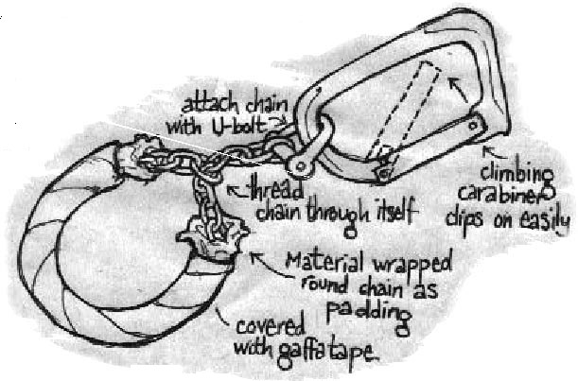
Using vehicles If the entrance is wide, and with no closable gates, then another possibility may be to block it with their own vehicles. Park up in a car with a couple of people prepared to lock-on and at least three support people in a spot where you can clearly observe vehicles preparing to leave the site (without being too obvious).
When you see a truck moving for the exit, drive out to meet it and park in front of it blocking its way. One support person should approach the driver and explain that there are two people attached to the truck. Ask the driver to turn off the engine and explain what the action is about. Meanwhile the other support person clearly stands in front of the truck, and the others lock on. The third support person should only drive off when given the nod from the talker that the engine has been switched off and that the driver is calm and understands what’s going on.
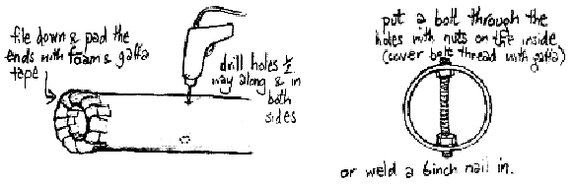
If the gate is big enough for two vehicles you will have to deal with incoming traffic. You’ll need at least another five people to block the gate to prevent another vehicle leaving or entering. If another truck approaches, two or more people should try and lock-on, but only if you’re sure that it has stopped and that it isn’t going to try and move off. This is much more risky than working with a parked car, generally drivers know better than to drive into another vehicle, but may try to accelerate towards a line of people.
Other bottlenecks If the entrances are too numerous or difficult to obstruct, other potential bottlenecks such as tight corners, turning circles, loading bays may provide the opportunity to totally disrupt the days normal working routine. If possible, lock onto fixed objects such as lamp posts on either side of the bottleneck and form a human chain using arm tubes. If there is nothing suitable you could rely on a stand-alone blockade such as a sit down, or an immovable human octopus formed by D -locking yourselves together adding people and arm tubes if necessary.
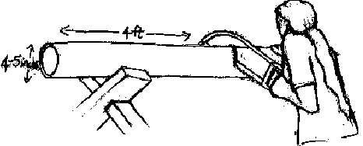
Tools of the trade You might simply get loads of people together and use the sheer force of numbers as the blockade. Unless you have hundreds of people and have somehow managed to catch the police unaware, this method is unlikely to work for long. Sitting down and linking arms will only delay the inevitable.
If you really want to be sure of maintaining a blockade for any reasonable length of time it may be more efficient and realistic to opt for fewer people and some appropriate technology.
D-locks These are just ordinary bike locks. But full sized versions that will fit around peoples necks and still have room to go around a post etc. Try them on and avoid the ones that swivel as they are virtually impossible to get on.
Arm-tubes or lock boxes These are normally used so that two or more people can link arms in a way that makes it very difficult for anybody to use force or torture techniques to break their hold. They are best made from metal but some people have used plastic drain pipes, cardboard or composites. To resist eviction at protest sites arm-tubes are often built into heavy or fixed objects such as oil drums filled with concrete.

Karabiner cuffs These are an essential accessory for lock box use
Tripods The photo above shows what a terribly photogenic way of occupying space tripods can be
(human armtube chains are also rather pretty). Tripods can be useful for blocking all sorts of things. They require three scaffolding poles, a bit of practise, and couple of minutes to set up. The tactic was developed during the nineties as a tool for road protests and Reclaim The Streets.
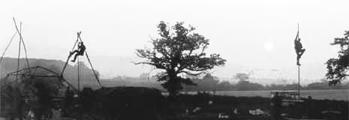
Consideration should be given as to how you will get your poles to the site. They can be roof racked on the top of a van or stashed somewhere close and carried in. (You would really appreciate aluminum poles if you can get them, they’re more expensive but much lighter). Loads of actions have been compromised due to the police confiscating the tripod before it arrives at the site. Spend some time working out the best way to get it there and have a backup plan just in case it doesn’t make it.
For your basic tripod you will need:
3 full length scaffolding poles (about 21ft long) 2 swivelling scaff clips Some rope. Cheap blue polyprop is fine. A spanner for the nuts on the clips. You will also need a fairly large space (high if indoors) for setting them up, experimenting and practising. It’s tricky to get the clips fitted on so that the poles can lie parallel as well as erect into tripods. See the assembly as 2 main poles in and ‘A’ shape, plus a third pole to prop them up.
The clip for the third pole has to be about a foot below the main poles’ clip, to allow the main poles to close over it. and the central swivel of the clip should be at roughly 120 degrees round the pole from that of the main clip. Experiment until you get the clips placed so that the poles can lie parallel and open into a tripod. With iron poles you will probably need at least 5 people to erect it - which is done after first spreading the feet of the ‘A’ while simultaneously raising the third foot. The jobs are- 2 strong people to lift each of the 2 main legs by walking down beneath it from apex to base.
One person to pull the third leg out to prop up the ‘A’. And 2 people with their feet braced against the base of each main pole to stop it slidding forward. These bracers must concentrate. If a foot slips the whole thing can crash down on someones head .With lighter aluminium poles you might manage it with 3 people.
Once it’s errected at least one person needs to shin up it at the speed of light to be out of reach at the top. If it’s a damp day this can prove very tricky, and a rope dangling down from the apex or a climbing harness with prusiks would be useful.
You can make a hammock sling to perch in out of strong light material like rip-stop nylon, knotted at either end, with the two ends of a short rope tied securely just inside these knots. The rope can be slung over you shoulders as you shin up, and slipped over the poles at the top.
When sorted out, paint ‘L’ ‘R’ and ‘M’ (left, right and middle) on the foot ends of the poles, the sides facing up as they lie ready to be raised. The M pole should be uppermost. PRACTISE putting it up for protection and extra stability you can install three short horizontal poles with clips. Leave each short pole dangling from one clip until the tripod is up, and then do up the second clip. A climbing harness and slings makes the job easier. Don’t forget the spanner. You could stabilise against accidental slippage with these bars by using a circumference of rope linking the legs 2 or 3ft above the ground.
Communication amongst ourselves.
When people are putting themselves at risk as a matter of personal conscience it is vital that they feel empowered by the experience and in no way devolve decisions to anyone else about what is happening. To do so takes away the vital exercising of personal responsibility and places an unfair burden on the person elected 'leader'. If the group does propose to act as a non-hierarchical co-operative of individuals, it's vital everyone's clear about what this
means in practice. There can never be enough communication going on at an action. It's the one thing people
always wish they'd done better, and probably the hardest and most affirming thing to do well.
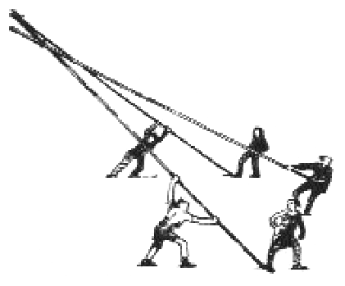
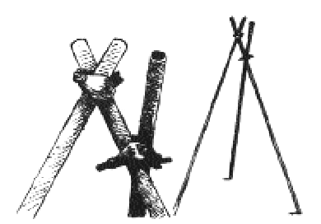
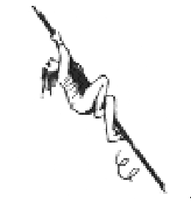
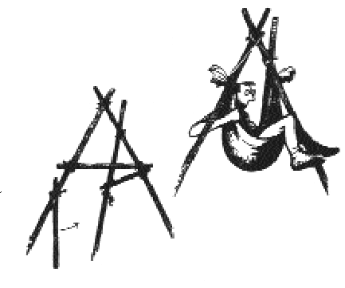
To facilitate updating and decision making there should preferably be one person (with a talent for listening, and who knows everyone) who's job it is to approach each individual in turn and tell them what seems to be going on, what the others are thinking, and to find out how that person is feeling about it all. Particularly if the person is locked on it's important to check that the message has been received and understood. It may even be an idea for the facilitator to
repeat back what they think the person has said to ensure they've got it right. Nine times out of ten this will probably be just a 'yeah, got that, seems fine', but it's really important to get it accurate if it's more complicated than that. The facilitator should regular inform the police liaison and media tart about what people are saying and any new information that arises. Be aware that if you're in a potentially uncomfortable lock on, or reeling from coping with the
aggression of others, it's difficult to think straight. Under these circumstances, you have to look out for one another and constantly double check with people that their decisions or behaviour are what they actually want to be doing and not a knee-jerk response. If in doubt, ALWAYS ASK.

After you do it. It's easy to forget to plan for the end, but try to ensure you have all the eventualities covered. People may be arrested and taken to the police station, in which case it's important that not only does your support person on the end of the phone know where everyone has been taken, but also that they can then call on people with vehicles to collect them when they are released (as well as sending in cheery notes and goodies to keep up their spirits while they wait.)
In the event of no one getting nicked you need to set a meeting point that can be reached without transport, a service station or a pub for example. Don't underestimate how tired you're likely to be by this stage, anywhere warm, nearby and with toilets will do. If people leave the site at separate times it's important to have someone who's responsible for waiting around until everyone's out, and check everyone's been accounted for. Also ensure that if there was shared transport on the way there, check that everyone gets a lift back. If you can possibly manage it have a 'debrief' - a full discussion about what worked and what didn't, straight away. Debriefs are a really good way of learning (and recording) important lessons, allowing people to tell their stories and giving everyone an opportunity to express how they felt. Actions are often very emotional experiences and plenty of space should be allowed both at the meeting and in the weeks afterwards, to talk about peoples responses. Keep the momentum, propose the next action. Then go down the pub.
Checklists:
Transport and vehicles. Before the day -
Make sure you know what vehicles are going to be used (if any). Ensure that they won’t contain anything you really wouldn’t want found if stopped. Make sure that somebody checks the water, oil and tyre pressure etc. Ensure all vehicles have plenty of fuel - don’t leave it until on the way to the action! Make sure you have drivers, they know the way and have no other vital roles. Plan where the vehicles will be parked during the action. Make sure everyone know what equipment needs to be in which vehicle Ensure people know which vehicle they need to be in. If doing it without vehicles, make sure everyone knows how to get there (and when).
Before you leave ‘home’ check you have-
Emptied your pockets and person of any incriminating information. A phone number for a lawyer Learned your rights with the police Pen and paper to note stuff down (like who's been taken where by who) A list of people’s mobile numbers. Watches (don’t forget to synchronise them if timing is important in your plan) and phones/short wave radios if you’re using them, and spare batteries. The stuff you need for your role - the camera if you're doing the photos, the d-lock you've been practising with if you're locking on, banners etc.
Food, drink and spare cash.
(Be aware that written stuff especially might be incriminating if you are arrested and searched so be prepared to destroy or eat paper work if necessary!)

For a complete handbook on blockading go to: http://www.geneticsaction.org.uk/delia.pdf read it!!

The Field Trials

Before committing yourself to any action, its worth finding out whether there is any sort of campaign against field trials underway already. Make contact with the campaign if there is one. The following website keeps track of local actions, www.pmea.org.nz and is trying to publish information about the location of field trials. So if you know here they are visit www.pmea.org.nz and let them know.
Locating trial sites You can find out if there is a trial site near you by visiting www.pmea.org.nz
All field trial have to be approved by ERMA Environmental Risk Management Authority) Details on applications lodged with ERMA can be found by searching their Application Register on the ERMA website at http://www.ermanz.govt.nz. Unless you know specific details it is best to do a general search using the GMF (Genetically Modified Organisms Field Testing in Containment) application code. Make sure you actually look for field trials and not other experiments that are not designed to ever leave the lab.
The register gives you access to the initial application, the evaluation and review report and ERMA decision document, and is a useful tool for finding out about proposed field trials. While it doesn’t provide specific location details, you should be able to find out details on the site layout, number of plants, boundary gaps, type of security etc. This will then help you find the site when you visit the are where it should be located.
Finding an actual site location will involve research and reconnaissance on your part (see section on reconnaissance below, and the later section on scouting generally).
Ideas for field trial actions Set up a petition - calling for the landowner and the company not to hold the field trial as the environmental effects are unknown (this will most likely only work when it comes to conditional releases, the field trial are usually located on land owned by the applicant)

Call a local public meeting – invite the landowner, the company, campaigners, local media etc (again this will not work for field trials but will work for conditional releases if it comes to that)
Put the field on trial – arrange a trial by public jury near to the site. Appoint a judge and people to lead the case for and against GE food. Invite comment and opinions for the audience.
Organise an organic picnic on or near the site – with speakers, entertainment, and safe food
Create a biohazard zone - dress up in decontamination suits and mark out the site with biohazard tape, set up warning signs on neighbouring properties.
Lead a citizen inspection - to measure the barrier crop, take samples to check for cross pollution, and put up bioharzard signs
Contaminate the site - plant similar seeds and plants amongst the crop this will disrupt the results
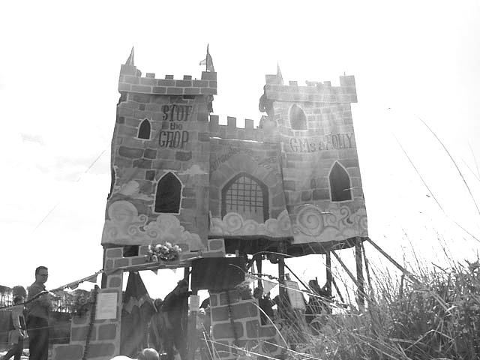
Transform the site set up a playground with swings, slides etc
Obstruct the planting - block access to the site, or place obstructions on the field
Occupy the site - set up camp on a planned field trial to prevent planting
Don’t forget that for action that involves contact with a contaminated site, everyone and anything that comes into contact with the soil or GE crops needs to be decontaminated. Pollen is microscopic and can easily get into your hair or clothing and inadvertently be transported by you into the wider environment. Precisely the thing that our actions are trying to prevent. To avoid this you should try and wear clothing that can be bagged up and safely disposed of afterwards.

Decontamination
Most of what follows applies to covert actions and has been shamelessly plagiarised from the UK guide ‘My first little book of GM Crop Decontamination. (A copy can be downloaded at http://www.geneticsaction.org.uk/littleBook/littleBook.pdf. For some useful information on overt actions have a look at the Genetix Snowball Handbook for Action found on their website at http://www.fraw.org.uk/gs/.

Decontamination will play a vital role in safeguarding our future. Anyone can take the responsible step of decontaminating a site. It is an activity suitable for people of all ages, shapes and sizes. You may not have thought of yourself as the sort of person who would take direct action of this kind, but it is up to all of us equally to act. Taking such action has its stresses, but it can also be empowering and liberating as well as effective.

The recce (this also applies to a lot of other GE actions e.g transport actions)
You will need to spend some time scouting for the field site. Go in a pair so you can compare notes, get a second opinion, and generally lend each other support. Give yourself plenty of time to find the site - you may well need all day or even longer. If you’re struggling to find the site, don’t panic. And don’t convince yourself hastily that you have found it - take your time. Don’t plump for a site you’re not sure of. Trashing the wrong crops gives the cause a bad name, and makes you appear as reckless vandals, alienates the public, not to mention being a waste of time and effort. It pays to have done your homework beforehand on crop identification.
Try and keep the number of visits to the area to a minimum, to avoid attracting attention. That said, it is a good idea for at least one person from each group or vehicle to have done a site visit. If you’re planning a covert action under cover of darkness then it’s a good idea to visit the site at night at least once, as objects and distances can appear very different in the dark. This will also help you assess the security measures on site during the time you will do your action.
Your reccy will include: location, size and nature of the field site on the ground; safe routes into and away from the area by vehicle; suitable parking or drop-off spots; routes from the vehicle to the site and back again. Take notes as you go in case you forget what you’ll think you’ll remember, and so that you can pass on accurate information, but dispose of such notes before you do the action as they are evidence against you. Note helpful landmarks such as particular trees, pylons, and buildings. You may find it useful to take photos, remember though that taking photos may look like suspicions behaviour. Destroy the photos and negatives before the action.
On site security is a possibility. If you want to be sure, then stake out the site overnight. Find a hidden vantage point, take a sleeping bag, a notebook, and a friend and sit there all night watching taking shifts.
The logistics In most cases you will need vehicles to get to and from the site. Ideally your vehicle will be a smart, middle of the range car in a forgettable colour. It should be reliable, reasonably quiet and unremarkable. For covert actions: after you get home make sure you clean the vehicle thoroughly inside and out.
Wear old disposable clothing, and take a spare set to change into when you get back into the car. Changing will reduce the risk of spreading genetic contamination from the crop. The safest thing to do is to bag up and throw away the old clothes you used after the action. If you are going to wear gardening gloves make sure they are cotton as others will mark your work.
The tools you will need will very according to the type of crop. Remember when considering whether to use tools that a tool may be used as evidence against you. Fingerprints and/or other forensic traces will be able to link you with the crop. If you do use tools make sure you clean then after the covert action. Warm soapy water is recommended.
Think carefully before taking hooks, scythes, sickles or slashes to a site. There is a very real possibility that in the dark, in a confused situation in a dense and perhaps tall crop, you may - perhaps seriously - injure one of your group. You should not use cloth or leather gloves with swinging, cutting tools as they slip on the handles.
If you are going to use tools make sure that everyone agrees to it Get some experience of using them properly in advance - before you start running about in a field at night with your mates - and make sure that you’re used to working together and that you stay aware of each other.
Final Preparations Have a get together before the action, Go over the plans and all the details so that everyone is clear. Make sure you have ironed out any uncertainties and worked through any disagreements. If everyone knows what they are doing then once you leave the vehicles you will not have to say anything. Stay silent throughout the action unless you really need to communicate something.
It’s a good idea to arrange yourselves into small groups, and into pairs. This way you should be able to work more efficiently, look out for each other and feel safe and supported. In case you lose track of each other it can be useful to arrange a simple, distinctive hand signal to identify your group.
Most people get nervous or frightened before an action. It is a good idea to talk about these feelings within your group before the start of the action, rather than all pretending to be okay. If you talk about it, this may help to dissipate the tension, as does the discovery that everyone else is feeling the same way.
Timing the action If at all possible carry out the action before the crop flowers and spreads genetic pollution by pollination. New Zealand gardening guides should give you a general idea of the normal sowing, flowering and growing patterns of various crops. These will vary according to weather, soil etc so you may need to monitor a crops progress and play it by ear.
Read the field trial applications carefully as well, as they may give clues as to expected planting and growing times.
Decontamination methods Try to work in a methodical and systematic manner, and keep in touch with each other as you work. Make as much mess as you can. Scatter any canes or signs as you do. If it looks a chaotic shambles then it is less likely to be considered salvageable.
Pace yourselves. It is satisfying but hard work, and two or three hours is a long time to go at it, but some of the smaller field trials can probably be done in as little as 20 minutes.
The method employed will depend on the size and nature of the crop. If the field trial is small then uprooting and bagging the entire crop is a feasible option. If no, then the following are some tried and tested methods:
Rolling - get on the ground and roll about on the crop, flattening it with your body. This is a tiring and soggy method and can be disorientating on the plus side it involves no tools.
The shuffle-crush - a sort of low level harvesting that involves kneeling down and moving sideways in a crablike fashion breaking handfuls of stems in front of you. Relatively slow but fairly effective and discreet.
The hoax crop circle - drill holes at either end of a metre or so length of wood. Take two generous lengths of rope, thread them through the holes and secure them. To use, you hold the ropes tightly in each hand and with one foot on top of the wood, step it firmly down on the crop. Then left and step forward and repeat. You need to step hard enough so that you snap or crush enough of the stems. This is a fast and not too tiring method.
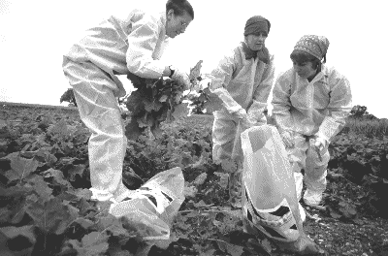
The whifflepoof - basically a log with nails in it. Choose a cylindrical log and hammer a large nail in each end for attaching ropes to. Then hammer in nails all over its length so they stick out about an inch or two. Drag the whiffleppof through the crop turning it cover occasionally. Bear it mind that it will get clogged and need to be unclogged periodically.
The broom handle - hold the broom handle horizontally in front of you with both hands, shuffle forwards in a kneeling position, leaning forward to crush the stems against the ground . Quick and effective on crops which are tall and brittle, but can be tough on your knees.
Snapping - highly recommended when the crop is high. You can reap several plants at a time by sweeping your arm low along a row, with your other arm held above, bracing against the plants to force them to snap.
Cutting - quick but potentially dangerous when there is a large group when in the dark. Not recommended when the crop is above shoulder height. (see note below on tools)
Pulling - if you are planning to try and remove the plants from the site afterwards then a useful method, otherwise there is danger that they can be replanted.
Other ideas:
For small seedlings rakes are quite effective. A heavy clump of brushwood dragged across a field can do quite a lot of damage to a young crop and it can be easily dumped afterwards. For best results tie large twiggy branches together and drag them so the smallest branches point forwards.
For Trees:
Lopping - young trees with slim trunks can be dispatched with a pair of loppers. Nice and quick, about 10 seconds per tree but takes some strength.
Sawing - this is relatively straightforward if the tree is young, but noisy. If the trees are larger make sure you know how to feel trees properly otherwise you risk injuring yourself or someone in your group.
Ring-barking - the effectively chokes the tree’s circulation. You will need to remove a single strip of bark several inches wide from around the circumference of the tree. Use a chisel with a half inch blade and allow 30 seconds per tree.

