SC207 Software Engineering
Term Paper 2003: My Best View of A Topic in Software Engineering

Review Report: From System Comprehension to Program Comprehension

- Abstract

This article by Tjortjis, Gold and Layzell discusses about the contributions of program and system comprehension in improving the process of software maintenance. Two methods are identified in providing better understanding at the two levels, showing how they can be used to meet the requirements set by industrial software maintainers. In addition, the article covers how the two methods can be coupled to provide a broader system understanding.

- Introduction

Program and system comprehension plays an important role during the process of software maintenance. Sufficient understanding at both levels determines the ease with which the maintainers go about their job. This enables them in isolating parts or modules which have to be changed (narrowing the work scope) and also in identifying the possible ripple effects in implementing such changes (containing errors).

However, it is often not an easy task in gaining good understanding at both the program and system level since existing methods and tools are only aimed at one or the other. Thus there is a need for a method or tool in assisting the understanding task during maintenance. Through the article, we will see how two existing methods can be combined and used as a single tool in achieving this goal.

- Elaboration of techniques

For System Level Comprehension-

Data Mining Code Clustering (DMCC) is identified to aid in comprehension on the system level. Data Mining refers to the analysis of data and algorithms, evaluating their pattern of flow and usage in the system itself. Clustering refers to the grouping of objects due to common properties or attributes. A member of a cluster is similar to another in the same group and different from those in others.

Therefore, Data Mining Code Clustering is the partitioning of data sets in the system into mutually exclusive groups by evaluating their algorithms and data parameters. This breaks down the system into many smaller subsystems with a special characteristic of their own, yet showing their relationship with one another in the same time. Thus it provides the users with a quick grasp of the overall view by simply identifying the main function that each subsystem is purposed to perform.

For Program Level Comprehension-

Hypothesis-Based Concept Assignment (HBCA) was developed by Dr. Nicolas Gold in 2000 to support software maintenance. This technique makes use of a knowledge base or library in which concepts are stored. Concepts are descriptive terms that express the function or role of certain segments of a code. Every concept has one or more indicators (in text string form) that are used to identify parts within the code which can be linked to the particular concept.

In the hypothesis generation (initial) phase of HBCA, the source code is scanned for indicators of various concepts. When a match is found, a hypothesis for the appropriate concept is generated. These hypotheses are then sorted and passed to the second phase. In the segmentation (second) phase, the sorted hypotheses are broken into segments and analyzed to determine if they can be broken into smaller segments. The result is a collection of segments each containing a number of hypotheses. In the concept binding (last) phase, the segments’ hypotheses are analyzed to determine the most substantial concept. Then the segment will be labeled with the name of that concept. This is repeated for all the segments.

The overall output is a code with concepts assigned to different parts within it defining their primary functions or roles played. This assignment enables users to better understand the code as general abstraction and classification can be easily obtained.

Total Software Comprehension-

For a total level comprehension, the above two methods can be integrated. By performing DMCC, the system is partitioned into clusters. HBCA can then be implemented to each of the individual clusters for a refined structure and layout towards the functionality of the program code within the clusters. DMCC produces results of higher order while HBCA produces results of lower order. As such, they can complement each other and provide users with an overall yet detailed view of the system.

- Contribution to the field of Software Engineering

The introduction of these techniques has resulted in insignificant influence in the area of software maintenance. It allows for switching between system and program views in a more orderly manner.

From the high level overview, the partitioned clusters easily enable the maintainers to pinpoint changes to a localized area and other portions of the system are left intact. The relationship between the clusters also enables them to visualize the ripple effect that might propagate to other area in the system due to the change and contain it. From the low level overview, codes are easier to understand as concepts defining their actions or roles have been assigned to them. This saves the maintainers from having to read through the entire code and deduce the functionality of each segment which is a tedious process for large programs.

As such, it can be seen that the methods, applied together, results in better comprehension of the software, both at the system and program level. Unnecessary time and effort in deciphering the code is then avoided.

- Related published works

Author(s) | Year | Article | Description | Relation to the main article
Roland T. Mittermeir | 2001 | Goal-driven combination of software comprehension approaches for component based development | Gives a report on different approaches to combine software comprehension techniques for greater efficiency | Different methods identified
Nicolas Gold | 2000 | Hypothesis-Based Concept Assignment to Support Software Maintenance: A Summary | Technical report by the developer of the HBCA technique | Explanation of HBCA in detail
U. Fayyad,  G. Piatesky-Shapiro  &  P. Smyth | 1996 | From Data Mining to Knowledge Discovery in Databases | An article on the importance of the technique data mining and implications | Explanation of data mining in greater detail
Susan Dart,  Alan M. Christie  &  Alan W Brown | 1993 | Study in Software Maintenance | A case study to find out more about problems relating to software maintenance | Background information on the difficulties of maintaining software

- Related lecture topic

The lecture topics that are very much related to this article are Object-Oriented and Function-Oriented Analysis.

The two style of analysis orientation, though different, provide the programmers with a complete documentation of the entire software through the representation of small independent units (classes in the case of OO Analysis, and functions and data in the case of Function Analysis). Program comprehension is achieved since the functions of each unit and the relationship between them can be easily obtained. System comprehension is also met since overview and concepts between modules can also be identified.

- Relation to the lab project

In my lab project, we are designing and implementing an online auctioning website. The requirements of our clients are bound to change over time, signifying the need for upgrading and maintenance. Through the methods outlined in the article, the effort and time spent on understanding the initial software, before implementing any changes, can be greatly reduced.

- Possible extension to the article

One extension that can be done to this topic is on the development of an empirical validation of the combined approach. With an empirical model, it will be more credible to determine the success in implementing this technique to real-life problems in the industry world.

Another possible extension can be on the development of a closer integration between the two identified methods. Currently, the coupling between the two is still rather loose and theoretical. A closer fit between them will benefit maintainers as it will give them the ability to easily switch between views.

- Comments on the article

The main idea of the article is to introduce two already existing methods to aid in understanding software at both system and program level. Usefulness of the methods in addressing the above problem is commented on. The authors went on to explain the application and of the methods, providing a better understanding of the topic.

In my opinion, however, the explanation itself could have been more thorough. Many terms were brought in without prior definition, making it rather hard to fully grasp the idea that the authors are trying to convey. A lot of reading up on other relevant sources was needed before an understanding of a certain degree can be reached. The only graph given in the article also serves little purpose in that it has no relation with the methods that the authors are introducing.

- Conclusion

In knowing the techniques identified in the article, it greatly facilitates the process of maintaining software as system and program level comprehension has been made such simpler. Time and effort spent through conventional way can then be reduced significantly. On the whole, the two methods (Data Mining Code Clustering and Hypothesis-Based Concept Assignment) will result in an increase efficiency and productivity when applied correctly.

- References

- Dr Nicolas Gold
“Hypothesis-Based Concept Assignment to Support Software Maintenance: A Summary”,
PhD Thesis,
Department of Computer Science 2001,
University of Durham, 2000

- SC207 Notes on Object-Oriented and Function-Oriented Analysis by Asst. Prof Edmond C. Prakash

- Acknowledgement

I would like to thank Asst. Prof. Edmond Prakash who has given me the chance to research on the term paper.

Appendix A

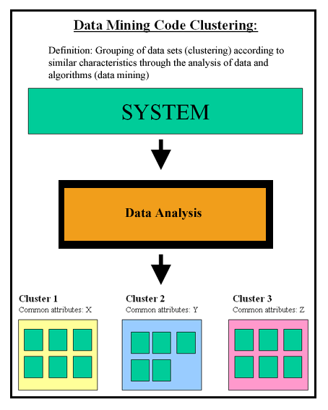

Appendix B

