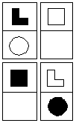
5
1
2
3
4
6
8
7
Ego
Super-Ego
Id
Super-Id

IntrovertExtrovert
ThinkerFeeler
SensingiNtuitive
JudgingPerceiving
Hidden Desire
Rejuvenation
Strongest Attribute
To Rejuvenate Others
Second Attribute
To Calm Others
Role
Draining
Weakest Point
Tension
Practiced Desire
Calming
Animal Instinct
To Make Others Tense
Seldom Used
To Drain Others

Structure, Internal Consistency, Algebraic Thinking
Productivity, Efficiency, Gathering Information
Relationships, Hidden Feelings
Visible Emotions
Understanding Physical Surroundings
Power, Force, Reacting Quickly
Making Predictions, Good Guesses, Procrastination
Possibilities, Crazy Ideas, Variety
Alpha
Enthusiast
Analyst
Mediator
Inventor
Beta
Conqueror
Romantic
Actor
Inspector
Gamma
Critic
Diplomat
Entrepreneur
Guardian
Delta
Empath
Director
Craftsman
Psychologist
Quadras
Temperament
Flexible
Psychologist
Conqueror
Diplomat
Inventor
Definitive
Actor
Director
Enthusiast
Entrepreneur
Adaptive
Romantic
Craftsman
Mediator
Critic
Stable
Empath
Inspector
Gaurdian
Analyst
Supervision Rings
Holographic
Analyst
Psychologist
Guardian
Conqueror
Cause-Effect
Inventor
Inspector
Diplomat
Empath

Vortex
Enthusiast
Craftsman
Entrepreneur
Romantic Algorithmic
Mediator
Actor
Critic
Director
Same Arrangement = Identical
Reversed Colors = Contrast
Director & Analyst = Illusionary
Flipped Horizontally = Dual
Flip 1&2; 3&4 = Mirror
Mirror + Duel = Activation
Flip 1&3 = Business
Flip 2&4 = Kindred
Business + Kindred = Super Ego
Duel + Kindred =Semi Duel
Conflict + Duel = Quasi Identity
Flipped Vertically = Conflict
Director > Mediator = Supervisor
Analyst > Craftsman = Benefactor

Clubs
+Humanitarian
Psychologist
Actor
Romantic
Empath
-Administrator
Conqueror
Director
Craftsman
Inspector
*Socialite
Diplomat
Enthusiast
Mediator
Guardian
/Researcher
Inventor
Entrepreneur
Critic
Analyst

Extroverts
- Are interested in what is happening around them.
- Are open and often talkative.
- Compare their own opinions with the opinions of others.
- Like action and initiative.
- Easily make new friends or adapt to a new group.
- Say what they think.
- Are interested in new people.
- Easily break unwanted relationships.

Sensing
  - See everyone and sense everything.
  - Live in the here and now.
  - Quickly adapt to any situation.
  - Like pleasures based on physical sensation.
  - Are practical and active.
  - Are realistic and self-confident.

Thinking
    - Are interested in systems, structures, and patterns.
    - Expose everything to logical analysis.
    - Are relatively cold and unemotional.
    - Evaluate things by intellect and right or wrong.
    - Have difficulties talking about feelings.
    - Do not like to clear up arguments or quarrels.

Judging
      - Do not like to leave unanswered questions.
      - Plan work ahead and try to finish it.
      - Do not like to change their decisions.
      - Have relatively stable workability.
      - Easily follow rules and discipline.
Introverts
- Are interested in their own thoughts and feelings.
- Need to have own territory.
- Often appear reserved, quiet and thoughtful.
- Usually do not have many friends.
- Have difficulties in making new contacts.
- Like concentration and quiet.
- Do not like unexpected visits and therefore do not make them.
- Works well alone.

Intuitive
  - Are mostly in the past or in the future.
  - Worry about the future more than the present.
  - Are interested in everything new and unusual.
  - Do not like routine.
  - Are attracted more to the theory than the practice.
  - Often have doubts.

Feeling
    - Are interested in people and their feelings.
    - Easily pass their own moods to others.
    - Pay great attention to love and passion.
    - Evaluate things by ethics and good or bad.
    - Can be touchy or use emotional manipulation.
    - Often give compliments to please people.

Perceiving
      - Act impulsively following the situation.
      - Can start many things at once without finishing them properly.
      - Prefer to have freedom from obligations.
      - Are curious and like a fresh look at things.
      - Work productivity depends on their mood.
      - Often act without any preparation.

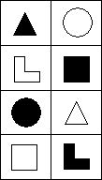
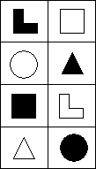
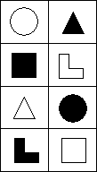
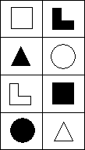
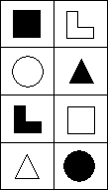
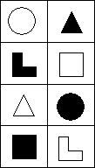
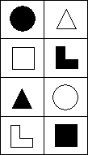
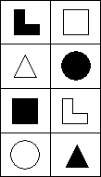
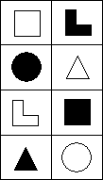
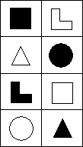
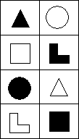
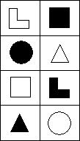
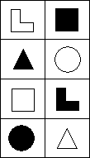
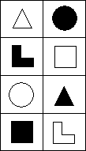
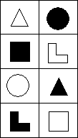
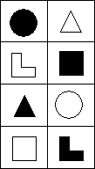
Psychologist
Enthusiast
Craftsman
Analyst
Director
Mediator
Conqueror
Actor
Inspector
Entrepreneur
Inventor
Guardian
Empath
Romantic
Critic
Diplomat

