

Camp Craft Proficiency Test

Section A | /12
Section B | /38
Section C | /20
Section D | /7
Section F | /23
Total | /100

Name: ______________
Class: ______________

This booklet contain a total of 8 pages including the cover page

Section A (12 marks)

- Name the term of the rope

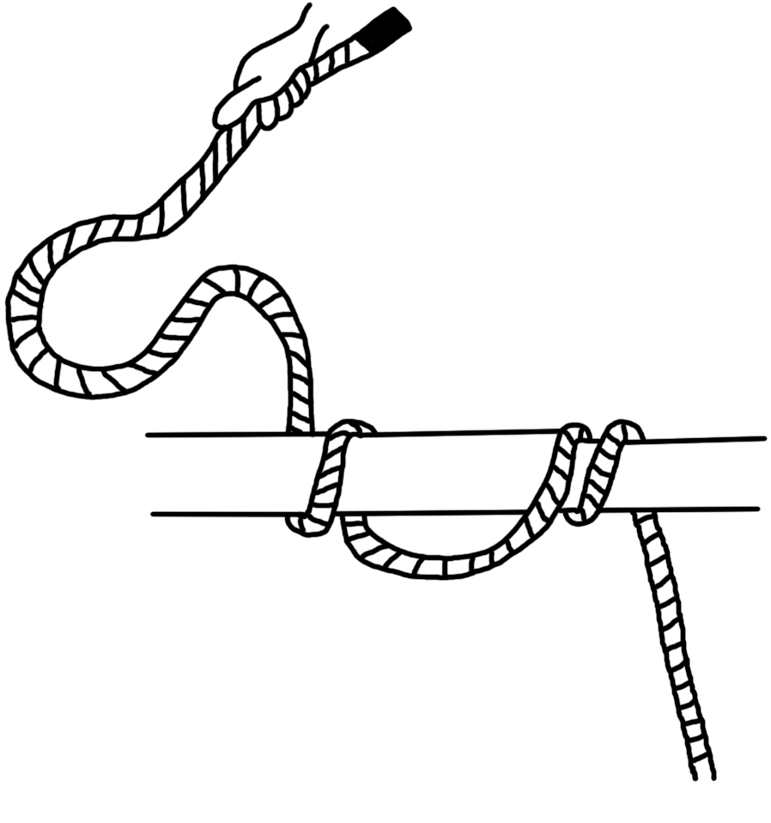

Marks:

Section B (38 Marks)

Name the knots/lashing and state the uses of them


1.

Name: _________________________________________________________________
Uses: _________________________________________________________________
_________________________________________________________ (2 Marks)

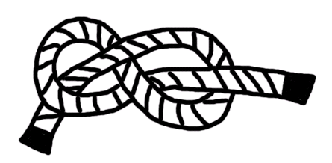
2.

Name: _________________________________________________________________
Uses: _________________________________________________________________
_________________________________________________________ (2 Marks)
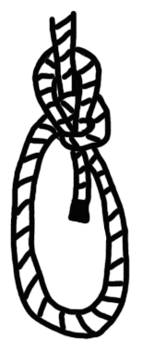
3.

Name: _________________________________________________________________
Uses: _________________________________________________________________
_________________________________________________________ (2 Marks)
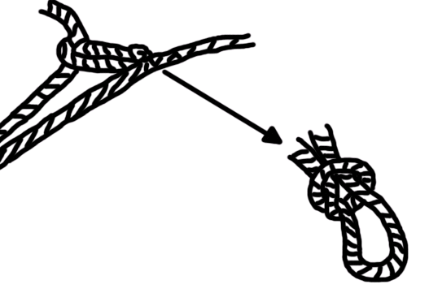
4.

Name: _________________________________________________________________
Uses: _________________________________________________________________
_________________________________________________________ (2 Marks)

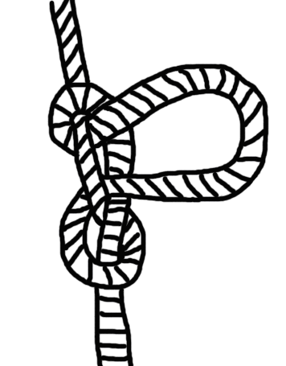
5.

Name: _________________________________________________________________
Uses: _________________________________________________________________
_________________________________________________________ (2 Marks)

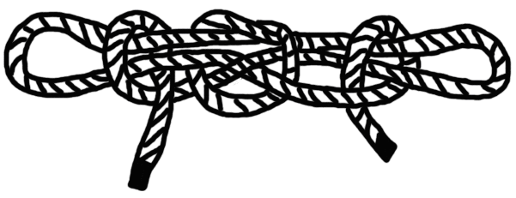
6.

Name: _________________________________________________________________
Uses: _________________________________________________________________
_________________________________________________________ (2 Marks)
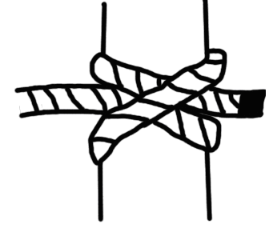
7.

Name: _________________________________________________________________
Uses: _________________________________________________________________
_________________________________________________________ (2 Marks)

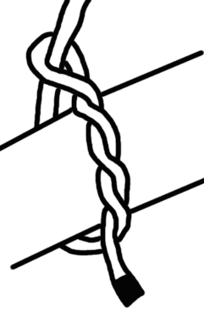
8.

Name: _________________________________________________________________
Uses: _________________________________________________________________
_________________________________________________________ (2 Marks)

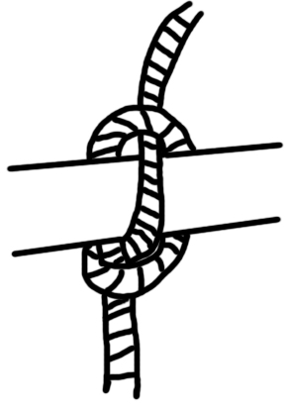
9.

Name: _________________________________________________________________
Uses: _________________________________________________________________
_________________________________________________________ (2 Marks)

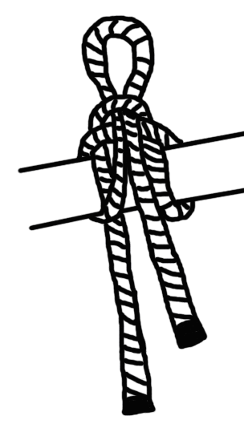
10.

Name: _________________________________________________________________
Uses: _________________________________________________________________
_________________________________________________________ (2 Marks)


11.

Name: _________________________________________________________________
Uses: _________________________________________________________________
_________________________________________________________ (2 Marks)
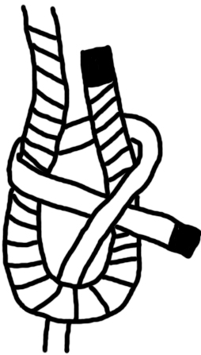
12.

Name: _________________________________________________________________
Uses: _________________________________________________________________
_________________________________________________________ (2 Marks)

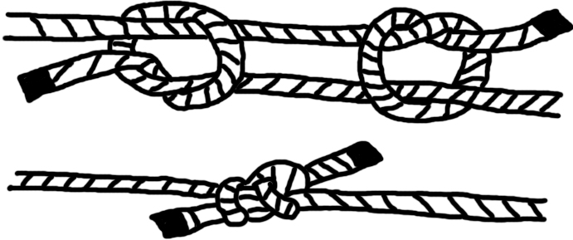
13.

Name: _________________________________________________________________
Uses: _________________________________________________________________
_________________________________________________________ (2 Marks)

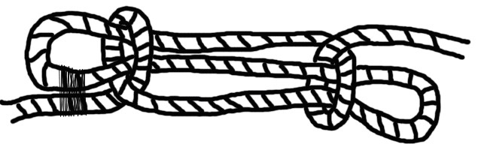
14.

Name: _________________________________________________________________
Uses: _________________________________________________________________
_________________________________________________________ (2 Marks)
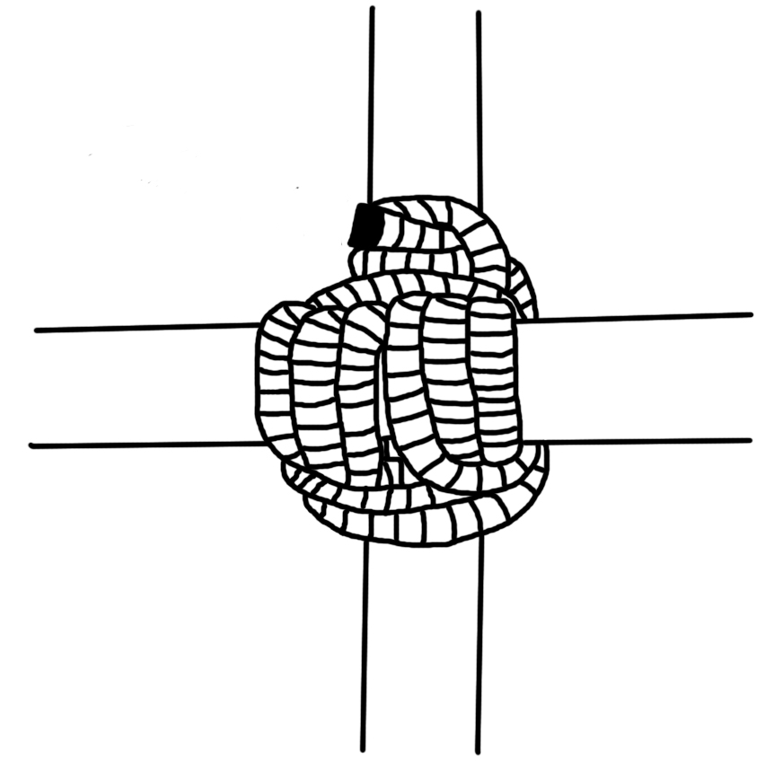
15.

Name: _________________________________________________________________
Uses: _________________________________________________________________
_________________________________________________________ (2 Marks)
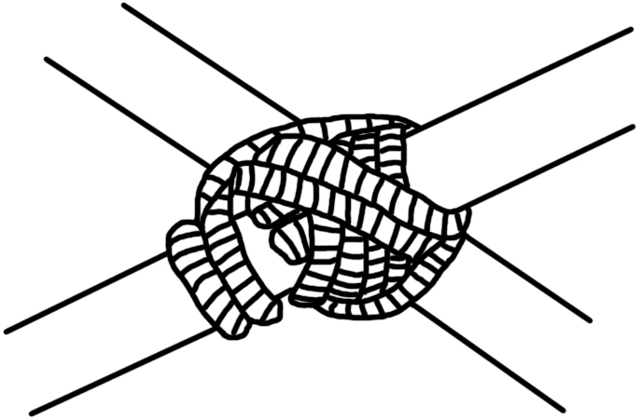
16.

Name: _________________________________________________________________
Uses: _________________________________________________________________
_________________________________________________________ (2 Marks)

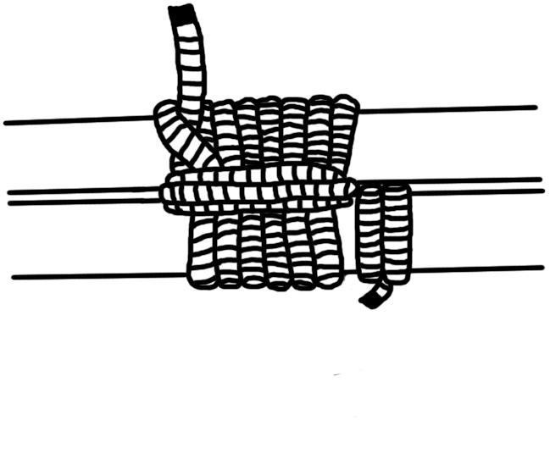
17.

Name: _________________________________________________________________
Uses: _________________________________________________________________
_________________________________________________________ (2 Marks)
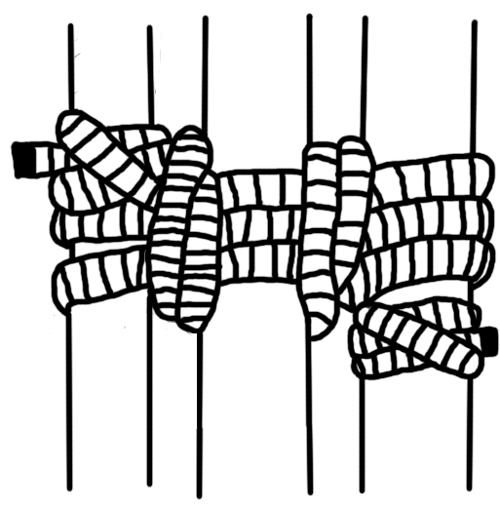
18.

Name: _________________________________________________________________
Uses: _________________________________________________________________
_________________________________________________________ (2 Marks)
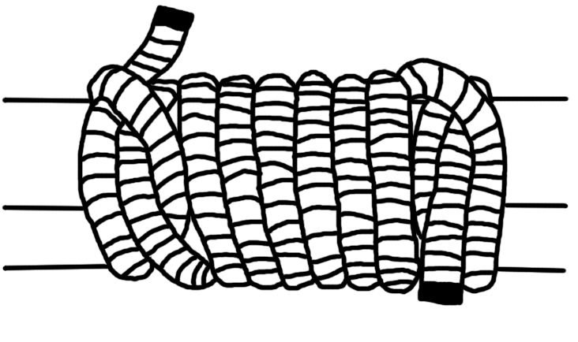
19.

Name: _________________________________________________________________
Uses: _________________________________________________________________
_________________________________________________________ (2 Marks)
Marks:

Section D (7 Marks)
Name the parts of the compass.

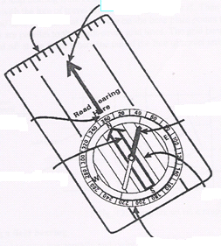

Marks:

Section C (20 marks)
Name the materials to build a 4 tent (7 marks)
Quantity | Parts

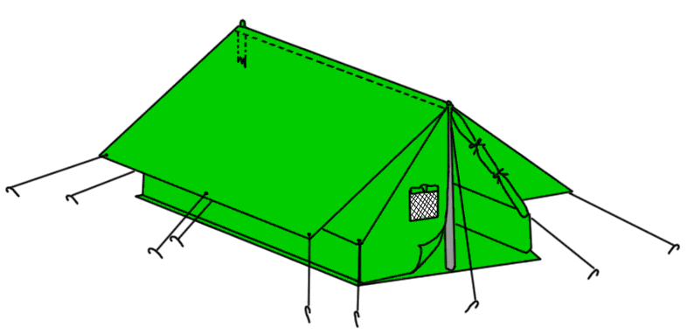
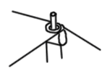

Marks:

