Worship Leader: John Audubon spent two years in the forests of America making drawings of birds. Then he nailed them up securely in a wooden box and went on a vacation. When he returned and pried open the lid, he found only gnawed bits of paper. A pair of rats had eaten their way into the box and ruined nearly a thousand sketches. It was a stunning blow, but defeat did not down him. Soon he rallied his courage, and started into the woods. “I’ll make better drawings than the rats spoiled,” he said. It took him three long years, but his second set of pictures was better than the first ones.
Are you brave enough to try again after your plans go wrong? Do you have the grit to rise after you fall? Then you have discovered the magic secret, which creates strength of manhood and turns failure into success.
Prayer
Everyone: ”God of patience, keep me from giving up when things do not turn out as I have planned. Help me to put forth greater efforts instead of wasting my strength in useless complaint. If my own courage fails, then may I become brave through my faith in Thee. Amen.”

Troop 626
Sunday Morning
October 24, 1999

Brave

Worship Leader: “A Scout is Brave.”
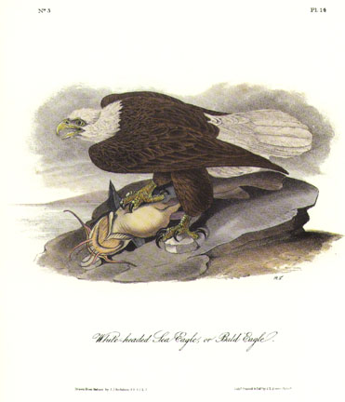Everyone: “When confronted with danger and temptation, let us be brave.”
Worship Leader: “To each of us comes danger, difficult tasks, and temptations. In choice of courage or cowardice may we be brave.”
Everyone: “A Scout has the courage to face danger even if he is afraid, and to stand up for what is right even against the coaxing of a friend, or the jeering, being made fun of, or the threats of an enemy.”
Worship Leader: “A Scout is brave. He obeys God rather than men. Some may perceive this as a weakness, but it is truly strength and bravery.”

Stand Up for Jesus
Stand up, Stand up for Jesus.
Ye soldiers of the cross;
Lift high the royal banner,
It must not suffer loss.
From victory unto victory,
His army shall He lead,
Till every foe is vanquished,
And Christ is Lord indeed.

Stand up, Stand up for Jesus.
Stand in His strength alone;
The arm of flesh will fail you,
Ye dare not trust your own.
Put on the gospel armor,
Each piece put on with prayer;
Where duty call or danger,
Be never wanting there.

Stand up, Stand up for Jesus.
The strife will not be long;
This day the noise of battle,
The next the victor’s song.
To him that overcometh,
A crown of life shall be;
He with the king of glory,
Shall reign eternally.

Psalm 27:14
Worship Leader: “Wait for the Lord. Be strong, and let your heart take courage. Yes, wait for the Lord.”
Everyone: “I do not ask Thee to shield me from every storm. I pray rather that I may have strength, like the oak on the hillside, to stand before the fierce wind without being uprooted or beaten down.”

II Timothy 4:7
Worship Leader: “I have fought the good fight; I have finished the course; I have kept the faith.”

Everyone: “O God, you can turn my weaknesses into strength, help me to not be afraid of what others may do to me or say about me.”

Onward Christian Soldiers
Refrain:
Onward Christian soldiers,
Marching as to war!
With the cross of Jesus, going on before.
Christ the royal master,
Leads against the foe,
Forward into battle, see His banners go!
Refrain.
At the sign of triumph,
Satan’s host dost flee,
On then Christian soldier, on to victory!
Hell’s foundations quiver, at the shout of praise.
Christians lift your voices, Loud your anthems raise!
Refrain.

