Prayer
Everyone: Dear Lord, I pray that I may become more courteous toward people I meet each day. Keep me from insisting on my own rights, while I forget the rights of others. In Jesus’ name, Amen.

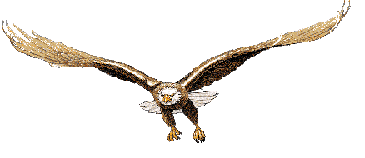

Troop 626
Stubblefield Lake Campout
May 16, 1999

Courteous

Worship Leader: “A scout is Courteous.”
Everyone: “A Scout is a polite to everyone regardless of age or position. He knows that good manners make it easier for people to get along together.
Worship Leader: “In an atmosphere of ill manner,”
Everyone: “Let us be Courteous.”
Worship Leader: “Courtesy is a mark of all faiths. It is shown in thoughtful acts and kind respect for everyone.
Everyone: “Let us take time to be courteous.”
Worship Leader: “A Scout should see the image of God in everyone. Courtesy comes from the heart and goes hand in hand with friendship. He knows good manners and makes it easy for people to get along with him.”
Everyone: “Let us have one set of manners for everyone.”
Michael Row the Boat Ashore
Michael row the boat ashore, Hallelujah
Michael row the boat ashore, Hallelujah

River Jordan is deep and wide, Hallelujah
River Jordan is deep and wide, Hallelujah

River Jordan is chilly and cold, Hallelujah
Chill the body but not the soul, Hallelujah

Exodus 20:12
Worship Leader: “Honor your Father and your Mother.”
Prayer
Everyone: Dear God, Help me to become more thoughtful of others and to understand the importance of good manners. May I remember that a kind heart should always express itself in gentle words and helpful deeds. In Jesus’ name, Amen

I Peter 3:8
Worship Leader: “Finally all of you have unity of spirit, sympathy, love of the brethren, a tender heart and a humble mind.
Everyone: Help me to do thy will. To be courteous to others, and love others at all times.

Homily
Worship Leader: Robert Fulgham wrote… “Everything we need to know, we learned in Kindergarten.” Most of what we really need to know about how to live, and what to do, we learned in Kindergarten. Wisdom is not at the top of the graduate school mountain, but there in the sandbox. These are the things that we learned:
Share everything.
Play fair.
Don’t hit people.
Put things back where you found them.
Clean up your own mess.
Don’t take things that aren’t yours.
Say you’re sorry when you hurt somebody.
Wash your hands before you eat.
Flush.
Warm cookies and cold milk are good for you.
Live a balanced life.
Learn some and think some and think some and draw and paint and sing and dance and play and work every day some.
Take a nap every afternoon.
When you go out into the world, watch out for traffic, hold hands and stick together.
Be aware of Wonder.

