READY SET BAKE
Dust off your rolling pin. It’s time for our
Pack 1 Family Bake Off.

Start Planning Now. You might create this years winning Masterpiece !!

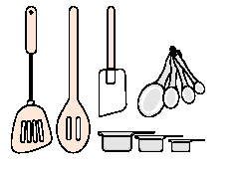Tuesday March 24th Pack Meeting

Certificates will be awarded to all entries in the following categories:

Best Use of Ingredients
Most Creative
Most Colorful
Got Milk
Best Cub Theme
Best Non-Cake
Cubmasters Pick
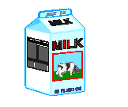Pack will provide Milk and Coffee 

