Worship Leader: Robert Baden-Powell, the founder of the Boy Scout movement, was an officer in the British army. When as a young man he went to his first station in India, he found that many of the officers came from rich families and received regular allowances from home in addition to their army pay. He resolved that he would live on what he received as a soldier. This made it necessary for him to watch his spending closely, and he gave up smoking because it cost too much to buy tobacco. At first he found it hard to get along without his pipe because the habit had a stronger hold on him than he realized, but he stuck to his resolution.
Because Baden-Powell knew the importance of saving even small amounts, he put in the Boy Scout Code the ninth law, which says, “A Scout is thrifty.”

Prayer
Everyone: ”Dear God, protect me from costly habits. Give me the courage to make my own decisions, and keep me from thinking I must do what others do. Help me to manage my time and resources wisely, and to know the joy of giving to those deserving. Amen.”



Troop 626
Sunday Morning
September 26, 1999

THRIFTY

Worship Leader: “A Scout is Thrifty.”
Everyone: “In an environment blighted by waste and extravagance, let us be thrifty.”
Worship Leader: “The world offers many gifts. A wise person uses them with care.”
Everyone: “A Scout works to pay his way and to help others. He saves for the future. He protects and conserves natural resources. He carefully uses time and property.”
Worship Leader: “A Scout is thrifty. He does not wantonly destroy property. He works faithfully, wastes nothing, and makes the best use of his opportunities. He saves his money so that he may pay his own way, is generous to those in need, and helpful to worthy projects. He may work for pay, but refuses tips for courtesies and good turns.”
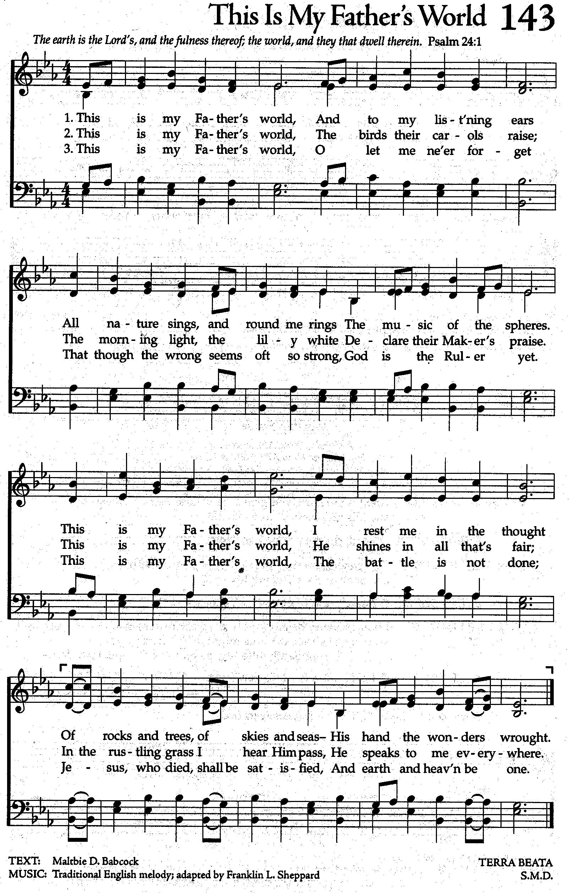
Proverbs 21:20
Worship Leader: “In the house of the wise are stores of choice food and oil, but a foolish man devours all he has.”
Everyone: “All that I have is Thine alone. A trust, O Lord, from Thee.”

I Timothy 6:19
Worship Leader: “Laying up for themselves a good foundation for the future…”

Everyone: “Love of money is the root of all evil, may I never seek it for its own sake, but only for the good it can do in Thy kingdom.”

Joyful, Joyful, We Adore Thee
Joy-ful, Joy-ful, we a-dore Thee.
God of glo-ry, God of love;
Hearts un-fold like flowers be-fore Thee,
Open-ing to the sun a-bove.
Melt the clouds of sin and sad-ness,
Drive the dark of doubt a-way.
Giv-er of im-mor-tal glad-ness,
Fill us with the light of day.

All Thy works with joy sur-round Thee,
Earth and heaven re-flect Thy rays,
Stars and an-gels sing a-round Thee,
Cen-ter of un-brok-en praise.
Field and for-est, vale and moun-tain,
Flow-ery mea-dow, flashing sea,
Chant-ing bird and flow-ing foun-tain,
Call us to re-joice in Thee.

