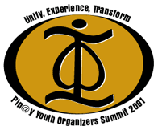

Dear Community and/or Youth Organizer,

Thank you for your interest in the first ever Pin@y Youth Organizers Summit to be held at San Jose State University from Thursday, August 2 to Saturday, August 4, 2001. Get ready to get down to business and really experience the movement. The mission of this Summit is to enhance community consciousness of the Pin@y community and to inspire collective action for personal growth and social transformation.

As you read about the history and purpose of the Summit, please completely fill out the registration information and send it back to the address provided. You will notice that there is very specific information that is being requested, so please read it carefully.

Pilipinos since the beginning of time have revolted for the right of their humanity and their freedom. First, Jose Rizal's propaganda movement lead to the revolutionary underground freedom fighters- the Katipuneros. Fighting and rebelling across the islands until proclaiming "we are the true Pilipinos!" Traveling across oceans feeling connection to a foreign land and settling on a land that they can call there own. Union organizers from north to south of the West established the Union Farm Workers Union to the 60's Pilipino consciousness raising. Third World Strike students, Filipino American National Historical Society (FANHS) and young people from all over were connecting for the mission of social justice and legitimizing our existence.

Thirty years pass and social services such as Filipino Youth Activities (FYA) in Seattle, Search to Involve Pilipino Associations (SIPA) in Los Angeles, West Bay Pilipino Multi-Services in San Francisco, Filipinos for Affirmative Action (FAA) in Oakland, Filipino American Social Services Agency (FASS) in Vallejo and Filipino Youth Coalition (FYC) in San Jose have continued to maintain and create tradition and culture within our community. Youth organizations such as Filipino Intercollegiate Networking Dialogue (FIND) from the East Coast, Midwest Association of Filipino Americans (MAFA) from the Midwest, Northern California Pilipino American Student Organization (NCPASO) from Northern California, Southern California Pilipino American Student Association (SCPASA) from Southern California, and National Filipino American Youth Association (NFAYA) have conferences that educate the masses about the beauty of our culture. The starting of the 90s' have brought upon Pilipino identity consciousness and youth while US and Canada have continuously organized to create leaders and inspire our next generation of cultural keepers.

Now….

The Pin@y Youth Organizers Summit has arisen and the need of wanting to connect on a different plane to move away from just educating Pilipinos about history transgressing to empowering youth for social justice. This progression of the Pilipino movement now occurs within us- within you! We create the Pin@y Youth Organizers Summit to contributes to our spiritual movement and renew our mission for social justice.

"Experience the Movement"

Sincerely,
Pin@y Community Venture

Pin@y Youth Organizers Summit


August 2 to 4, 2001

San Jose State University

personal information Please fill out one form for each participant.

Last Name ____________________________ First Name _________________________ Sex F M

Address ______________________________ City ___________________ State _____ Zip ______

Contact Phone # ( )____________ Fax# ( ) ____________ Email _______________________

Email Address __________________________ URL http://________________________________

Please check which best represents you. (Select all that apply)

YOUTH and NON-PROFIT
- Middle School Student
- High School Student
- College Student
- Non-Profit Worker

PROFESSIONAL
- College Professor
- Young Professional

organizational information

Organization Name ____________________________________________________________________

Address ______________________________ City ___________________ State _____ Zip ______

Contact Phone # ( )____________ Fax# ( ) ____________ Email _______________________

Email Address __________________________ URL http://________________________________
registration information

Choose the type of registration and check how many days you will be attending the Summit. Choose either one from Regular Registration or Registration with Housing.

Regular Registration*
 | Youth  Non-Profit* | # of days |  | Standard | # of days
 | $30 | 3 days |  | $50 | 3 days
 | $25 | 2 days |  | $45 | 2 days
 | $15 | 1 day |  | $35 | 1 day

*To qualify for the student/ non-profit rate, you must provide a valid school ID (from Summer or Spring session) or a copy of your latest transcript if you are a student. If you are a non-profit worker, please submit proof of employment (ie business card with your organization name on it, or a recent paycheck stub, etc)

Registration with Housing**
 | Youth  Non-Profit* | # of days |  | Standard | # of days
 | $72 | 3 days |  | $100 | 3 days
 | $54 | 2 days |  | $75 | 2 days
 | $36 | 1 day |  | $50 | 1 day
Please mail your completed registration forms along with your payment to:

Pin@y Youth Organizers Summit: Registration
38787 Stonington Terrace
Fremont, Ca 94536
Accepted forms of payment are personal checks and money orders. Please make checks payable to Akbayan Pilipino Club of San Jose State University (SJSU).

If you have any questions regarding registration,
please email at yosummit@yahoo.com or call us at 510.220.2208.

The Pin@y youth organizers summit 2001, will be hosted at San Jose State University, in conjunction with the Akbayan Pilipino Club of SJSU.
What to Bring
If you require housing please bring a pillow and sheets or a sleeping bag, as the cost of housing does not include bedding. Spending money for lunch and for snacks is recommended, as well as slippers or chinelas if you plan to stay in the dorms. And most importantly, bring an open mind filled with ideas!
Food
Breakfast and dinner will be provided. Please bring spending money for your lunches. A Map of local restaurants near campus is provided.
Talent Show
On the second day of the summit we will be planning a talent show as our evening edutainment. If you would like to participate please let us know so that we can schedule you into the evening. Please contact Tony Santa Ana at 408-494-5594, or email us at yosummit@yahoo.com. Due to time constraints participation in the talent show is limited to a first come first serve basis.
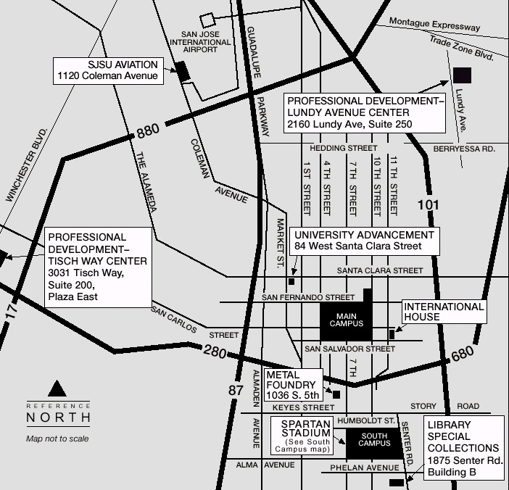
Directions to San Jose State University
From Highway 101 in either direction:
Highway 101 to the Highway 280 north interchange Highway 280 to Seventh Street exit north, make a right turn; cross San Salvador and left into Seventh Street Garage ($2 exact change required for a day permit).
From Highway 280 in either direction:
Highway 280 to Seventh Street exit north (left turn coming from north, right turn coming from south); cross San Salvador and left into Seventh Street Garage ($2 exact change required for a day permit).
From Highway 680:
Highway 680 south to Highway 280 north; Highway 280 to Seventh Street exit north, make a right turn; cross San Salvador and left into Seventh Street Garage ($2 exact change required for a day permit).
From Highway 880/17 in either direction:
Highway 880/17 to Highway 280 South interchange; Highway 280 south to Seventh Street exit north, make a left turn; cross San Salvador and left into Seventh Street Garage ($2 exact change required for a day permit).
From San Jose International Airport:
Take Guadalupe Parkway (becomes Highway 87) south to I-280 southbound. Exit at 7th street. Turn left on 7th Street to campus.
For those who are coming from out of state, please try and arrange to have your flights arrive and depart out of San Jose International Airport. If you would like to be picked up and dropped off from the San Jose International Airport, please let us know so that we can make arrangements. If you arrive at any other airport, you are responsible for your own transportation.

Program Overview
Mornings will begin with large group dialogue around pertinent topics and will be followed in the afternoon by more specific small group sessions. The entire weekend is not a "class", a "conference" or a series of "workshops". The summit is an extended conversation created for, about and in the service of community organizers. The kinds of topics we will be covering over the course of the summit is listed below. But please keep in mind that these are but some of the issues that our community faces. And until the days of the summit occur, there's no telling what may come out of the conversations that occur.
Day 1 – Who Do We Organize and Why | 7:30am - Breakfast & Registration  9:00am – Welcome  9:30am - History of the Summit  10:00am - 12:00pm - Group DialogueDealing with issues we've seen before at "conferences"  12:00pm - 1:00pm - Lunch Caucus  1:00pm - 5:30pm - Breakout Interactivities - Discussions will follow theme of the day in four different areas - Sexuality, Family, Social Justice, and Education  6:00pm - 8:00pm – Dinner  8:00pm - 11:00pm - Edutainment - Community Party, Meet, Network, Just chill and reunite with old friends and make new ones.
Day 2 – Organizers & Organizational Support | 7:30am - Breakfast & Registration  9:30am - Presentation of FILCRA timeline  10:00am - 12:00pm - State of the Community - History Panel of Community Organizers who have been around for awhile sharing their experiences  12:00pm - 1:00pm - Lunch Caucus  1:00pm - 5:00pm - Breakout Interactivities - Discussions will follow theme of the day in two different areas - Initiate & Maintain, and Development & Structure  5:30pm - 7:30pm – Dinner  8:00pm - 11:00pm - Edutainment - Talent Show, Come and show your stuff, and also see what others in the community has to show.
Day 3 – The Future, Next Steps | 8:00am - Breakfast & Registration  9:00am - Morning group exercise  9:30am - 12:00pm- Breakout Interactivities - Discussions will follow the theme of the day, topics will be about the application of arts, media and technology, and steps we can take to make a difference in our communities.  12:00pm - 1:00pm - Lunch Caucus  1:00pm - 2:00pm - Breakout interactivities continued.  3:00pm - 5:30pm - Group Dialogue - Creating a timeline and Next steps we need to take to transform our community,  6:00pm - 7:00pm – Dinner  7:00pm - 11:00pm - Edutainment - Spoken Word / Creative Expressions Night- Time to experience the creation of our community collectively through the words and art inspired by ourselves and the community that surrounds us.

