NAME: YI CHI CINDY HSIEH

THURSDAY LAB

LAB # 5

NICOTINIC RECEPTORS & NEUROMUSCULAR BLOCKING AGENTS

MCDB 126/226AL

PHARMACOLOGY LABORATORY

THE EFFECTS OF NEUROMUSCULAR BLOCKING AGENTS
ON NICOTINIC RECEPTORS IN RAT DIAPHRAGM

INTRODUCTION
The rat diaphragm was used as the isolated tissue for this experiment. In this experiment the effects of nicotinic receptors, and neuromuscular block agent drugs at the striated muscle was measured with its response towards electrical stimulation on phrenic nerve.
The rat diaphragm is the muscle in between intestinal tract and pericardial cavity. The phrenic nerve is located at cervical spinal roots and passes down towards thorax for innervations of diaphragm in controlling breathing. When phrenic nerve is stimulated by the orthodromic electric, acetylcholine will be released between phrenic nerve and diaphragm resulting in contraction. Other than finding the voltage needed for this stimulation, excess contraction will also led to the point where the tissue will not return to resting potential. The measurement of such, which is called tetanus, was also measured in this lab with minimal and maximal measurement of the muscle contraction.
The main nervous system controlling the action of the striated muscle in this experiment is primary the somatic nervous system. Somatic nervous system is the nervous system in charge of the action of skeletal muscle. It contains an afferent division that sense and sends information into the central nervous system. It also contains an efferent division that works away from the central nervous system in more of a motor action on the muscle. The somatic nervous system uses acetylcholine as its neurotransmitter with no ganglia in targeting nicotinic receptors using excitatory effects on the skeletal muscle in stimulating action of the muscle.
There are three drugs that were used in the experiment to exam the reaction of the skeletal muscle’s reactions through affecting the somatic nervous system.
First, Tubocurarine is an example of a competitive nicotinic antagonist of acetylcholine receptor. Tubocurarine acted by binding to acetylcholine receptor in motor plate in blocking the action of acetylcholine. This resulted in induction of histamine releasing that will cause muscle relaxation. When it was dosed with a depolarizing drug as Succinylcholine, it resulted in increment of contraction, since it will reduce the block causing by a depolarizing agent. When Succinylcholine is treated with Tetanus, it resulted in a sustained fade that slowly return to normal skeletal contraction.
Second, Succinylcholine is an example of depolarizing agent that affects the neuromuscular neuron nicotinic receptor for acting upon Somatic nervous system. It contains 2 routes, including depolarizing antagonist at phase 1 during low dosage, and direct antagonistic action at the nicotinic receptor at phase 2 during high dosage. During phase 1 when there is low concentration of drug, Succinylcholine will act in keeping ion channel open in resulting muscle depolarization resulting in fasciculation. The antagonist will keep ion channels open so repolarization of muscle is inhibited. During the second phase, the Succinylcholine will act as competitive inhibitor with Ach in desensitization resulting in muscle relaxation. When Succinylcholine dosage was treated with Tubocurarine dosage in the tissue, it resulted reverse in block, which will contract the striated muscle due to Competitive antagonist’s action towards depolarizing agent. When Succinylcholine was treated with Tetanus, it resulted in a rapid fade that will fade quickly to return to its normal skeletal contraction
Last, Edrophonium, which is a drug that is used for muscle contraction. It acts as a reversible competitive cholinesterase inhibitor at the nicotinic receptor by increasing the remaining acetylcholine and acetylcholine receptor into a higher concentration leading towards short-termed muscle contraction. When this is used following dosage of Tubocurarine, it resulted in block reversed, since Tubocurarine is a non-depolarizing agent that blocks the contraction by competitive antagonist on the Acetylcholine nicotinic receptor. When this is used following dosage of Succinylcholine, it resulted in block enhanced. Since Succinylcholine is hydrolyses by butylcholinesterase, and it act by having prolonged action potential. With Edrophonium acting in inhibiting cholinesterase, it resulted in enhancing the Acetylcholine, causing muscle contraction.

METHODS

Table 1: Dilution Table
Drug | Stock [M] | Bench [M] | Dilution  Factor | Volume drug: Volume Ringers (mL) | Dose Volume (mL) | Bath Volume (mL) | Bath [M]
Tubocurarine | 3.0e-4 | 3.0e-4 | ------ | ------ | 1.0mL | 50mL | 6.0e-6
Tubocurarine | 3.0e-4 | 1.0e-4 | 1:3 | 1mL: 2mL | 1.0mL | 50mL | 2.0e-6
Succinylcholine | 3.0e-2 | 3.0e-3 | 1:5 | 2mL: 8mL | 1.0mL | 50mL | 1.2e-4
 |  | 6.0e-4 | 1:50 | 1mL: 9mL | 1.0mL | 50mL | 1.2e-5
Succinylcholine | 3.0e-2 | 3.0e-3 | 1:10 | 1ml: 9mL | 1.0mL | 50mL | 6.0e-5
 |  | 3.0e-4 | 1:10 | 1mL: 9mL | 1.0mL | 50mL | 6.0e-6
Edrophonium | 5.0e-2 | 3.0e-3 | 3:50 | .6mL: 9.4mL | 1.0mL | 50mL | 6.0E-5

Sample Calculation
1. [STOCK], [BATH]: Given, [BATH V]: 20mL, [DOSE V]:0. 2mL
2. [BENCH]: 100 x [BATH}
Tubocurarine [BENCH] =100 x 1.0e-4=1.0e-6
3. [DILUTION FACTOR]: [STOCK]/[BENCH]
Tubocurarine DF=3e-4/1e-4-=3
4. [SERIAL DLUTION] for (Tubocurarine)
DF=1000-= (10)(10)(10)(10)
C1*V1=C2*V2, V1=(C2*V2)/C1, DF: (1/10000)
V1=(1e-4*0.2mL)/3e-4= out of 20mL = (1/10)
To get into [Bath] = 1e-9, need to dilute 1/100

Dilution Procedure
First vials and needles were obtained, and labeled after each drug. Prepared Krebs ringers solution to do the dilution. First, Tubocurarine was prepared: 1mL of 3.0e-4M Tubocurarine was mixed with 2mL of krebs ringers solution to make 1.0e-4M. 1mL of 3.0e-4M Tubocurarine from the stock and the 1.0e-4M Tubocurarine dilution were kept for later dosage. Second, 2mL of 3.0e-2M Succinylcholine was mixed with 8mL of ringers solution to make 3.0e-3M dilution. Then 1mL of 3.0e-3M Succinylcholine was mixed with 9mL of krebs ringers solution to make 6.0e-4M Succinylcholine. After this, 1mL of 3.0e-2mL from the stock was mixed with 9mL of krebs ringers solution to make another 3.0e-3M dilution. Then, from the 3.0e-3M dilution, 1mL of it was mixed with 9mL of krebs ringers solution to make 3.0e-4M dilution. Both the 6.0e-4M and the 3.0e-4M Succinylcholine dilutions were kept for later dosage. Last, 0.6mL of 5.0e-2M Edrophonium was mixed with 9.4mL krebs ringers solution to make 3.0e-3M Edrophonium and kept for later dosage. The dilutions were kept and stored in ice bucket in all time and used for the dosage.

Tissue & Stimulator Preparation
The rat was obtained with preparation of aerated krebs ringers solution, scissors, and plastic forceps. First, the fur was removed with the scissors around the thoracic area and chest. After the furs were removed, the muscles covering the thoracic area were removed with gentle cuts to avoid breakage of the diaphragm. After the muscles were removed, and the ribs are obviously showing, a cut was done at the 4th rib carefully to make sure that the nerve and the diaphragm was not being cut. After it is done, the phrenic nerve and diaphragm were identified and isolated from lungs and other unnecessary connective tissues to the nerve and diaphragm. After the isolation was done, a suture was tied at the end of the phrenic nerve near the thymus and isolated from the body. After that, free the diaphragm and suture the diaphragm. Finally, wrap the phrenic nerve around the small electrode wire at the tissue holder and the diaphragm was placed under the loop with the ribs aiding it. After these are done, the diaphragm was being putting into the tissue bath with aerated oxygen and ringers solution in there.
Stimulator was being turned on with stimulation rate of 1, by turning large dial to 1 0and small dial into 0.1x. Then, the duration was set into 0.3 msec, pulse into pulses, and output into “on”. Then the isolator was set with coupling into “direct”, and polarity into Normal. Then set the multiply input volts by into 1 and ensure that the plug is in the polygraph and power.
For the calibration, the Polyview were opened. Then a new file was being opened and created the file name of “experiment 5”. After that, the markers were typed with the different concentration of the drugs, and also wash and end-wash. After these are done, the transducer was set to 0.00 for the baseline, then pressed record and allowed it to run through the whole experiment. When recording, every action was marked. At the end of the lab, the graph was being review, and the page per second was being changed to find the best way to present the graph.

Dose Cycle
First, the Threshold, Maximal and Supramaximal voltages, and Tetanus frequency were found. Threshold, and Maximal were found by starting the voltage at 0.1 volts with 0.2 volts increment until Threshold response were found, and Maximal response were found. Then the Supramaximal will just be1 volts over the Maximal voltage, and this will be the voltage for the experiment. After this, Tetanus frequency were found by increasing the stimulation rate by 1 each time until it reaches to almost a line, Whenever Tetanus was performed at the experiment, the stimulator was turned off and adjusted into the tested frequency with chart speed into 100, then turn the stimulator on. After these were done, dosage begun.
First obtain 1mL of 1e-4M Tubocurarine and dose into the 50mL tissue bath with aerated ringers solution, and waited until 50% paralysis is obtained then wash. Second, 1mL of 1e-3M Tubocurarine was dosed and 1mL of 3e-3M Edrophonium was dosed when 50% paralysis had developed then washed. Third, 1e-4M Tubocurarine was dosed, with Tetanus for 10 seconds when 50% paralysis had developed then washed. Fourth, 1mL of 3e-3M Tubocurarine was dosed in the bath with 1mL of 6e-4M Succinylcholine dosage when 10-20% paralysis had developed then washed. Fifth, 1mL of 6e-4M of Succinylcholine was dosed in the bath, and washed. Sixth, 1mL of 6e-4M Succinylcholine was dosed with tetanus performed at 50% paralysis, then washed. Seventh, 1mL of 6e-4M of Succinylcholine was dosed with 1mL of Tubocurarine at 50% paralysis then washed. Last, 1mL of 6e-4M Succinylcholine was dosed with 1mL of 3e-3M Edrophonium in 50% paralysis.

Instrument and Equipment used during the experiment:
- Polyview
- Stimulator S44
- Isolator
- 500mL Tissue Bath

Figure 1 Working Station with Polygraph and computer
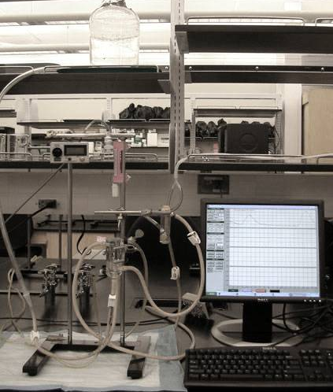

Figure 3 Tissue Preparation
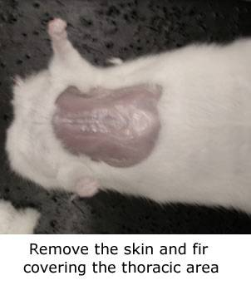
Figure 2 Tissue Bath
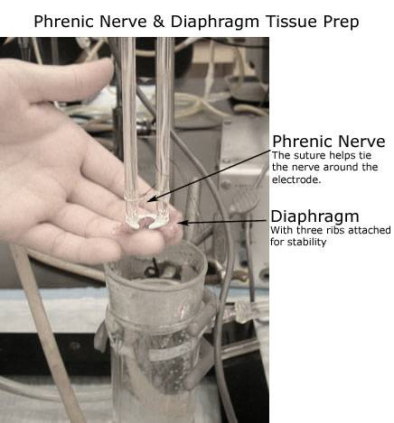

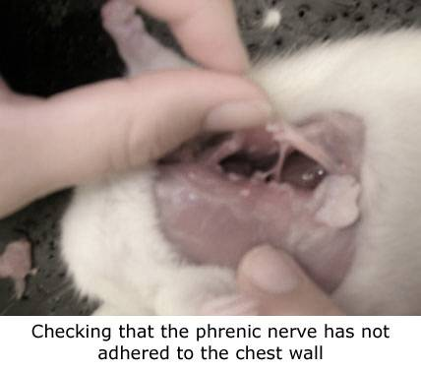

RESULTS

Table 2 Result Table
Admin  Time | Drug/Action | Drug  Type | Nervous  System | Receptor  Involved | [Bath]  (M) | %  Paralyze | Observed  Response | Expected  Response | %  Resps.
0:35:27 | Threshold | ----- | ------- | ------ | ------ | ------ | +0.15g | Increase | Control
0:37:45 | Maximal | ----- | ------- | ------ | ------ | ------ | +0.47g | Increase | +313%
0:55:45 | Tetanus | ----- | ------- | ------ | ------ | ------ | +0.31g | Increase | +207%
1:17:40 | Tubocurarine | Antagonist | Somatic NS | Nicotinic | 2.0e-6 | 50.0% | -0.09g | Decrease | -26.5%
1:26:20  1:29:55 | Tubocurarine  Edrophonium | Antagonist  Inhibitor | Somatic NS  Somatic NS | Nicotinic  Cholinesterase | 2.0e-6  6.0e-5 | 50.0%  ------ | Control  +0.03g | Decrease  Increase | Control  + 9.1%
1:37:00  1:40:15 | Tubocurarine  Tetanus | Antagonist  ------ | Somatic NS  ------ | Nicotinic  ----- | 2.0e-6  ------ | 75.0%  ------ | -0.02g | Decrease  Rapid Fade | -10.0%  ------
1:56:40  1:58:30 | Tubocurarine  Succinylcholine | Antagonist  Depolarizing  Agent | Somatic NS  Somatic NS | Nicotinic  Nicotinic | 6.0e-6  6.0e-6 | 50.0%  ------ | Control  +0.04 | Decrease  Increase | Control  +50.0%
2:28:25 | Succinylcholine | Depolarizing  Agent | Somatic NS | Nicotinic | 1.2e-5 | 73.7% | -0.04g | Decrease | -11.8%
2:34:00  2:39:50 | Succinylcholine  Tetanus | Depolarizing  Agent  ------ | Somatic NS  ------ | Nicotinic  ------ | 1.2e-5  ------ | 50.0%  ------ | -0.10g | Decrease  Sustained | -20.0%  ------
2:53:05  2:57:00 | Succinylcholine  Tubocurarine | Depolarizing  Agent  Antagonist | Somatic NS  Somatic NS | Nicotinic  Nicotinic | 1.2e-5  2.0e-6 | 66.7%  ------ | Control  -0.20g | Decrease  Increase | Control  -20.0%
3:04:00  3:08:25 | Succinylcholine  Edrophonium | Depolarizing  Agent  Inhibitor | Somatic NS  Somatic NS | Nicotinic  Cholinesterase | 1.2e-5  6.0e-5 | 71.4%  ------ | Control  -0.02g | Decrease  Decrease | Control  -5.0%

Sample Calculation 1:
Observed Response= Control height-Response height
Control as the control height prior dosage
[Tubocurarine & Edrophonium] Observed Response=(0.33-0.36)=0.03
% Response= 100*[(Control height-Response height)/(Control height)]
[Tubocurarine]& Edrophonium % Response=100*[(0.33-0.36)/(0.33)]=9.1% increment

Table 3 Result Table
Treatment | Voltage | Stimulation Rate | Response (g)
Threshold Voltage | 48 volts | 1 pulses | 0.15g
Maximal Response | 66 volts | 1 pulses | 0.62g
Supramaximal Response | 67 volts | 1 pulses | 0.72g
Tetanus | 67 volts | 23 pulses | 0.45g

Sample Calculation 2:
Response: Control height-Response height
Threshold as control
[Max Response] Response= (0.15)-(0.62)=0.47g increment

Fig. 4 Drug Structures

Tubocurarine  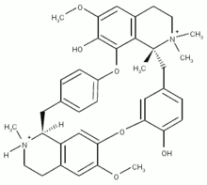 | Edrophonium  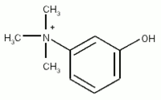
Succinylcholine

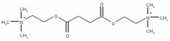

DISCUSSION

This experiment is purposed in measuring the effects of neuromuscular blocking agents on the nicotinic receptors of the striated muscle in rat diaphragm. Instead of the smooth muscle, the experiment was tested on the striated skeletal muscle in the rat diaphragm and the phrenic nerve.
Unlike smooth muscle, skeletal muscle contains a very unique anatomy, and mechanism. Skeletal muscle contains an alternative light and dark band that has multi-nuclei character in forming muscle in many bundles. It is excited through a structure called neuromuscular junction, in which action potential caused the neurotransmitter Acetylcholine to release at the nicotinic receptor on the skeletal muscle in opening Sodium and Potassium ion channel. This will then resulted in muscle depolarization causing skeletal muscle contraction.
The main nervous system controlling the action of the striated muscle in this experiment is primary the somatic nervous system. Somatic nervous system is the nervous system controlling voluntary actions. It contains an afferent division as the sense organs in obtaining the input to send information into the central nervous system. It also contains an efferent division that works away from the central nervous system in more of a motor action as an output to the skeletal muscle. The somatic nervous system uses acetylcholine as its neurotransmitter, with no ganglia, using excitatory effects directly on the nicotinic receptor on the skeletal muscle in stimulating action of the muscle.
The purpose of these nerve preparation is to isolate the phrenic nerve and diaphragm from the rat to place the phrenic nerve at the electrode wire in the tissue bath. This process is proceed to exclude any materials that might interfere with the results of the drug’s interaction with the tissue, isolating the rat rib, diaphragm, and phrenic nerve for the experiment. A new equipment called stimulator was used to provide the action potential needed for the experiment. By wrapping the phrenic nerve around the electrode wire, it allowed the simulator to interact with the diaphragm since phrenic nerve is connected with the diaphragm in sending signal in normal body. Because the tissue bath lack in action potential present in the body, the simulator will trigger artificial action potential via the electrode wire to interact with the phrenic nerve. The stimulator will create an action potential in triggering acetylcholine from phrenic nerve to diaphragm resulting in contraction. The different neuromuscular blocking agent drugs used in the experiment will act on the Acetylcholine nicotinic receptor in blocking the action. The anti-cholinesterase agent will also perform at the nicotinic receptor in inhibiting drugs from being cholinesterase to enhance muscle relaxation.
Before dosage of the drugs, Threshold, Maximal, Supramaximal, and Tetanus frequency was tested. Threshold is the minimal voltage for measurable contraction. Maximal is the maximum contraction the muscle can get from the action potential voltage, with Supramaximal simply 1 volt more than the maximal. Tetanus is the sustained muscle contraction caused by electrical stimulation that was determined by increment of frequency. Tetanus was developed rapid repetitive stimuli of action potential were induced that caused a state of continuous muscular contraction. The purpose of these nerve preparation is to isolate the phrenic nerve and diaphragm from the rat to place the phrenic nerve at the electrode wire at the tissue bath. After the phrenic nerve is placed at the electrode wire for stimulation, then it can be stimulated for establishing the voltage needed for showing the reaction accurately, and the Tetanus that will be performed in between the experiment to see the different effects of the drug interactions with Tetanus.
During this experiment, Edrophonium was dosed with presence of Tubocurarine, and Succinylcholine as an example of how depolarizing agent and non-depolarizing agent react towards cholinesterase inhibitor. There are 2 types of Cholinesterase, including the acetylcholinesterase, and butylrylcholinesterase. Acetylcholinesterase located at synapse that terminates cholinergic neurotransmission by hydrolyzing acetylcholine. Butylrylcholinesterase, which is also called pseudocholinesterase, is a plasma cholinesterase that has weaker affinity for acetylcholine. It inactivates local anesthetic and muscle relaxant, in this case, hydrolyses Succinylcholine.
The Tubocurarine is a non-depolarizing competitive antagonist that binds directly toward nicotinic acetylcholine receptor. Tubocurarine will block the nicotinic receptor from binding to Acetylcholine resulted in muscle relaxation. When 2.0e-6M Tubocurarine was dosed with dosed by itself into the bath, it resulted in 26.5% decrement that shows muscle contraction. When 6.0e-5M Edrophonium was dosed after 2.0e-6M Tubocurarine was dosed, it resulted in 9.1% contraction. This is due to Edrophonium’s feature of reversing the block of non-depolarizing agent. When Tetanus was performed after dosage of 2.0e-6M Tubocurarine, the tetanus rapidly faded. This is due to tetanus is stimulated by rapid repetition of action potential. Since Edrophonium is an non-depolarizing agent, it does not induce action potential in the tissue. Therefore, when the artificial stimulation of Tetanus was set off, it then rapidly faded back to its normal contraction rates. When 3.0e-5M Succinylcholine was dosed after dosage of 6.0e-6M Tubocurarine, the result was 50% increment of muscle contraction. This is due to low dosage of Succinylcholine as a depolarizing drug in phase 1. This is when ion channels of the striated muscle were open resulting in depolarization to muscle twitches. This will result in a noncompetitive inhibition of repolarization. When this is treated with Tubocurarine, a non-depolarization it will reverse the block to contract the skeletal muscle.
Second, the high dose of Succinylcholine displaying phase 2 blockage. When 1.2e-5M Succinylcholine was dosed in the bath, it resulted in a 11.8% decrement of amplitude in muscle relaxation. This is due to high concentration of depolarizing drug that cause a competitive inhibition with acetylcholine blocking binding of acetylcholine receptor resulting in desensitization. When 1.2e-5M Succinylcholine was performed with Tetanus followed by, it resulted in a sustained fade. This is due to Tetanus that is caused by rapid repetitive stimuli of action potential in causing continuous muscle contraction. Since Succinylcholine is a depolarizing agent that depolarizes the tissue causing action potential in the tissue, when the artificial stimuli of Tetanus was set off, it will not rapidly faded back to normal, instead, it will sustained its action and slowly faded. When Succinylcholine was dosed with Tubocurarine, the result was not accurate. It resulted in 20% decrement, in enhancing muscle relaxation. This should resulted in reducing the block that will increase the muscle contraction. This error may be due to the insensitivity of the muscle, since this was tested at near the end of the experiment. Last, when Succinylcholine was dosed followed with Edrophonium, it resulted in 5% decrement of amplitude in muscle relaxation. This is due to Edrophonium’s ability of inhibition of cholinesterase. Since butylrylcholinesterase is the factor that hydrolyses and inactivates Succinylcholine, with cholinesterase inhibitor presence, the block may be enhanced resulting in muscle relaxation.

REFERENCES
- Thrower, Douglas. MCDB126A Lecture. “The Somatic NS and Neuromuscular Blocking Agent”. Santa Barbara. University of California Santa Barbara. 1996. Slide1-13
- Thrower, Douglas. MCDB126A Lecture. “Cholinesterase”. “Drugs that affects the Parasympathetic NS”. Santa Barbara. University of California Santa Barbara. 1996. Slide 7
- Thrower, Douglas. MCDB126AL Lecture. “Experiment 4”. Santa Barbara. University of California in Santa Barbara. 1996.
- Thrower, Douglas. MCDB126AL Lab Manual. “Experiment 5 Rat Diaphragm & Phrenic nerve”. Santa Barbara. University of California in Santa Barbara. 1996. Pg1-7
- “Edrophonium”. 1996. Answer’s Corporation. New York [http: www.answers.com/edrophonium]
- “Succinylcholine”. 1996. Answer’s Corporation. New York [http:
- www.answers.com/succinylcholine]
- “Tetanus”. 1996. Answer’s Corporation. New York [http: www.answers.com/tetanus]
- “Tubocurarine”. 1996. Answer’s Corporation. New York [http: www.answers.com/tubocurarine]

