p1: No rotation, No mirror reflection, No glide reflection

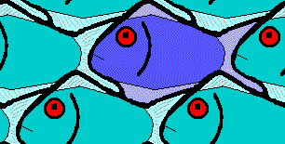

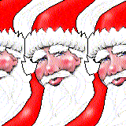

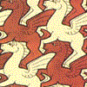
pg: No rotation, No mirror reflection, With glide reflection
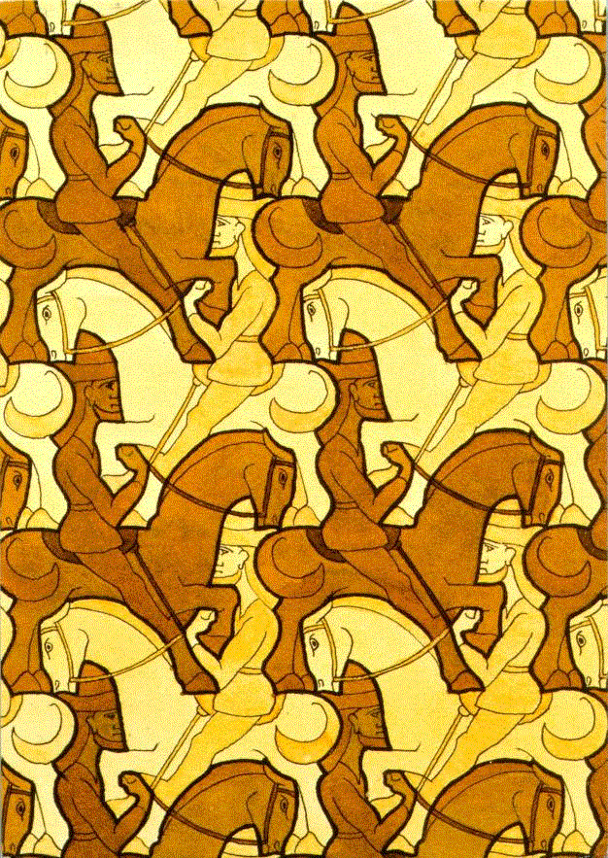
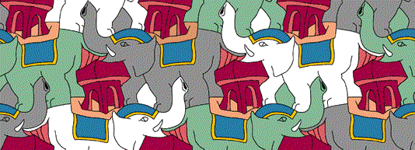
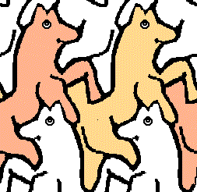
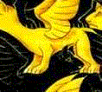

pm: No rotation, Reflection in 1 direction,

All glide reflections occur along lines of symmetry
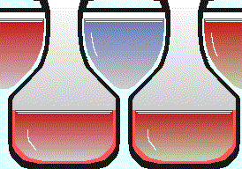

cm: No rotation, Reflection in 1 direction,
Some glide reflections do not occur along lines of symmetry

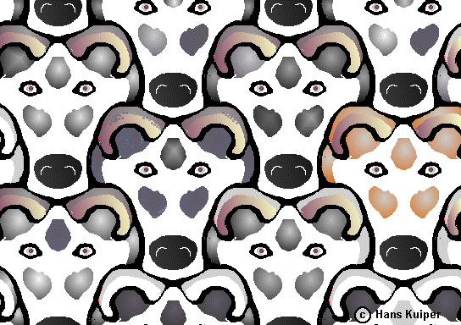

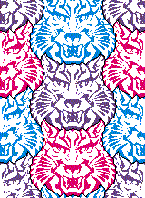

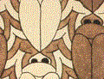

web.inter.nl.net/hcc/Hans.Kuiper/17system.htm “17 Wall Paper Symmetry Groups”

