p2: Rotation of order 2, No mirror reflection, No glide reflection

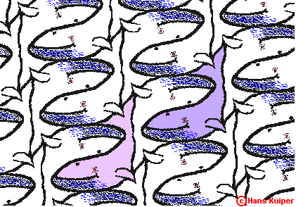

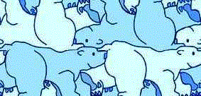


pgg: Rotation of order 2, No mirror reflection, With glide reflection

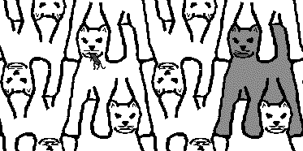

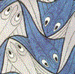

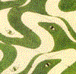
pmg: Rotation of order 2, Reflection in 1 direction

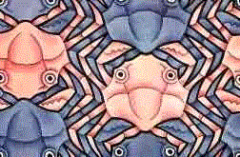

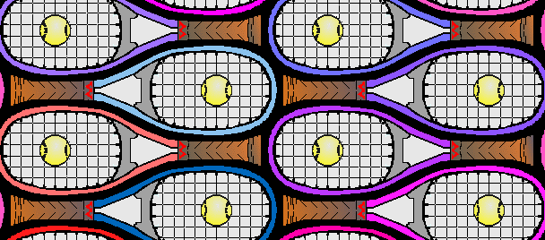

pmm: Rotation of order 2, Reflection in 2 directions,
All glide reflections occur along lines of symmetry

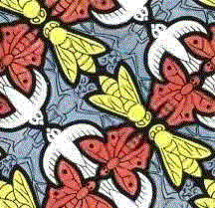

cmm: Rotation of order 2, Reflection in 2 directions,
Some glide reflections do not occur along lines of symmetry

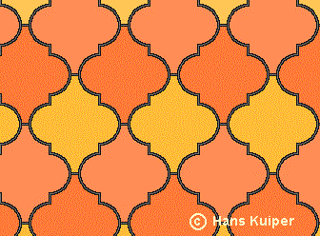

web.inter.nl.net/hcc/Hans.Kuiper/17system.htm “17 Wall Paper Symmetry Groups”

