p3: Rotation of order 3, No reflection



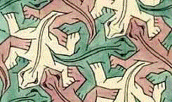

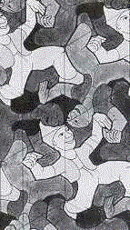

p3ml: Rotation of order 3, Reflection in 3 directions,
All rotations occur along lines of symmetry

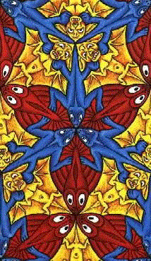

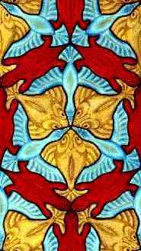

p3lm: Rotation of order 3, Reflection in 3 directions,
Some rotations do not occur along lines of symmetry

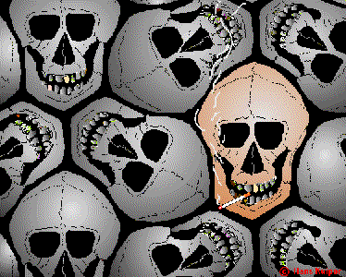

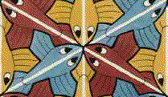

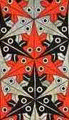

web.inter.nl.net/hcc/Hans.Kuiper/17system.htm “17 Wall Paper Symmetry Groups”

