p4: Rotation of order 4, No reflection

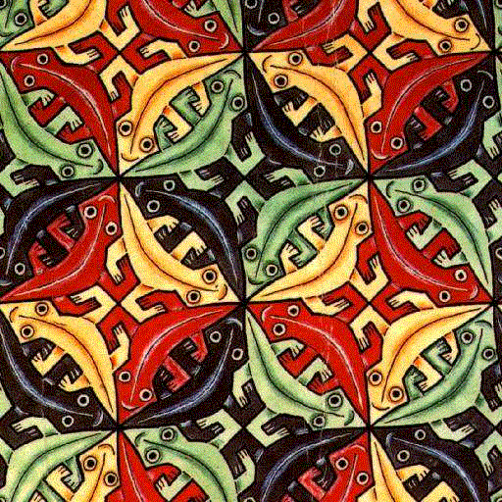

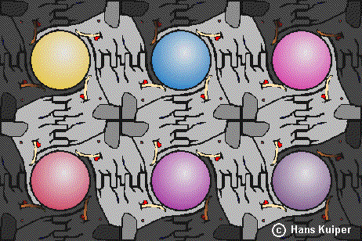



p4g: Rotation of order 4, Reflection in 2 directions

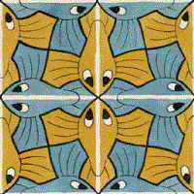

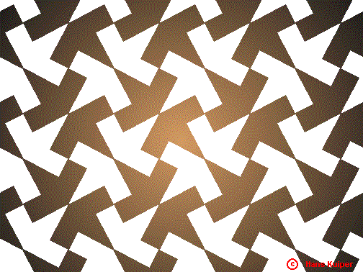
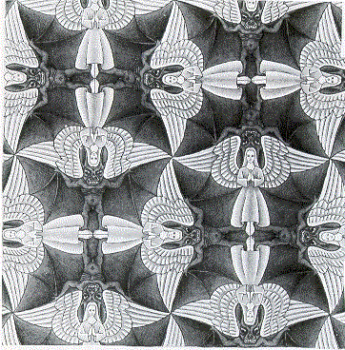

p4m: Rotation of order 4, Reflection in 4 directions

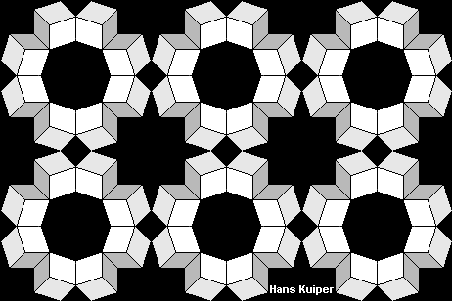

web.inter.nl.net/hcc/Hans.Kuiper/17system.htm “17 Wall Paper Symmetry Groups”

