Greek

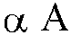 | 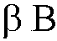 | 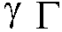 | 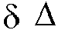 | 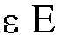 | 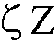
alpha | beta | gamma | delta | epsilon | zeta
a | b | g | d | e | z
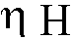 | 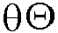 |  | 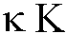 | 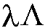 | 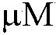
eta | theta | iota | kappa | lambda | mu
ee | th | i | k | l | m
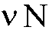 | 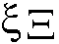 |  | 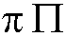 | 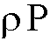 | 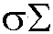
nu | xi | omicron | pi | rho | sigma
n | ks | o | p | r | s
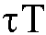 | 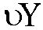 | 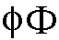 | 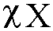 | 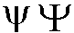 | 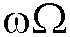
tau | upsilon | phi | chi | psi | omega
t | u | f | kh | ps | oo

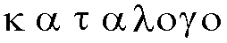  katalogo  catalogue | 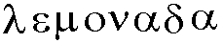  lemonada  lemonade | 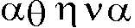  atheena  Athens
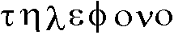  teelephono  telephone | 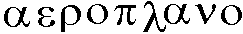  aeroplano  aeroplane | 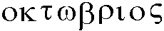  oktoobrios  October

En archee een ho logos  In beginning was the word |  | kai ho logos een pros ton theon  and the word was with the God
kai theon een ho logos  and God was the word |  | houtos een en archee pros ton theon  this [one] was in beginning with the God
panta di autou egeneto  all [things] through him came into being |  | kai chooris autou egeneto oude hen  and without him came into being not even one
 | o gegonen en autoo zooee een  the created in him life was |  | kai hee zooee een to phoos toon anthroopoon  and the life was the light [of] the people
Ref: www.ibiblio.org/koine/greek/lessons/john1.html
www.ukindia.com/zip/zgk1.htm

