PUNJABI

 | 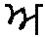a |  | 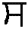s | 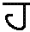h
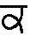k | 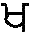kh | 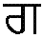g | 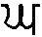gh | 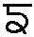ng
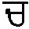ch | 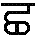ch’ | 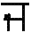j | 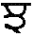jh | 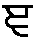nj
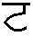t | 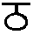th | 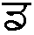d | 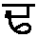dh | 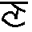nh
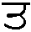t’ | 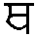th’ | d’ | 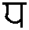dh’ | 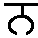n
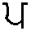p | 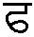ph | 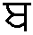b | 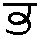bh | 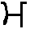m
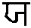y | 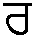r | l | 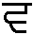w, v | 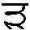rh
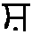sh | 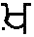kh’ | 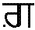g’ | 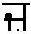z | 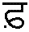f

 | independent | vowels | short vowels | long vowels
a | 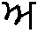a | 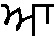– |  | –
i | 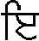i | 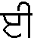– | i | –
u | u | – | u | –
e | e | 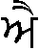ai | e | ai
o | 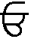o | 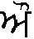au | o | au

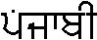  Pnjaab– | 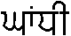  Ghandh– | 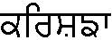  Krishn’– | 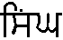  singh
khan | 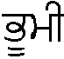  bh–m– = earth |   main = I | 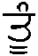  t’–n = you

