Syllabus--Economic Geography 3303
GEO 3303 -- FALL 2006-- T/R 12:30 – 1:45 -- ELA 116
Instructor: Dr. Brock Brown, Office: 370 Evans Liberal Arts

OFFICE HOURS: Tuesday/Thursday 10:30-11:00 AM, 2:00-3:15 PM, Wednesday 4:30-6:00 PM, or by appointment.

I am in my office many times other than office hours. If my door is open, students are welcome and invited to come in if they wish to see me. I am also happy to make appointments to meet with students at other times.

Contact: 512.245.3202/512.245.8353 (fax) -- brockbrown@txstate.edu

The Final Exam for this course is Tuesday, December 12, 11:30 am. This is the last day of finals. Students are expected to take the final at this time and early finals will not be given.

CATALOG COURSE DESCRIPTION: This course analyzes the patterns and processes of geographic organization of economic activities as well as distribution of factors and resources from global to local scales. Economic and geographical concepts, ideas, theories, as well as historical and current information will be investigated in search of an understanding of the interrelationships and connections between the economy, the environment, and political behavior across space and scale.

COURSE LEARNING OUTCOMES:
Knowledge: Students will demonstrate the ability to apply the geographic perspective and economic geography to the observation and analysis of the spatial aspects of economic distributions, underlying processes, and economic decision making and policy generation. The role of political behavior and environmental sustainability will be central to the course.
Skills: Students will be able to use tabular and graphic data and relevant literature to assess economic related problems, identify the various viewpoints, and propose solution strategies

REQUIRED MATERIALS:

Hungry Planet, Menzel, Peter and Faith D’Alusio, Material World and Ten Speed Press
State of the World 2006. WorldWatch Institute.
Student Atlas of World Geography. John Allen, Ed. Fourth Edition, 2005. McGraw Hill. 2005.
World Data Sheet 2005 or 2006. Population Reference Bureau.
Other materials from internet sites as assigned.
SPECIAL REQUIREMENTS:

- Students must be able to access BLACKBOARD, receive emails, and obtain readings and materials from the internet.
- Use of Google Earth may be required from time to time.
- Students are expected to read newspapers, watch, listen, or visit on the web quality news programs, and be aware of current events relative to course topics.

CLASSROOM POLICIES:

1. CLASS ATTENDANCE IS MANDATORY--STUDENTS ARE EXPECTED TO ATTEND CLASS. Since most of the questions on the exams will come directly from class presentations, regular attendance and good note taking are in your best interest. More importantly, if you are a serious student this class will be of much greater benefit if you attend regularly.

2. CLASS WILL BEGIN PROMPTLY AT THE SCHEDULED TIME AND STUDENTS ARE EXPECTED TO BE ON TIME. If unavoidable circumstances make it necessary for you to come to class late please enter the classroom quietly and avoid disturbing others. Class will never run past the end-time. If you must leave class early, notify the instructor before class and sit toward the back of the room so that you will not disturb the class when you leave.

3. DURING CLASS PRESENTATIONS STUDENTS ARE EXPECTED TO BE ATTENTIVE. Talking to other people in the class or on the phone, passing notes, reading newspapers and magazines, listening to music, sleeping, working on other projects, or any other activities that disturb either the instructor or other students will not be permitted. Cell phones, pagers and beepers, and other interruptive technologies are to be turned off during class.

4. STUDENTS HAVING SPECIAL NEEDS/DISABILITIES: Students with special needs (as documented by the Office of Disability Services) that will require compensatory arrangements must contact the instructor no later than the fourth class period to discuss specific arrangements and logistics. Students who have not already done so will be required to contact the Office of Student Disability Services located at LBJ5-5.1 (245.3451). Texas State is dedicated to providing theses students with necessary academic adjustments and auxiliary aids to facilitate their participation and performance in the classroom.
(http://www.swt.edu/effective/upps/upps-07-11-01.html)

5. TEXAS STATE ACADEMIC DISHONESTY POLICY Learning and teaching take place best in an atmosphere of intellectual fain-minded openness. All members of the academic community are responsible for supporting freedom and openness through rigorous personal standards of honesty and fairness. Plagiarism and other forms of academic dishonesty undermines the very purpose of the university and diminish the value of an education. Specific sanctions for academic dishonest are outlined in SWTexan.
(http://www.swt.edu/effective/upps/upps-07-10-01.html)

6. GRADING: Grades will be assigned on the basis of total points earned. The student with the highest cumulative score will determine the top of the curve.

ASSIGNING GRADES-- THE CURVE. The SCORE OF THE STUDENT WITH THE HIGHEST NUMBER OF TOTAL POINTS AT THE END OF THE SEMESTER (not highest number possible) will determine the top of the semester curve. All scores within 90% of that score will receive the grade of "A". Students with scores between 89% and 80% of that score will receive the grade of "B", and so forth. The specific breakdown is as follows:
A=100-90% OF HIGHEST TOTAL SCORE EARNED
B= 89-80%
C= 79-70%
D=69-60%
F =59-00%

Last minute grades of incomplete (I) will only be given in the event of documented illness\ or other catastrophe that prevents a student from taking the last exam. Grades of “I” automatically convert to the grade of “F” if course work is not completed in one year.

Earning Points: Up to 190 total points are possible
- 140 points from exams
- Up to 50 points in writing exercises

Three exams (140 points)

- Two mid-terms worth 40 points each for a total of 80 points (Unit I and II)
- Comprehensive final exam with emphasis on Unit III is worth 60 points.
- The Final Exam for this course is Tuesday, December 12, 11:30 am
  - Early exams will no be given.
- The final exam schedule can be found at http://www.swt.edu/registrar/final.htm

In order to take exams students need to bring the following:
1. Several sharpened #2 pencils, preferably with erasers.
2. A valid Texas State Id or other acceptable photo id such as a passport, driver's license, or military ID.

Exam Policy: Students are expected to take the exams when scheduled. If extreme circumstances make it impossible to take an exam at the scheduled time, notify the instructor as far in advance as possible or immediately after an unanticipated emergency that make it impossible to take an exam. Students must provide documentation supporting the reason for missing the exam. If the reason is justifiable, an essay or other format make-up covering the same material and of the same difficulty may be offered at the end of the final exam period. This must be agreed upon by the instructor in advance.

Checking Your Exam Grade: Texas State does not permit grades to be posted. As soon as grading is completed (usually the first class period following the exam) individual student reports will be handed out in class. These reports will identify which questions (IF ANY) you missed and Brock will go over the exam at that time. You must be at class by the start time if you want to have your exam report while the exam is being discussed. Since the final exam is comprehensive it is important that you are present so you can identify areas that may need more study during the semester. This will also serve to straighten out any confusion or misunderstanding about the material in the last unit. If you disagree with brock about the correct answer talk to him personally in his office to make your case. Please write out your argument prior to our meeting.

In-class/out-of-class writing (up to 50 points) You must put your ALPHA NUMBER on all writing assignment for full credit
- On an unannounced schedule, class may begin or end with question prompts. Students will write responses that address the reading and lecture material. Students who are absent or tardy will not be able to make up the writing assignments.
- With advanced notice, students will address economic geography issues in class
- Out-of-class writing assignments may be made from time to time.

All humans, from the earliest hand full of scattered hunting and gathering tribes to today’s nearly six and one half billion globalizing consumers, rely solely and without exception upon their collective technology and access to energy in order to reach into the finite Earth environment and extract the resources they deem necessary for survival, and for a few, great abundance and comfort.

Human Need

Want/Desire

ECONOMIC DEMAND
EARTH

Natural/Physical Environmental System

Raw Materials
Access to Technology/Energy
Standard of Living

Resources
Surplus
Wealth
Human/Society-Environment Interaction
Cultural Impacts/Environmental Impacts
Cultural Ecology

Brock’s Generic Model of the Economic Process
Economic Incentive/Political Process to Achieve
TENNATIVE SHORT COUSE OUTLINE

Unit 1 mid-term 1, date to be announced in class
Introduction to the course content, expectations, requirements, policies
Introduction to the geographic perspective
Introduction to economic geography
Brock’s economic-environmental-political model
Global patterns of development
Spatial/temporal analysis of population/resources
Sustainability futures
Unit 2 mid-term 2, date to be announced in class
Pre-Industrial economic activity
Agriculture, culture hearths
Surplus and advantage: evolution of cities, empires, and societies
Mercantilism and the global economy
Evolution of industrial cores and globalization of production models
Industrialization and reorganization or economic cores
Agriculture and development
Unit 3—Final = Tuesday, December 12, 2006, at 11:30 am in the classroom
Industrialization/energy/transportation
Urban landscapes and land use
Transportation and communication
Retail location/Target marketing
Industrial location, local, regional, global
International business and marketing
World economy and culture: globalization and internationalization
Development, environment, and sustainability for planet Earth
THE GEOGRAPHICAL PERSPECTIVE
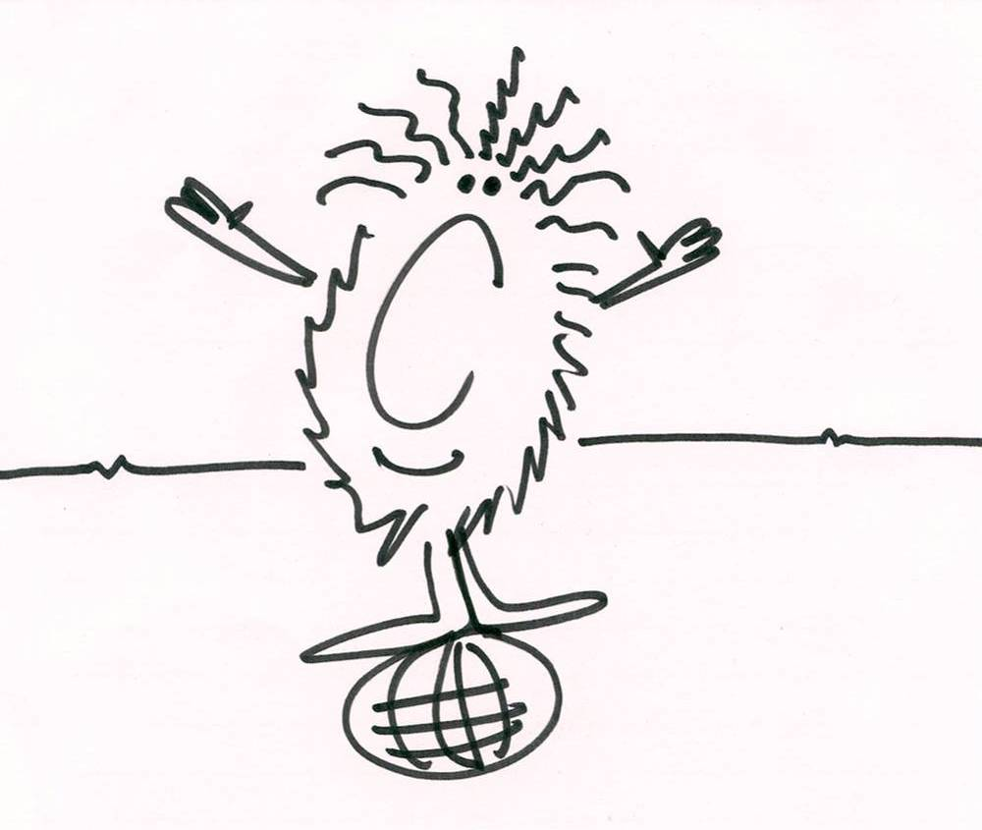

Name__________________________________

1. What do you currently believe GEOGRAPHY to be?

2. When people use the term ECONOMY what to they mean?

3. In the table below, identify some goods or services that are important in your life in the first column and describe how and where you obtain them in the second column. In the third column try to speculate on the number of people involved in making the good or service available to you.

Things important in your life | How/where you obtain them? | How many people are involved in providing this?

Do you know were your day-to-day resources come from?

Identify which parts of the world provide you with the day-to-day resources (good and services) you have cone to expect AND which resources come from with places.

