MONTEGO BAY COMMUNITY COLLEGE

ASSIGNMENT 1

PROGRAMMME: MIS II NAME: _________________________ DATE:Sept. 10, 2007

ANSWER ALL QUESTION

Multiple Choice
Identify the letter of the choice that best completes the statement or answers the question.

____ 1. _____ is/are the steps that tell the computer how to perform a particular task.
a. | Data | c. | Instructions
b. | Information | d. | Documentation

____ 2. A _____ is an input device that allows a user to speak into the computer to enter data and instructions.
a. | mouse | c. | microphone
b. | keyboard | d. | scanner

____ 3. The circuitry of the system unit usually is part of or is connected to a circuit board called the _____.
a. | fatherboard | c. | brotherboard
b. | motherboard | d. | sisterboard

____ 4. Storage holds _____ for future use.
a. | data | c. | information
b. | instructions | d. | all of the above

____ 5. A computing phrase — known as _____ — points out that the accuracy of a computer’s output depends on the accuracy of the input.
a. | what you see is what you get | c. | nothing ventured, nothing gained
b. | garbage in, garbage out | d. | better safe than sorry

____ 6. People around the world use the Internet to _____.
a. | communicate with and meet other people
b. | shop for goods and services
c. | access sources of information and leisure
d. | all of the above

____ 7. In _____, people can communicate with multiple users at the same time — much like a group discussion.
a. | e-mail | c. | a chat room
b. | instant messaging | d. | file transfer

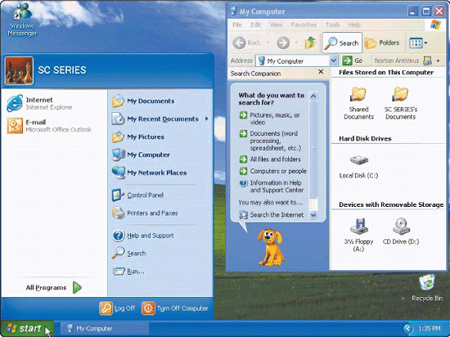

____ 8. Software today has a _____, like that shown in the accompanying figure.
a. | command-line interface | c. | menu-driven interface
b. | graphical user interface | d. | coded-row interface

____ 9. A(n) _____, such as those shown in the accompanying figure, is a small image that represents a program, an instruction, or some other object.
a. | menu | c. | icon
b. | command | d. | window

____ 10. A widely used type of application software related to communications is _____, which allows users with an Internet connection to access Web pages.
a. | a Web browser | c. | database software
b. | word processing software | d. | spreadsheet software

____ 11. _____ calculates numbers arranged in rows and columns and allows users to perform financial tasks.
a. | A Web browser | c. | Database software
b. | Word processing software | d. | Spreadsheet software

____ 12. A computer’s _____ determine the category it best fits.
a. | size and speed | c. | price
b. | processing power | d. | all of the above

____ 13. Two types of _____ are desktop computers and notebook computers.
a. | personal computers | c. | midrange servers
b. | mobile computers | d. | mainframes

____ 14. The more popular style of desktop computer system unit is the tall and narrow _____, which can sit on the floor vertically — if desktop space is limited.
a. | land | c. | oasis
b. | tower | d. | plane

____ 15. The most popular type of mobile computer is the _____.
a. | supercomputer | c. | notebook computer
b. | handheld computer | d. | desktop computer

____ 16. A(n) _____ is more powerful than a workstation, but less powerful than a mainframe.
a. | tower computer | c. | midrange server
b. | supercomputer | d. | Tablet PC

____ 17. With _____ software, a home user can play games such as solitaire, chess, and Monopoly; compose music; make a family tree; or create a greeting card.
a. | reference | c. | entertainment
b. | educational | d. | systems

____ 18. _____ include local law practices, accounting firms, travel agencies, and florists.
a. | Mobil users | c. | Large business users
b. | Small offices | d. | Power users

____ 19. Many small office/home office users (SOHO) are entering the _____ arena and conduct business on the Web.
a. | e-commerce | c. | e-transit
b. | multimedia | d. | multidimensional

____ 20. Many large businesses have _____ software, which allows the company to provide a personalized touch and customized service to its customers.
a. | computer-aided manufacturing (CAM)
b. | desktop publishing (DTP)
c. | customer relationship management (CRM)
d. | Web-based training (WBT)

____ 21. A recent study shows that the 20 largest cities in the United States receive _____ percent of Internet delivery.
a. | 26 | c. | 66
b. | 46 | d. | 86

____ 22. Microsoft and hardware partners such as Toshiba and IBM are part of the _____ that provides teachers and students with notebook computers ready with Microsoft applications and Internet access.
a. | Here and Now Learning program
b. | Anytime Anywhere Learning program
c. | Today and Tomorrow Learning program
d. | Wherever Whenever Learning program

____ 23. Through _____, health-care professionals in separate locations can have live conferences on the computer.
a. | teledoc | c. | telecare
b. | telemedicine | d. | teleremedy

____ 24. _____ are two of the more widely accessed Internet services.
a. | The World Wide Web and e-mail | c. | Mailing lists and chat rooms
b. | FTP and message boards | d. | Instant messaging and newsgroups

____ 25. Unlike higher-speed access, which is connected to the Internet the entire time the computer is running, with _____ a connection must be established to the Internet.
a. | DSL | c. | ISDN
b. | dial-up access | d. | a cable modem

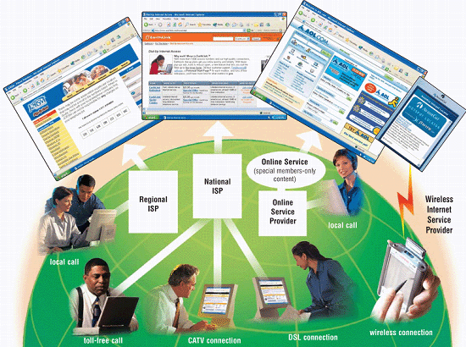

____ 26. In the accompanying figure showing common ways to access the Internet, a(n) _____ usually provides Internet access to a specific geographic area.
a. | wireless Internet service provider (WISP)
b. | online service provider (OSP)
c. | regional ISP
d. | national ISP

____ 27. In the accompanying figure showing common ways to access the Internet, a(n) _____ is a larger business, such as AT&T WorldNet and EarthLink, that provides Internet access in several major cities and towns.
a. | wireless Internet service provider (WISP)
b. | online service provider (OSP)
c. | regional ISP
d. | national ISP

____ 28. In the accompanying figure showing common ways to access the Internet, a(n) _____ has many members-only features, such as special content and services, in addition to providing Internet access.
a. | wireless Internet service provider (WISP)
b. | online service provider (OSP)
c. | regional ISP
d. | national ISP

____ 29. The major carriers of network traffic on the Internet are known collectively as the _____.
a. | Internet cartilage | c. | Internet backbone
b. | Internet nerve | d. | Internet artery

____ 30. _____ is the process of a computer receiving information, such as a Web page, from a server on the Internet.
a. | Streaming | c. | Flowing
b. | Downloading | d. | Uploading

____ 31. A wireless portal is a portal specifically designed for _____.
a. | desktop computers | c. | Web-enabled mobile devices
b. | mainframe computers | d. | supercomputers

____ 32. An educational Web site _____.
a. | contains content that promotes or sells products or services
b. | offers exciting, challenging avenues for formal and informal teaching and learning
c. | contains content that describes a cause, opinion, or idea
d. | is maintained by a private individual or family who normally is not associated with any organization

____ 33. An advocacy Web site _____.
a. | contains content that promotes or sells products or services
b. | offers exciting, challenging avenues for formal and informal teaching and learning
c. | contains content that describes a cause, opinion, or idea
d. | is maintained by a private individual or family who normally is not associated with any organization

____ 34. _____ enables users to listen to music as it downloads to their computers.
a. | Streaming audio | c. | Streaming video
b. | Flowing audio | d. | Flowing video

____ 35. The _____ defines a popular video compression standard.
a. | Moving Pictures Experts Group (MPEG)
b. | Advanced Research Projects Agency (ARPA)
c. | National Science Foundation (NSF)
d. | Digital Subscriber Line (DSL)

____ 36. _____ consists of the sale of goods and services by a company to the general public.
a. | Consumer-to-business (C2B) e-commerce
b. | Business-to-consumer (B2C) e-commerce
c. | Consumer-to-consumer (C2C) e-commerce
d. | Business-to-business (B2B) e-commerce

____ 37. _____ occurs when one consumer sells directly to another consumer, such as in an online auction.
a. | Consumer-to-business (C2B) e-commerce
b. | Business-to-consumer (B2C) e-commerce
c. | Consumer-to-consumer (C2C) e-commerce
d. | Business-to-business (B2B) e-commerce

____ 38. Today, _____ is a primary communications method for both personal and business users.
a. | e-commerce | c. | chat room
b. | FTP | d. | e-mail

____ 39. The entire collection of Internet newsgroups is called _____, which contains thousands of newsgroups on a multitude of topics.
a. | ARPANET | c. | Dragnet
b. | NSFnet | d. | Usenet

____ 40. In some newsgroups, a posted article is sent to a _____, who reviews the contents of the article and then posts it, if appropriate.
a. | message board | c. | news server
b. | newsreader | d. | moderator

____ 41. Some mailing lists are called _____, named after a popular mailing list software product.
a. | LISTSERVs | c. | ARPANETs
b. | MPEGs | d. | W3Cs

____ 42. For _____ to work, both parties must be online at the same time and the receiver of a message must be willing to accept messages.
a. | e-mail | c. | instant messaging
b. | FTP | d. | all of the above

____ 43. _____ is an unsolicited e-mail message or newsgroup posting sent to many recipients or newsgroups at once.
a. | An emoticon | c. | A flame
b. | Spam | d. | FAQ

____ 44. Use _____, such as :) or :( , to express emotion in an e-mail message or newsgroup posting.
a. | spam | c. | emoticons
b. | FAQs | d. | flames

____ 45. All of the following are rules of netiquette except _____.
a. | be polite and avoid offensive language
b. | keep messages brief and use proper grammar and spelling
c. | be careful when using sarcasm and humor
d. | use all capital letters

____ 46. Web page authoring software is software specifically designed to help users _____ Web pages.
a. | plan | c. | create
b. | deploy | d. | maintain

____ 47. _____ is free software, but it has been donated for public use and has no copyright restrictions.
a. | Shareware | c. | Freeware
b. | Public-domain software | d. | Packaged software

____ 48. The _____ is a small symbol displayed on the screen that moves as a user moves the mouse.
a. | menu | c. | icon
b. | button | d. | pointer

____ 49. A _____ is a list of commonly used commands for completing a task related to the current activity or selected item.
a. | command box | c. | dialog box
b. | shortcut menu | d. | submenu

____ 50. _____ includes programs such as word processing, spreadsheet, database, presentation graphics, personal information manager, PDA software, software suite, project management, and accounting.
a. | Business software
b. | Graphics and multimedia software
c. | Software for home, personal, and educational use
d. | Communications software

____ 51. A feature of word processing software called _____ allows users to type words in a paragraph continually without pressing the ENTER key at the end of each line.
a. | replace | c. | wordwrap
b. | search | d. | collaboration

____ 52. To cut involves removing a portion of a document and storing it in a temporary storage location, sometimes called a _____.
a. | dialog box | c. | template
b. | clipboard | d. | submenu

____ 53. When computer users _____ a document, they change its appearance.
a. | edit | c. | save
b. | create | d. | format

____ 54. A single point is about _____ of an inch in height.
a. | 1/9 | c. | 1/36
b. | 1/18 | d. | 1/72

____ 55. When computer users _____ a document, the computer sends a copy of the document to a medium such as paper.
a. | create | c. | format
b. | print | d. | edit

____ 56. When using spreadsheet software, each worksheet typically has _____.
a. | 56 columns and 536 rows | c. | 256 columns and 65,536 rows
b. | 536 columns and 56 rows | d. | 65,536 columns and 256 rows

____ 57. Using the _____ =SUM(B10:B14) totals the contents of cells B10 through B14 in a worksheet.
a. | label | c. | formula
b. | value | d. | function

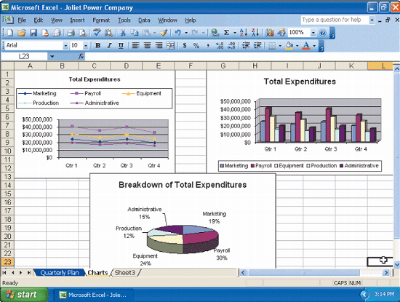

____ 58. The accompanying figure illustrates a spreadsheet feature called _____, which depicts data in graphical form.
a. | querying | c. | recalculating
b. | scrolling | d. | charting

____ 59. Most PDAs today include, among other features, _____ functionality.
a. | DTP | c. | CAD
b. | PIM | d. | WBT

____ 60. Two of the more commonly used _____ are Microsoft Office 2003 and Sun StarOffice.
a. | personal information managers | c. | clip art/image galleries
b. | software suites | d. | application service providers

____ 61. _____ is ideal for the production of high-quality color documents such as textbooks, corporate newsletters, marketing literature, product catalogs, and annual reports.
a. | Professional DTP software | c. | Professional CAD software
b. | Word processing software | d. | Web page authoring software

____ 62. The programs within a software suite (for personal use) use a _____.
a. | different interface and have completely different features
b. | different interface but share some common features
c. | similar interface but have completely different features
d. | similar interface and share some common features

____ 63. An e-mail program allows _____.
a. | real-time exchange of messages or files with another online user
b. | geographically separated people to transfer audio and video
c. | transmission of messages and files via a network such as the Internet
d. | users to access and view Web pages on the Internet

____ 64. _____ is the delivery of education at one location while the learning takes place at other locations.
a. | Extended training (ET) | c. | Remote teaching (RT)
b. | Faraway schooling (FS) | d. | Distance learning (DL)

____ 65. Web sites that offer Web-based help often have a(n) _____ list to help users find answers to common inquiries.
a. | DTP (directly transmitted problems) | c. | PDA (privately disclosed answers)
b. | FAQ (frequently asked questions) | d. | CAD (commonly admitted difficulties)

True/False
Indicate whether the sentence or statement is true or false.

____ 66. Storage devices often function as a source of input because they transfer items from storage into memory.

____ 67. Hardware is the key to productive use of computers.

____ 68. Most notebook computers can operate on batteries or a power supply or both.

____ 69. Most PDAs offer a variety of application software such as word processing, spreadsheet, personal finance, and games.

____ 70. Mainframes store only small amounts of data, instructions, and information.

____ 71. Applications requiring complex, sophisticated mathematical calculations use supercomputers.

____ 72. Home users type letters, homework assignments, and other documents with personal finance software.

____ 73. A network version of software usually costs more than purchasing a separate software package for each desktop or notebook computer.

____ 74. Employees that telecommute have rigid work schedules that prevent them from combining work and personal responsibilities.

____ 75. Many Web sites provide up-to-date medical, fitness, nutrition, or exercise information.

____ 76. Despite their larger size, national ISPs usually offer fewer services and have a smaller technical support staff than regional ISPs.

____ 77. The fees for using an OSP sometimes are slightly higher than fees for an ISP.

____ 78. Some Web servers can pull content from a user’s computer at regular intervals or whenever updates are made to the site.

____ 79. Many United States government agencies have informational Web sites providing information such as census data, tax codes, and the congressional budget.

____ 80. JPEG is a format that expands graphics to increase their file size, which means the file takes up less storage space.

____ 81. It is legal to download copyrighted music regardless of whether the song’s copyright holder has granted permission for users to download and play the song.

____ 82. In the past, e-commerce transactions were conducted primarily using mobile computers and devices.

____ 83. Many current word processing packages include Web page authoring features so users can create basic Web pages that contain text and graphics.

____ 84. The software on memory cards allows PDA users to create documents, take notes, manage budgets and finances, create slide shows, view and edit photographs, read electronic books, plan travel routes, and play games.

____ 85. Power users such as engineers, architects, desktop publishers, and graphic artists often use sophisticated software that allows them to work with graphics and multimedia.

____ 86. Some operating systems include audio editing and video editing capabilities.

____ 87. Most of the programs for home, personal, and educational use are relatively expensive, often priced more than one thousand dollars.

____ 88. Educational software exists for very few subjects.

____ 89. The drawback of the distance learning tools supplied by WBT companies is they generally are quite difficult to learn and use for both instructors and the students.

____ 90. Often, online Help is context-sensitive, meaning that the Help information relates to the current task being attempted.

Completion
Complete each sentence or statement.

91. _________________________ conveys meaning and is useful to one or more people.

92. Anyone can create a Web page and then make it available, or _________________________ it, on the Internet for others to see.

93. A(n) _________________________ is a freestanding computer, usually with a touch screen, that provides information or allows customers to place orders, make payments, and access the Web.

94. Each electronic document on the Web is called a(n) _________________________, which can contain text, graphics, audio (sound), and video.

95. A(n) _________________________ is a collection of related Web pages and associated items, such as documents and pictures, stored on a Web server.

96. A(n) _________________________ is a Web site that offers a variety of Internet services from a single, convenient location.

97. A(n) _________________________ is a request for specific data from a database.

98. _________________________ is software that allows users to draw pictures, shapes, and other graphical images with various on-screen tools such as a pen, brush, eyedropper, and paint bucket.

99. _________________________ is software that lets users modify audio clips and produce studio-quality sound tracks.

100. _________________________ is software that includes various simplified tools, tailored to meet the needs of the home and small business users, to draw pictures, shapes, and other images.

