- Data Communication Hardware

Front-End Processor
A front-end processor (FEP) is generally a computer or processing unit that produces and manipulates data before another computer or processor receives it. (A processor is generally a shortened name for a microprocessor or a central processing unit (CPU).) FEPs are so called because they go between the communications lines (that sometimes directly connect into the processor) and the processor itself. The front-end processor is sometimes synonymous with a communications controller (an intermediary device used in transferring communications to and from the host ("main") computer to which it is connected), though the latter is usually not as flexible in its functions as that of an FEP.
Front-end processors were invented to reduce routine teleprocessing functions on processors within mainframe computers. Later FEPs were designed to be inexpensive to install and maintain in order to reduce using the higher priced CPUs. Front-end processors were engineered to provide the common functions needed to attach terminals, printers and other devices to computer systems through communication lines. They typically attach to the computer through channel interfaces and communication circuits via Line Interface Cards. FEPs are usually used to relieve the processor of such routine tasks as transmitting, receiving, and encoding messages; assembling and disassembling groups of data ("packets"); detecting, correcting, and controlling errors, and managing the lines running to and from other devices.

Front end processor

From Wikipedia, the free encyclopedia
•
A front end processor (FEP), or a communications processor, is a small-sized computer which interfaces to the host computer a number of networks, such as SNA, or a number of peripheral devices, such as terminals, disk units, printers and tape units. Data is transferred between the host computer and the front end processor using a high-speed parallel interface. The front end processor communicates with peripheral devices using slower serial interfaces, usually also through communication networks. The purpose is to off-load from the host computer the work of managing the peripheral devices, transmiting and receiving messages, packet assembly and disassembly, error detection, and error correction. ^{[1]} Two examples are the IBM 3705 Communications Controller and the Burroughs Data Communications Processor.
Sometimes FEP is synonymous with a communications controller, although the latter is usually not as flexible.
Front end processor is also used in a more general sense in asymmetric multi-processor systems. The FEP is a processing device (usually a computer) which is closer to the input source than is the main processor. It performs some task such as telemetry control, data collection, reduction of raw sensor data, analysis of keyboard input, etc.

Digital Multiplexer:
A multiplexer or multiplexor is a device for combining several digital signals into an aggregate bit stream. Digital multiplexing may be implemented by interleaving bits, in rotation, from several digital bit streams either with or without the addition of extra framing, control, or error detection bits. A multiplexer or multiplexor is also reffered as a Multiplexor in some parts of the world, but the function of the multiplexer is the same.
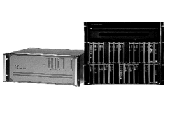
The multiplexer or multiplexor is required equipment when combining multiple data, voice, fax and LAN traffic to a public or private carrier. The multiplexer or multiplexor also provides compression and spoofing. The multiplexer or multiplexor can also provide signal regeneration or extension.
A communications device that multiplexes (combines) several signals for transmission over a single medium. A demultiplexor completes the process by separating multiplexed signals from a transmission line. Frequently a multiplexor and demultiplexor are combined into a single device capable of processing both outgoing and incoming signals.
A multiplexor is sometimes called a mux.
A type of multiplexor that combines multiple channels onto a single transmission medium in such a way that all the individual channels can be simultaneously active. For example, ISPs use concentrators to combine their dial-up modem connections onto faster T-1 lines that connect to the Internet.

Concentrator
In telecommunication, the term concentrator has the following meanings:
- In data transmission, a functional unit that permits a common path to handle more data sources than there are channels currently available within the path. A concentrator usually provides communication capability between many low-speed, usually asynchronous channels and one or more high-speed, usually synchronous channels. Usually different speeds, codes, and protocols can be accommodated on the low-speed side. The low-speed channels usually operate in contention and require buffering.
- A device that connects a number of circuits, which are not all used at once, to a smaller group of circuits for economy.
ISP usually use concentrators to enable modem dialing, this kind of concentrator is sometimes called a modem concentrator or a remote access concentrator.

Protocol converter
A Protocol Converter is a device used to convert standard or proprietary protocol of one device to the protocol suitable for the other device or master station to achieve the interoperability between the two. There are varieties of protocols used in different fields like Power Generation, Transmission & Distribution, Oil & Gas, Automaton, Utilities, AMR, Remote Monitoring applications etc. The major protocol translation messages involve conversion of data messages, events, commands, time synchronization etc.

[edit] General Architecture
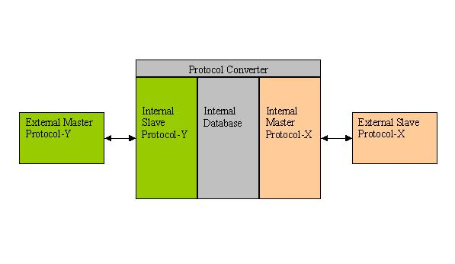
The general architecture of a protocol converter include an internal master protocol communicating to the external slave devices and the data collected is used to update the internal database of the converter. When the external master requests for data the internal slave collects the same from the database and send it to the external master. There will be different schemes for handling the spontaneous reporting of events and commands. There can be different physical medium for communication on protocol-X & Y which include RS232, RS485, Ethernet, etc.

