1- Project Background and Basic Idea:

Project Concept

The project strategy is to produce Tires model Radial designates that the tire for trucks and van.

The strategy is focusing on high-quality product on the selected export markets, and using the know how of foreign joint-venture partner

Company Profile:

Our current company is producing tires Radial model "1000/20" and "1200/24" with average weight is 54.78 and 79.91 , located at Amriya -Free Zone
It is planned to expand our factory to produce tires

Project Procedure:

The primary data will be collected from market surveys and focus groups
The secondary data will be collected from ATCO planning and budget department
The pre feasibility study began in march-2004
The promoter is an Egyptian Company called "VANTOM company”

2-Pre-Investment and Preparatory Investigation:

Pre-investment study includes: Determination of product and market, growth rate, expected market share, and input resources
Preparatory investigation includes: land and area survey, building materials, the right way and legal laws, and environmental requirements
The cost items are shown below

var.manufacturing cost
main raw materials |  | labour cost | other.prod,exp | total variable cost |  | other variable cost(sales)
348400000 |  | 14,100,000 | 32,000,000 | 394,500,000 |  | 7,100,000
manufacturing fixed cost

depreciation cost |  | labor cost | other exp | total fixed cost
43,500,000 |  | 7,200,000 | 9,100,000 | 59,800,000
other fixed cost

general&adminstration |  | sales | knowhow | total other fixed cost
9,500,000 |  | 4,100,000 | 14,500,000 | 28,100,000
 | finance charge |  | total cost(var+fix)&finance
 | 9,500,000 |  | 499,000,000

3-Market Analysis & Marketing Concept:

3.1. Analysis of Competitors

The tires industrial is at the end of maturity phase (the no. of competitors are two in Egypt ATCO (Pirelli) and TRENCO.

Other models in market is Bridgestone,Goodyear,MICHELIN

The unit price for1000/20 is 820 LE (local) and 780LE for export. The unit price for 1200/24is 1400 LE (local) and 1180LE for export
The total weight for 1000/20 is 1,095,532kg/year.
The total weight for 1200/24is 17,581,021kg/year.

3.2 Market Analysis

Our Marketing Policy concerned Low Price and good quality (Cost Leadership)
The customer analysis showed that:
There are no season for tires industrial.
Most of the end users complaint about price and life of the tires.
After market segmentation analysis, our customer analysis is in a public sector, original equipment, and 6 big distributors.
Capacity of market structure is 650,000 tire/year
Capacity of plants in year = 600,000 tire/year.
So the market share needs 50,000 tire /year.
We will start in 40,000 tire /year.

3.3 Marketing Mix
- Product: tires Radial model "1000/20"&"1200/24" -,
- policy concerned Low Price and Long life.
- Price: The unit price for1000/20 is 820 LE(local)and 780LE for export . The
unit price for 1200/24is 1400 LE(local)and 1180LE for export
- Place: at big and industrial cities , Export Sales = KSA & U.A. E
- Promotion: Egyptian promotion campaign.
- The marketing cost is projected as percentage from sales revenues both for local and foreign. See the next table and schedule III-2 in the attachments.
Production Center:
Code;

Market:
(Local &Export)

Currency: LE
Units: 1

Cost projection for year: 2004

Cost Item

Local costs

Foreign costs

Variable

Fixed

Variable

Fixed

Promotion
- Advertising
- Public relation
- Sales promotion
- Brand policy

place:
- Channel distribution
- Transport

0.01%

0.02 %
0.01 %

0.5 %
1 %

500,000
300,000

0.05 %
0.05%
.08%

300,000
200,000
200,000
100,000

4-Overhead Costs:
Cost item | Local cost |  | Foreign cost
Cost item | Variable | Fixed EL | Variable | Fixed
- Production cost center  - Service cost center  - Plant management  - Purchasing  - Stores  - Lighting  - Administration  - General admin.  - Training  - IT | 2.5% sales revenue  1% sales revenue  3 % “ “  4 % “  0.2% sales revenue  0.15 % “  0.2 % “ | 5,600 ,000  2,000,000  600,000  1,050,000  60,000  6,500,000  200,000  300,000 | 500,000  200,000 | 300,000  400,000

- The overhead costs are divided into three main categories, the factory overheads (wages and salaries not directly included in production, factory supplies, and utilities and maintenance), the service center overheads ( plant management, purchasing, stores, and lighting), and the administration overheads ( general, training, and infrastructure)

5- Estimated Demand

- As mentioned before, the secondary data had reflected the historical demand for the past 11 years.

years | period(x) | demand(y) | FORCAST |  | error analysis
1995 | 1 | 230000 |  |  | forecast | error | absolute | squared
1996 | 2 | 245000 |  |  | 214909.0909 | 15090.90909 | 15090.9091 | 2.28E+08
1997 | 3 | 250000 |  |  | 232151.5152 | 12848.48485 | 12848.4848 | 1.65E+08
1998 | 4 | 255000 |  |  | 249393.9394 | 606.0606061 | 606.060606 | 367309.5
1999 | 5 | 270000 |  |  | 266636.3636 | -11636.36364 | 11636.3636 | 1.35E+08
2000 | 6 | 280000 |  |  | 283878.7879 | -13878.78788 | 13878.7879 | 1.93E+08
2001 | 7 | 300000 |  |  | 301121.2121 | -21121.21212 | 21121.2121 | 4.46E+08
2002 | 8 | 350000 |  |  | 318363.6364 | -18363.63636 | 18363.6364 | 3.37E+08
2003 | 9 | 360000 |  |  | 335606.0606 | 14393.93939 | 14393.9394 | 2.07E+08
2004 | 10 | 385000 |  |  | 352848.4848 | 7151.515152 | 7151.51515 | 51144169
2005 | 11 |  | 387333.3 |  | 370090.9091 | 14909.09091 | 14909.0909 | 2.22E+08
 |  |  |  |  | total | 2.91038E-11 | 130000 | 1.99E+09
intercept | 197666.7 |  |  |  | avareg | 2.91038E-12 | 13000 | 1.99E+08
slope | 17242.42 |  |  |  | bias | MAD | MSE
FORCAST IN 2005 |  | 387333.3 |  |  |  | 13000 | 8.4703E-23

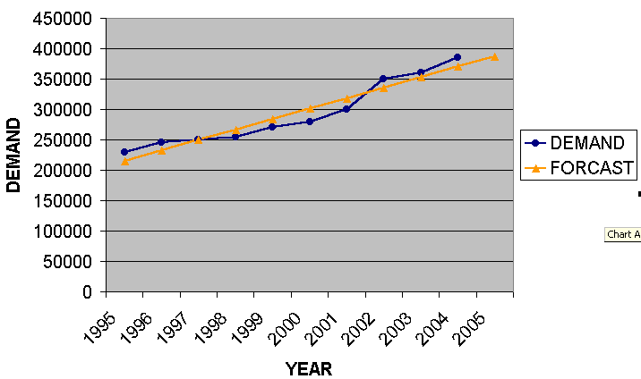

years | period(x) | demand(y) | FORCAST | Error analysis
1995 | 1 | 230000 |  | forecast | error | absolute | squared
1996 | 2 | 245000 |  | 214909.1 | 15090.90909 | 15090.90909 | 227735537
1997 | 3 | 250000 |  | 232151.5 | 12848.48485 | 12848.48485 | 165083563
1998 | 4 | 255000 |  | 249393.9 | 606.0606061 | 606.0606061 | 367309.458
1999 | 5 | 270000 |  | 266636.4 | -11636.36364 | 11636.36364 | 135404959
2000 | 6 | 280000 |  | 283878.8 | -13878.78788 | 13878.78788 | 192620753
2001 | 7 | 300000 |  | 301121.2 | -21121.21212 | 21121.21212 | 446105601
2002 | 8 | 350000 |  | 318363.6 | -18363.63636 | 18363.63636 | 337223140
2003 | 9 | 360000 |  | 335606.1 | 14393.93939 | 14393.93939 | 207185491
2004 | 10 | 385000 |  | 352848.5 | 7151.515152 | 7151.515152 | 51144169
2005 | 11 |  | 387333.3 | 370090.9 | 14909.09091 | 14909.09091 | 222280992
2006 | 12 |  | 404575.8 | total | 2.91038E-11 | 130000 | 1985151515
2007 | 13 |  | 421818.2 | avareg | 2.91038E-12 | 13000 | 198515152
2008 | 14 |  | 439060.6 | bias | MAD | MSE
 |  |  |  |  | 13000 | 8.47033E-23
intercept | 197666.7
slope | 17242.42
FORCAST IN 2006 |  | 404575.8
FORCAST IN 2007 |  | 421818.2
FORCAST IN 2008 |  | 439060.6

years | period(x) | demand(y) | FORCAST |  | Error analysis
1995 | 1 | 230000 |  |  | forecast | error | absolute | squared
1996 | 2 | 245000 |  |  | 214909.0909 | 15090.90909 | 15090.9091 | 2.28E+08
1997 | 3 | 250000 |  |  | 232151.5152 | 12848.48485 | 12848.4848 | 1.65E+08
1998 | 4 | 255000 |  |  | 249393.9394 | 606.0606061 | 606.060606 | 367309.5
1999 | 5 | 270000 |  |  | 266636.3636 | -11636.36364 | 11636.3636 | 1.35E+08
2000 | 6 | 280000 |  |  | 283878.7879 | -13878.78788 | 13878.7879 | 1.93E+08
2001 | 7 | 300000 |  |  | 301121.2121 | -21121.21212 | 21121.2121 | 4.46E+08
2002 | 8 | 350000 |  |  | 318363.6364 | -18363.63636 | 18363.6364 | 3.37E+08
2003 | 9 | 360000 |  |  | 335606.0606 | 14393.93939 | 14393.9394 | 2.07E+08
2004 | 10 | 385000 |  |  | 352848.4848 | 7151.515152 | 7151.51515 | 51144169
2005 | 11 |  | 387333.3 |  | 370090.9091 | 14909.09091 | 14909.0909 | 2.22E+08
2006 | 12 |  | 404575.8 |  | total | 2.91038E-11 | 130000 | 1.99E+09
2007 | 13 |  | 421818.2 |  | avareg | 2.91038E-12 | 13000 | 1.99E+08
2008 | 14 |  | 439060.6 |  | bias | MAD | MSE
2009 | 15 |  | 456303 |  |  | 13000 | 8.4703E-23
2010 | 16 |  | 473545.5
2011 | 17 |  | 490787.9
2012 | 18 |  | 508030.3
2013 | 19 |  | 525272.7
2014 | 20 |  | 542515.2
2015 | 21 |  | 559757.6

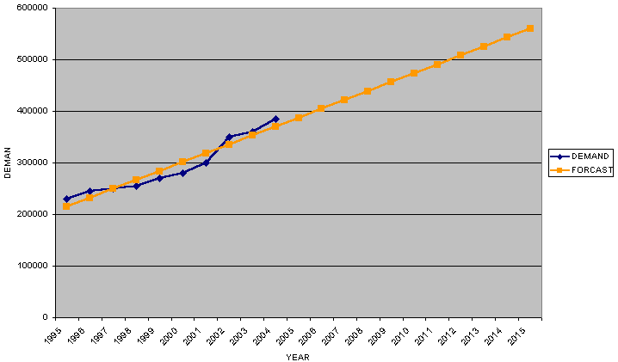

6- Bill of Materials, Operation and Process Charts (see

document no.1)

The next Figures show the bill of material

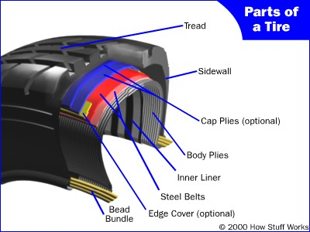

6-2 see production main equipments ---document no, 2
6-3 see production process flow diagram-----document no, 3
6-4 flow chart for tires industrial see document (4)

7. Raw Materials and Supplies

- As shown in the product analysis, most of the factory’s raw materials are rubbers. We have grouped the raw materials into 2 major group normal components & metal parts, as shown below.

Model 1000/20
Category | Cost / unit
Category | Quantity Consumed | Cost/unit | Total Cost /product
Raw Materials  - Natural rubbers kg  - Synthetic rubber kg  - Carbon black kg  - Ingrediens kg  Metal parts  - Bead wire kg  - Steal cord kg  SUPPLIES  - Electricity (kwt)  - Water M/T  - Steam M/T  - Spare parts  - Indirect cost | 15,200  2,900  8,100  4,900  2,500  6,500  50,500  200  86,200 | 8.5 LE  9.5LE  3.4LE  11LE  5  15  .18  1.5  29 | 129,200 LE  27,550  27,540  53,900  12,500  97,500  13,200  9,100  300  2,500  6,500  10,500

Model (1200/24)

Category | Cost / unit
Category | Quantity Consumed | Cost  /unit | Total Cost /product
Raw Materials  - Natural rubbers kg  - Synthetic rubber kg  - Carbon black kg  - Ingrediens kg  - Metal parts  - Bead wire kg  - Steal cord kg  - SUPPLIES  - Electricity (kwt)  - Water M/T  - Steam M/T  - Spare parts  - Indirect cost | 15,200  2,900  8,100  4,900  2,500  6,500  50,500  200  86,200 | 10  11.5  4  13  7  20  .2  1.9  33 | 152,000LE  333,50  32,400  63,700  17,500  130,000  10,100  380  2,844  12,000  12,000

8-location factors and importance.
Purchasing Taxes
The taxes of purchasing is very important to our project as most of our machines and production lines are imported from foreign countries , so it should be graded with a high score
HR Skills
The human resource skills should also has a high score , but since our plant is constructed in Egypt and this department is not well known and not obviously clear , so we can’t give it its true score

HR Housing
As the previous factor , very important in the top industrial countries in the world , but not well defined in our country.
Water quality
Our industry needs water in few stages for example the curing stage use need water and steam and some chemicals , the quality of the water is not very important .
Transportation & Communication Cost
Very important to us , we know that the cost of transportation can directly affect the profit the business ,so we should select the place with the least cost ever , but we know that in the new industrial areas like borg el arab and el amria and 6th of October ,there is already transportation services and it should be counted in my decision.
Availability of Area need
We need a large place for this factory so we should search out side the city for several reasons , medium score is fair for this factor.
Labors Costs
Very important to minimize the total cost of the project ,should be graded with a high score.

Near from Suppliers

Try to fulfill this request to minimize the time of production .

Near from Owners

We can ignore it .

Cost of Land

Actually it’s the magnet which will attract my location decision , should be graded with the highest score .

Factors Affecting Location Selection

Cost of compliance
Purchasing Taxes
HR Skills
HR Housing
Water quality
HR Availability
Trans.&Comm. Cost
Affect By Wastes
Building mat. Ava./Cost
Atmosphere
Availability of Area need
Labors Costs
Investment in export
Near from Suppliers
Near from Owners
Near from Competitors
Installation Availability
Cost of Land
Trans.&Comm. Availab.
Factors |  | Weight |  | Alexandria |  |  |  | Cairo
 |  |  | free zone(amria) | score | borg alarab | score | 10-ramadan | score | 06-Oct | score
Cost of compliance |  | 3 | 2 | 6 | 3 | 9 | 4 | 12 | 5 | 15
Purchasing Taxes |  | 7 | 5 | 35 | 7 | 49 | 5 | 35 | 6 | 42
HR Skills |  | 8 | 4 | 32 | 3 | 24 | 4 | 32 | 5 | 40
HR Housing |  | 6 | 5 | 30 | 4 | 24 | 5 | 30 | 7 | 42
Water quality |  | 3 | 2 | 6 | 5 | 15 | 8 | 24 | 8 | 24
HR Availability |  | 4 | 4 | 16 | 6 | 24 | 7 | 28 | 3 | 12
Trans.&Comm. Cost |  | 9 | 7 | 63 | 4 | 36 | 2 | 18 | 4 | 36
Affect By Wastes |  | 3 | 2 | 6 | 8 | 24 | 5 | 15 | 9 | 27
Building mat. Ava./Cost |  | 4 | 6 | 24 | 5 | 20 | 4 | 16 | 2 | 8
Atmosphere |  | 3 | 7 | 21 | 4 | 12 | 6 | 18 | 8 | 24
Availability of Area need |  | 8 | 5 | 40 | 8 | 64 | 5 | 40 | 5 | 40
Labors Costs |  | 6 | 5 | 30 | 2 | 12 | 3 | 18 | 6 | 36
Investment in export |  | 6 | 7 | 42 | 3 | 18 | 4 | 24 | 4 | 24
Near from Suppliers |  | 7 | 8 | 56 | 2 | 14 | 2 | 14 | 7 | 49
Near from Owners |  | 6 | 7 | 42 | 8 | 48 | 5 | 30 | 5 | 30
Near from Competitors |  | 4 | 6 | 24 | 3 | 12 | 6 | 24 | 6 | 24
Installation Availability |  | 6 | 4 | 24 | 7 | 42 | 3 | 18 | 3 | 18
Cost of Land |  | 9 | 5 | 45 | 7 | 63 | 4 | 36 | 4 | 36
Trans.&Comm. Availab. |  | 8 | 9 | 72 | 4 | 32 | 7 | 56 | 8 | 64
Sum |  | 110 |  | 614 |  | 542 |  | 488 |  | 591

Due to the result and high score we select freezone in alexandria

From Schedule, we could conclude that the Free Zone in El-Amriya in the best location among the 4 recommended locations with total score of 614 compared to 542,488 and 591 for Borg Elarab and 10th Ramadan 6th october cities respectively.

7- Engineering and Technology

- According to forecasting result until 2015 , we assumed the capacity of plant as shown per year.

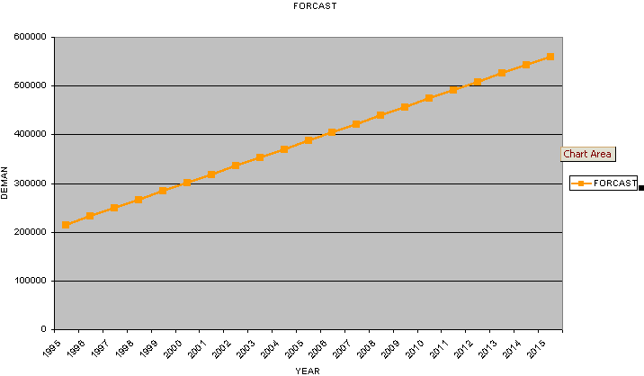

7-1 Technology Choice and Acquisition

The technology required to produce the tires will know from Pirelli Company .

Documentation in the form of manufacturing drawings
The technology will be covered by registered trade marks and trade name
Technology will be acquired by licensing. Determination and selection of required plant machinery and equipment and the know-how’s are embodied in our technology’s choice
- Lump-sum payments for patents and trade marks, for special rights and concessions and for unpatented know-how are capitalized.
- Royalty payments are included in production costs

7.2 Technology Costs:

- the cost of licensing technology including all technical aids and know-how’s and the cost of annual training for workers and The royalty payments shown in Estimate of Technology Costs file
. 7.3 Machinery and Equipment
- Assume that the life time for machines = 12years
- We assumed also; that the spare parts and tool life = 3 and 4 years respectively.
- Some of the machines will be imported, and the rest of the spare parts and machines will be purchased from the local market..
- Schedule “D” in the attachment shows he cost projection of machines and equipment.
- Schedule “E” in the attachment shows the detailed factory layout

8- Organization and Human Resources

The factory organization chart in schedule “F”

Determination of the Available Days/Year
Assume that the year = 365 days
- Then, the available days = 365 days (365/7= 52 weeks) – Fridays = 313 days
- Religious + National Holidays = 13 days
- Holidays = 18 days
- Sickness = 20 days
- Training = 9 days
- Then, the total non working time = 60 days
- Total working days = 313 – 60 = 253 days
Then, the extra payment = 60/253 = 23.7 %

9- Project Implementation: Planning and Budgeting

The scheduled planning for project implementation is shown in document F

