Thousand words
Learns poetry and verse

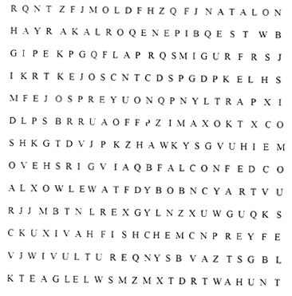




Damian Lee
Ms. Yamamoto
Soph Eng 1st
3/28/04

Table of Content

Page number Assignment Title

1 narrative poem A midnight walk till morning
2 lyric poem Love affair
3 choice poem The dragon
1. personification
2. alliteration
3. assonance

4 rhyming poem Reflection
5 free verse When people meet words

6 Respected Poet’s Poem “Manege de la Villette”
By Jesse Lee Kercheval
7 Poetry analysis

8 Works cited

A midnight walk till morning


One day at night,
No possibility of sight,
Wandering like a beggar where,
None but loneliness awaits there.

Shocked by the quiet silence,
Mute with the lack of sense;
Running around in search of food,
But only trashcans change my mood.

Walking down the long road;
Jumping to home like a toad.
Just to meet a detestable slap
Across my face, sounding like a clap.

Disturbed by the heavy weather;
Scratching my nose because of a feather.
Already my cheek itching,
Woke up hearing birds singing.

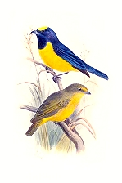



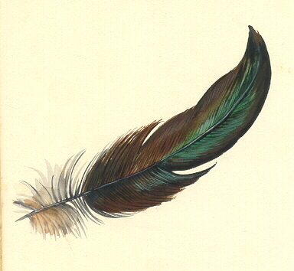

Love affair




Would somebody be able to catch love
With just bare hand?
Or is love as hot as a stove?

Love can be as cold as ice
Small like a tiny mouse and
Soft like everyday meal, rice.

Does love have to be aggressive like love of fire?
Can love be calming or is it a dangerous calamity,
Able to destroy the most peaceful shire?

IF love is reached, how would it feel like?
Hot, cold, small, huge, poisonous, felicity;
I wonder how love is like.


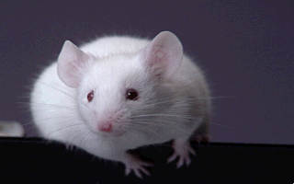
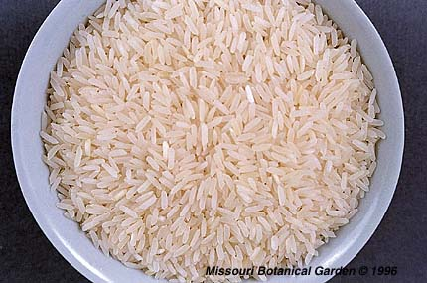

The dragon

A dragon is a mythical animal,
That its body dances just
Like a snake moves or crawl.

It is furious, forceful, fast, and famous.
It can be a very malicious creature,
One who hides its fangs, ready to strike at any moment.

A dragon can be a tricky and dangerous creature.
One that runs in amok causing havoc
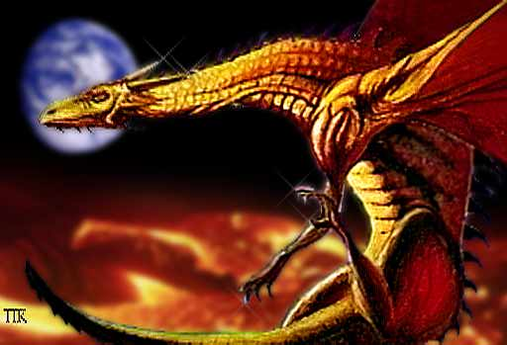
Or shows mercy, just to strike back later.

Reflection

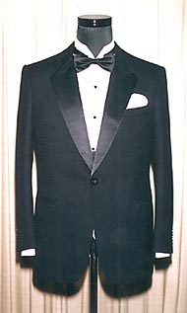
There’s sharp look,
Thirty minutes took,
Clean and handsome,
Tan lacking some.

Not strong brawn,
Looking at dawn;
Must exercise more,
To look hardcore.

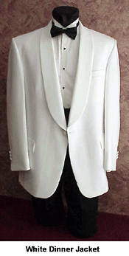

Bad choice of cloth,
Might attract a moth.
Shall change clothes soon
Or have runaway moon

Black, white, which color?
Strong, weak, tasty odor?
Up and down
Good looks own

When people meet words

When people meet words
Man fight with words
Woman expresses their love through words
Words are for bad and good use

When words meet people
Curses drive men to war
Wonderful words fill women’s beauty
People befits themselves with words

