Tax Calculating Web Service

----For Securities Gains and Losses



Author: Zahn, Jean

2004

Problem Description

This is an application system of web service for calculating the securities gains and losses according to the related tax rules from IRS.
Each year, many American people will struggle for filling the Tax Return form out. When concerning the part of Capital gain or (loss), it always make people headache because of complicacy. This service will help to fill Schedule D (Form 1040) out. These rules include:

- Terms:
Schedule D has two parts for capital gains and losses: short term and long term. For short-term capital gains and losses, the holding period is 1 year or less. For long-term capital gains and losses, include those the holding period is more than 1 year and those are acquired by inheritance. (We will ignore about the inheriting capital in this project.)

- Data items:
To calculate the result, we need:
Description of property

Date acquired
Start price
Date sold
End price
These information can be got from the securities companies which the users engage their stock trading. (Refer from diagram below:)

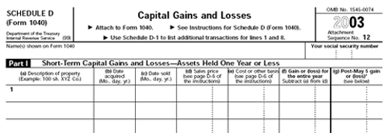

- Specific instructions:
  - For column (a), stock ticker symbols or abbreviations can be used to describe the property.
  - For column (b), enter in the date the stock was acquired (the trade date). If a block of stock acquired through several different purchases was sold, it must be reported on one line and enter “VARIOUS”. And then still report the short-term gain or (loss) on the sale in Part I and report the long-term gain or (loss) in Part II.
  - For column (c), enter in the date the stock was sold (the trade date).
  - For column (d), enter in the amount of the gross sales price or the net amount that gross proceeds minus commissions and option premiums.
  - For column (e), enter in the amount cost of the stock plus purchase commissions and improvements minus depreciation, amortization and depletion. If the commissions and option premiums have been subtracted in column (d), then don’t report them again. There is exception for “wash sale”.
  - For column (f), for each entry subtract the amount in column (e) from the amount in column (d) and enter negative amounts in parentheses.
  - For column (g), enter in all gains and losses that are reported in column (f) from sales, exchanges, or conversions after May 5, 2003 (for the different tax rate).
  - Enter on line 7a, column (g), and the post-May 5 short-term loss. If the total of lines 1 through 5 in column (g) is a gain, enter zero.

4. “Wash Sale”:
A wash sale occurs when customers sell stock or securities at a loss and, within 30 days before or after the sale, customer buys substantially identical stock or securities. Report a wash sale transaction on line 1 or 8. Enter the full amount of the (loss) in column (f). Also report this amount incolumn (g) if the transaction occurred after May 5, 2003. Directly below the line, on which the loss was reported, enter “Wash Sale” in column (a), and enter as a positive amount in column (f) (and column (g) for transactions after May 5 2003) the amount of the loss not allowed.

Users can log onto this web service to get the up-to-date data. If the user wants, he (or she) can get the print version of the data similar to the form of Schedule D.
Administrators can log onto the web application to maintain data of the system remotely or locally.

Analysis

First of all, we need the data from Securities Company. We can set up connections with different securities companies. We ask for data transfer from them and then calculate the data, get the result and send to our customers.

- Get the data from Securities Company
Since different Securities Companies could be on different servers and different platforms, we consider realizing this part of function by using XML Web Services that provide a way for unrelated platform, operating systems, and programming languages to exchange information in harmony.
We can create Web Service on corresponding server for each of the Securities Companies.
To make this more flexible, we can transfer the data into the format we need through a stored procedure.

- Make the main application
We will consider of two types of customers in our application system. One is kind of individual, another is kind of broker.
For individual customer, we will offer the function of calculating the gains and losses, and function to update his (her) own information. And also, after calculate the result, customer can choose to print out the result.
For broker customer, he (she) could have more than one his (her) own customers. In this case, we need to help him (her) get all the customers’ information. So we will offer the function of modifying his (her) own information, function of calculating his (her) customers’ gains and losses, and function of printing out the result, etc.
At this part, we should also have our engine for calculating. To make things more flexible, we choose stored procedure to realize this engine.

- Web administration
In this part, we have some functions to maintain our system’s information, such as administrator’s information, Securities Companies information, customers’ information and the calculating engine (the stored procedure) that may have some small differences in every single year.

Modeling

This system can be realized as a three-tired architecture application. (3 subsystems) The context picture can be show as below:

Data Source Tier
DBMS

Applications Service Tier
Securities Company

Trading Data

Capital Gains and Losses Calculating system

IRS Rules

……
Securities Company

Trading Data

Client Tier:
Output
User Interface

This three-tiered approach enables to separate the business logic from the processing logic. This modularity allows business changes to be more rapidly incorporated into applications. New software modules and program objects can be written to work with existing databases or data sources, taking advantage of the resident programming logic rather than requiring an entirely new application to be written.
To realize this three-tiered system, we can module the whole system into 3 function blocks.

Web Administration
(Web Application)

Main
(Web Application)
Remote date transfer (Web Service)

- Main application:
  - Customer register
Each customer must have unique customer identification in this system. We need the information about a customer including customer’s name, identification, password to login, email address to contact him (her), the securities company he (she) enrolls in and the account number to be used to fetch his (her) trade data, his (her) credit card number to charge the money for service and etc.
Flow chart is as below:
Customer’s information

No
Valid?

Yes
Submit

Customer ID
Exist?

Yes No

Write into database

  - Customer login
Verify the customer’s id and password. First, check if the id belongs to individual ids, if not, second check if it’s a broker’s id.
The flow chart:
Input customer id and password

Individual customer?
Yes

No
Enter into sevice
for individual customer

Broker customer?
Yse

Enter into service
No for broker customer

Show error message for invalid customer id

  - Modify information
Customer may change his (her) securities company or account number, or his (her) credit card is expired, or he (she) wants to change his (her) password, etc. This function will offer to update these kinds of information about a customer.
  - Calculate gains and losses and print out
Customer will send the command to calculate gains and losses for the year he (she) chooses and print out.
In this part, there are three steps. First, call the remote web service to transfer the data we need to local. Second, call the rule engine to calculate the result. Third, put the result onto crystal report and show out. As below:
…

Customer requet
Call remote web service to transfer data

Call rule engine to calculate the taxes according to the year customer input

Put the result data onto crystal report

In the second step, I fulfill the rule engine through stored procedure. The flow chart below descripts the process:

Get all sell records for the specific year into a sell cursor

…
The record is this year’s record

No

Yes

Insert this record into temp result table
Delete this record

Get all buy records for the specific stock into a buy cursor

Difference of the date between buy date and sell date

>365

Long term

<=365
Short term

Sell and buy records are matched

Need more buy amount to match

Matched (two situations)
Judge the aquired date is various or not,
Calculate cost
Calculate balance
If balance <0, judge if there exist wash sale, if there does exist, record the wash sale and update the basis of the buy record.
If the matched buy record has some balance left, update the balance for next match.
Count the total

Fetch next sell record

No
End of sell cursor

Yes
…

- Remote date transfer
  - Transfer the data into the format that the main application can use to calculate.
The data format is similar to the table Trade. For the purpose of calculatin wash sale, the data include all the sell records between the beginning of December of the year before the specific year and the end of December of the specific year, all the corresponding buy records before the end of January of the next year of the specific year.
This process is realized by a stored procedure.
The remote web service will send the data to main application. In main application we create a class corresponding the web service.

- Web administration
  - Add, delete, modify information of administrator of this system
  - Modify the information about this system, such as securities companies list, etc
I use a customer control to realize the menu of this application. The details will be descripted in the part of implement.

Class And Database

- Classes (Components and Classes):
As a web application, the principal classes are web forms. Besides, we need some components used to contact databases, we need class to communicate with remote web service, and we also need class that realizes calculation.
- Web forms for registration
In the registration forms, there are some validators to verify the items’ validation.
- Login form
- Calculating form
The calculating report will be shown on this form. To make the report shown on a crystal report, we need a crystal report component.
- Crystal report component
- Modify information forms
One kind of form is for customers, including individual and broker, to modify information. Another kind of form is for broker to modify the information of his (her) own customers.
- Client class used to communicate with remote web service
- Calculator class for calculating
- Classes used as interfaces between databases and forms
- Web service class
- Web form for administration

- Databases:
In this system, the main database will include customers’ information, history-trading records, gains and losses for each customer, and the information of the securities companies, etc. So there are one database includes tables as below:
- Trade:
InnerID (an id used inside system) int(4)
Account (account in securities company) varchar (12)
TradeDate smalldatetime(4)
Description (sell of buy) char(1)
Symbol (stock name) varchar(4)
Quantity int(4)
Price decimal(6,3)
Change decimal(6,3)

- GainsLosses: (each field is similar to the item on Schedule-D form)
InnerID int(4)
Account varchar(12)
Term (short term or long term) char(1)
Description varchar(30)
AcquiredDate varchar(20)

SoldDate varchar(10)
Price decimal(12,2)

Cost decimal(12,2)
Balance decimal(12,2)
Special decimal(12,2)

- Individual:
InnerID int(4)
CustID varchar(10)
FullName varchar(30)
Password varchar(10)
Email varchar(30)
PwdQuestion varchar(50)
PwdAnswer varchar(30)
CreditCard varchar(16)
CreditSec char(3)
CreditExpDate char(5)
SecComName varchar(30)
SecAccount varchar(12)

- Broker:
InnerID int(4)
CustID varchar(10)
FullName varchar(30)
Password varchar(10)
Email varchar(30)
Address varchar(30)
AddrCity varchar(30)
AddrState char(2)
AddrZip char(5)
PwdQuestion varchar(50)
PwdAnswer varchar(30)
CreditCard varchar(16)
CreditSec char(3)
CreditExpDate char(5)
SecComName varchar(30)

- SecCom (Securities Company):

ID int(4)
Name varchar(30)

- Administrator:
UserID varchar(10)
Password varchar(10)
FullName varchar(30)

- BrokerCustomer:
InnerID int(4)
CustName varchar(30)
Account varchar(12)

- State:
ID (the count number) char(2)
FullName varchar(20)
SimpleName char(2)

- PasswordQuetion:
QuestionID char(2)
Question varchar(30)

In this system, we simulate we have some customers who enroll in a securities company. We simulate we will get the trade data from that remote server. So we create another database that includes the trade data. The only table we need is:
- Trade:

Account varchar(12)

TradeDate smalldatetime(4)

Description char(1)

Symbol varchar(4)

Quantity int(4)

Price decimal(6,3)

Change decimal(12,2)

Screen Shoots:
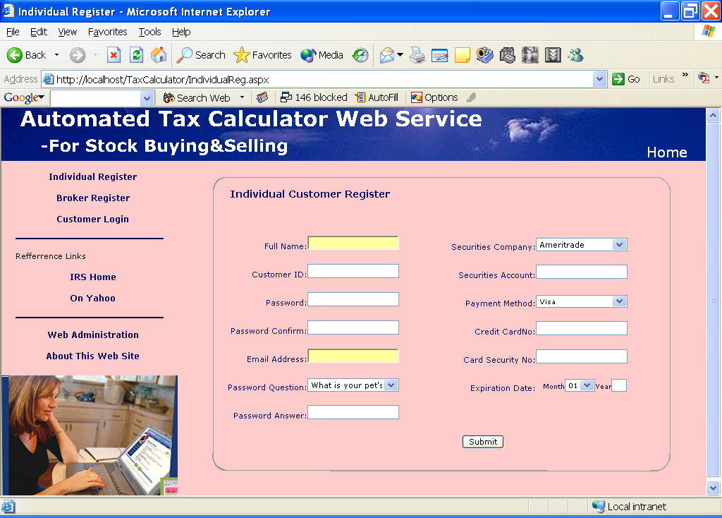

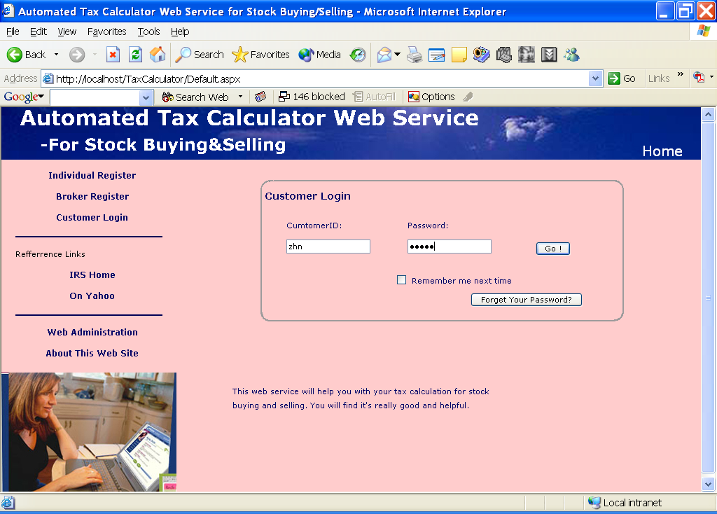

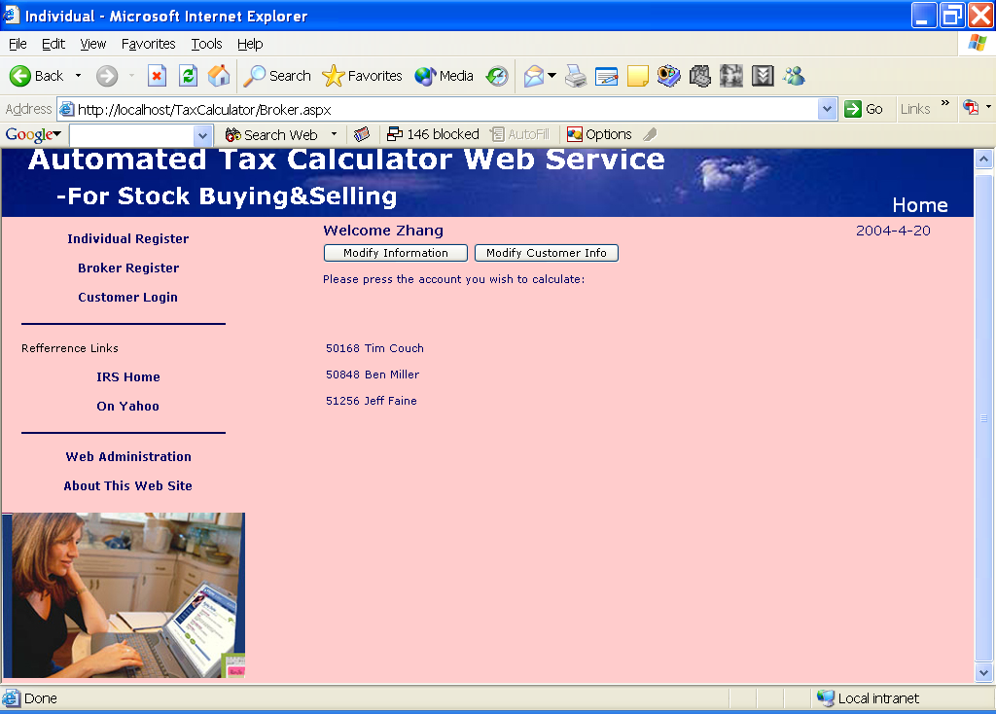

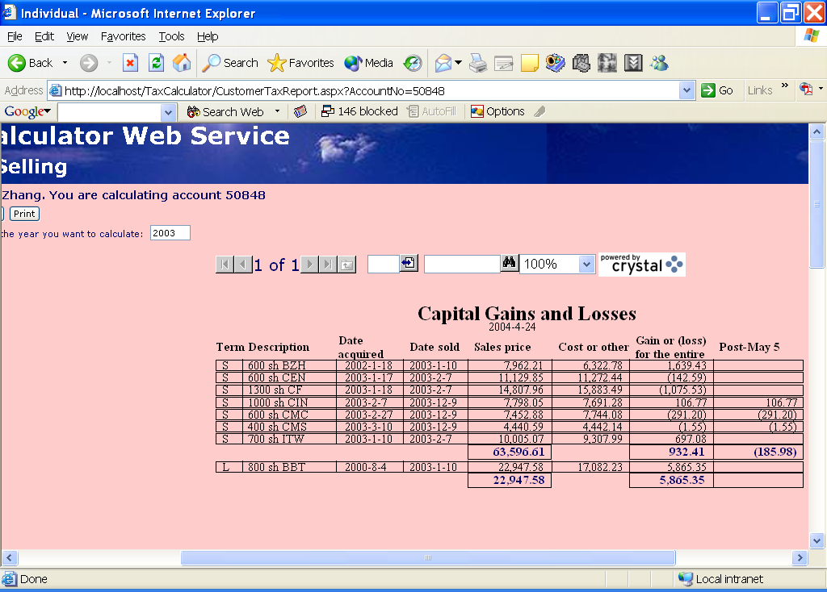

Implement

This system is base on SQL Server, MS IIS, using ASP.Net (C# as the back language) programming language and other techniques.
- User controls
To make a uniform sense to customer, I create 2 user controls. One is the header for forms; another one is the menu for forms.
Header:
<%@ Control Language="c#" AutoEventWireup="false" Codebehind="uc_Header.ascx.cs" Inherits="TaxCalculator.uc_Hearder" TargetSchema="http://schemas.microsoft.com/intellisense/ie5"%>
<%--

This user control forms the header for each page.

--%>
<table cellSpacing="0" cellPadding="0" width="100%" border="0">
<tr>
<td background="images/hd_bkgrd1.jpg">
<table cellSpacing="0" cellPadding="0" width="100%" border="0">
<tr>
<td vAlign="bottom" colSpan="2"><IMG src="images\Header.gif">
</td>
<td vAlign="bottom" noWrap align="middle">
<asp:HyperLink Font-Name="Verdana" Font-Size="12pt" ForeColor="#ffffff" ID="headlink" NavigateUrl="Default.aspx" Runat="server">&nbsp; Home &nbsp;</asp:HyperLink>
</td>
</tr>
</table>
</td>
</tr>
</table>

Menu:
<%@ Control Language="c#" AutoEventWireup="false" Codebehind="uc_Menu.ascx.cs" Inherits="TaxCalculator.uc_Menu" TargetSchema="http://schemas.microsoft.com/intellisense/ie5"%>
<%--

This user control creates a menu forming the left-hand navigation of the pages.

--%>
<table cellspacing="0" cellpadding="0" width="250" border="0">
<tr height="10">
<td></td>
<tr valign="top" height="30">
<td align="middle">
<asp:HyperLink cssclass="Menu" id="HyperLink1" Text='Individual Register' NavigateUrl='IndividualReg.aspx' runat="server" />
</td>
</tr>
<tr valign="top" height="30">
<td align="middle">
<asp:HyperLink cssclass="Menu" id="Hyperlink2" Text='Broker Register' NavigateUrl='BrokerReg.aspx' runat="server" />
</td>
</tr>
<tr valign="top" height="30">
<td align="middle">
<asp:HyperLink cssclass="Menu" id="Hyperlink3" Text='Customer Login' NavigateUrl='Default.aspx' runat="server" />
</td>
</tr>
<tr valign="top">
<td align="middle">
<img src="images/line.gif" border="0"></A>
</td>
</tr>
<tr valign="top" height="30">
<td>
<asp:Label CssClass="NormalControl" ForeColor="black" text="&nbsp;&nbsp;&nbsp;&nbsp;&nbsp;Refferrence Links" Runat="server" id="Label1" />
</td>
</tr>
<tr valign="top" height="30">
<td align="middle">
<asp:HyperLink cssclass="Menu" id="Hyperlink4" Text='IRS Home' NavigateUrl='http://www.irs.gov' Target="_blank" runat="server" />
</td>
</tr>
<tr valign="top" height="30">
<td align="middle">
<asp:HyperLink cssclass="Menu" id="Hyperlink5" Text='On Yahoo' NavigateUrl='http://tax.yahoo.com' Target="_blank" runat="server" />
</td>
</tr>
<tr valign="top">
<td align="middle">
<img src="images/line.gif" border="0"></A>
</td>
</tr>
<tr valign="top" height="30">
<td align="middle">
<asp:HyperLink cssclass="Menu" id="Hyperlink7" Text='Web Administration' NavigateUrl='http://localhost/TaxWebAdministration/Default.aspx' Target="_blank" runat="server" />
</td>
</tr>
<tr valign="top" height="30">
<td align="middle">
<asp:HyperLink cssclass="Menu" id="Hyperlink6" Text='About This Web Site' NavigateUrl='about.aspx' Target="_blank" runat="server" />
</td>
</tr>
<tr height="10">
<td></td>
<tr valign="top">
<td>
<img src="images/pic1.jpg" border="0">
</td>
</tr>
</table>

- Crystal Report
I embed a crystal report to show the result of the calculating. This is realized by embedding a crystal report viewer in the form, then make crystal report to be the data source of the viewer, and bind the data (in this application, I use a dataset to store data) to the crystal report.

protected CrystalDecisions.Web.CrystalReportViewer TaxReportCRV;

private void btnCalculate_Click(object sender, System.EventArgs e)
{
taxreport = new TaxReportCR();

TradeDataService tradeDataWS = new TradeDataService();
DataSet ds = tradeDataWS.GetData(Request.Cookies["Account"].Value,Convert.ToInt32(txtYear.Text));
Calculator calculator = new Calculator();

TaxReportDataSet resultDs = calculator.Calculate(ds, Convert.ToInt32(Request.Cookies["InnerId"].Value), Request.Cookies["Account"].Value,Convert.ToInt32(txtYear.Text));

taxreport.SetDataSource(resultDs);

TaxReportCRV.Visible = true;
TaxReportCRV.ReportSource = taxreport;

}

DataSet for the report:

<xs:element name="GainsLosses" xmlns:xs="http://www.w3.org/2001/XMLSchema">
<xs:complexType>
<xs:sequence>
<xs:element name="InnerID" type="xs:int" />
<xs:element name="Term" type="xs:string" minOccurs="0" />
<xs:element name="Description" type="xs:string" />
<xs:element name="AcquiredDate" type="xs:string" minOccurs="0" />
<xs:element name="SoldDate" type="xs:string" minOccurs="0" />
<xs:element name="Price" type="xs:decimal" minOccurs="0" />
<xs:element name="Cost" type="xs:decimal" minOccurs="0" />
<xs:element name="Balance" type="xs:decimal" />
<xs:element name="Special" type="xs:decimal" minOccurs="0" />
</xs:sequence>
</xs:complexType>
</xs:element>

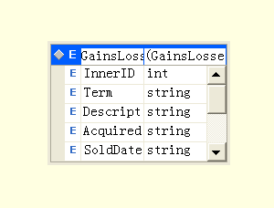
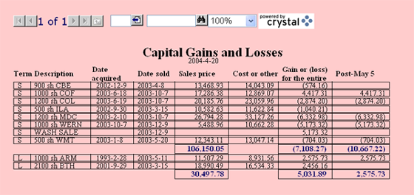

- Repeater
Repeater is used in broker’s form. Since a broker may have more than one customers of his (her) own, to show all the customers, the flexible way to so this is using a repeater and put an item template in it. The items are related to database.
<asp:Repeater ID="rptCustomerList" Runat="server">
<ItemTemplate>
<tr>
<td width="400" colspan="2">
<asp:HyperLink NavigateUrl='<%# "CustomerTaxReport.aspx?AccountNo=" + DataBinder.Eval(Container.DataItem, "Account")%>' Height=20 CssClass=NormalControl Text='<%#DataBinder.Eval(Container.DataItem, "Account")%>' runat="server"/>
<asp:HyperLink NavigateUrl='<%# "CustomerTaxReport.aspx?AccountNo=" + DataBinder.Eval(Container.DataItem, "Account")%>' Height=20 CssClass=NormalControl Text='<%#DataBinder.Eval(Container.DataItem, "CustName")%>' runat="server" ID="Hyperlink1"/>
</td>
</tr>
</ItemTemplate>
</asp:Repeater>

- Calculator
Calculator is a class that calculates gains and losses according to the source data.

using System;
using System.Data;
using System.Data.SqlClient;
using System.Web;
using System.Web.SessionState;
using System.Collections;
using System.Configuration;

namespace TaxCalculator
{
/// <summary>
/// Summary description for Calculator.
/// </summary>
public class Calculator
{
public Calculator()
{
//
// TODO: Add constructor logic here
//
}

public TaxReportDataSet Calculate(DataSet ds, int innerid, string account, int year)
{
SqlConnection calConnection = new SqlConnection(ConfigurationSettings.AppSettings["connectionString"]);
//SqlDataAdapter calAdapter =new SqlDataAdapter();
calConnection.Open();
SqlCommand Cmd = new SqlCommand("Delete from Trade where InnerId=@innerid And Account=@account", calConnection);

SqlParameter prmInnerId1 = new SqlParameter("@innerid", SqlDbType.Int, 4);
prmInnerId1.Value = innerid;
Cmd.Parameters.Add(prmInnerId1);

SqlParameter prmAccount1 = new SqlParameter("@account", SqlDbType.NVarChar, 12);
prmAccount1.Value = account;
Cmd.Parameters.Add(prmAccount1);

Cmd.ExecuteNonQuery();

Cmd = new SqlCommand("INSERT INTO Trade (InnerID, Account, TradeDate, Description, Symbol, Quantity, "+
"Price, Change) VALUES (@InnerId, @Account, @TradeDate, @Description, @Symbol, @Quantity, @Price, @Change)", calConnection);

//SqlParameter prmAccount = new SqlParameter("@Account", SqlDbType.NVarChar, 12);
//Cmd.Parameters.Add(prmAccount);

SqlParameter prmInnerId2 = new SqlParameter("@InnerId", SqlDbType.Int, 4);
prmInnerId2.Value = innerid;
Cmd.Parameters.Add(prmInnerId2);

SqlParameter prmAccount2 = new SqlParameter("@Account", SqlDbType.NVarChar, 12);
prmAccount2.Value = account;
Cmd.Parameters.Add(prmAccount2);

SqlParameter prmTradeDate = new SqlParameter("@TradeDate", SqlDbType.SmallDateTime, 4);
Cmd.Parameters.Add(prmTradeDate);

SqlParameter prmDescription = new SqlParameter("@Description", SqlDbType.NChar, 1);
Cmd.Parameters.Add(prmDescription);

SqlParameter prmSymbol = new SqlParameter("@Symbol", SqlDbType.NVarChar, 4);
Cmd.Parameters.Add(prmSymbol);

SqlParameter prmQuantity = new SqlParameter("@Quantity", SqlDbType.Int, 4);
Cmd.Parameters.Add(prmQuantity);

SqlParameter prmPrice = new SqlParameter("@Price", SqlDbType.Decimal, 5);
Cmd.Parameters.Add(prmPrice);

SqlParameter prmChange = new SqlParameter("@Change", SqlDbType.Decimal, 9);
Cmd.Parameters.Add(prmChange);

foreach (DataRow dr in ds.Tables[0].Rows)
{
// prmAccount.Value = dr["Account"];
prmTradeDate.Value = dr["TradeDate"];
prmDescription.Value = dr["Description"];
prmSymbol.Value = dr["Symbol"];
prmPrice.Value = dr["Price"];
prmQuantity.Value = dr["Quantity"];
prmChange.Value = dr["Change"];

Cmd.ExecuteNonQuery();
}

// Start to Calculate
Cmd = new SqlCommand("Calculator", calConnection);

Cmd.CommandType = CommandType.StoredProcedure;

// Add Parameters to SPROC
SqlParameter prmYear = new SqlParameter("@Year", SqlDbType.Int, 4);
prmYear.Value = year;
Cmd.Parameters.Add(prmYear);

SqlParameter prmInnerID = new SqlParameter("@InnerID", SqlDbType.Int, 4);
prmInnerID.Value = innerid;
Cmd.Parameters.Add(prmInnerID);

SqlParameter prmAccount = new SqlParameter("@Account", SqlDbType.NVarChar, 12);
prmAccount.Value = account;
Cmd.Parameters.Add(prmAccount);

// Execute the command
//myConnection.Open();
//SqlDataReader result = myCommand.ExecuteReader(CommandBehavior.CloseConnection);

SqlDataAdapter myDA = new SqlDataAdapter();
myDA.SelectCommand = Cmd;

TaxReportDataSet result = new TaxReportDataSet();
myDA.Fill(result, "GainsLosses");

calConnection.Close();

// Return the dataset result
return result;

}
}
}

- Class TradeDataService
This class is generated by wsdl. This class is the client of the remote web service. Its function is to communicate with the web service.

//------------------------------------------------------------------------------
// <autogenerated>
// This code was generated by a tool.
// Runtime Version: 1.0.3705.0
//
// Changes to this file may cause incorrect behavior and will be lost if
// the code is regenerated.
// </autogenerated>
//------------------------------------------------------------------------------

//
// This source code was auto-generated by wsdl, Version=1.0.3705.0.
//
using System.Diagnostics;
using System.Xml.Serialization;
using System;
using System.Web.Services.Protocols;
using System.ComponentModel;
using System.Web.Services;

/// <remarks/>
[System.Diagnostics.DebuggerStepThroughAttribute()]
[System.ComponentModel.DesignerCategoryAttribute("code")]
[System.Web.Services.WebServiceBindingAttribute(Name="TradeDataServiceSoap", Namespace="http://tempuri.org/")]
public class TradeDataService : System.Web.Services.Protocols.SoapHttpClientProtocol {

/// <remarks/>
public TradeDataService() {
this.Url = "http://localhost/TradeDataService/TradeData.asmx";
}

/// <remarks/>
[System.Web.Services.Protocols.SoapDocumentMethodAttribute("http://tempuri.org/GetData", RequestNamespace="http://tempuri.org/", ResponseNamespace="http://tempuri.org/", Use=System.Web.Services.Description.SoapBindingUse.Literal, ParameterStyle=System.Web.Services.Protocols.SoapParameterStyle.Wrapped)]
public System.Data.DataSet GetData(string account, int year) {
object[] results = this.Invoke("GetData", new object[] {
account,
year});
return ((System.Data.DataSet)(results[0]));
}

/// <remarks/>
public System.IAsyncResult BeginGetData(string account, int year, System.AsyncCallback callback, object asyncState) {
return this.BeginInvoke("GetData", new object[] {
account,
year}, callback, asyncState);
}

/// <remarks/>
public System.Data.DataSet EndGetData(System.IAsyncResult asyncResult) {
object[] results = this.EndInvoke(asyncResult);
return ((System.Data.DataSet)(results[0]));
}
}

- Web Service
The only method in web service is getting the data which calculator needs.

using System;
using System.Collections;
using System.ComponentModel;
using System.Data;
using System.Diagnostics;
using System.Web;
using System.Web.Services;
using System.Configuration;
using System.Data.SqlClient;

namespace TradeDataService
{
/// <summary>
/// Summary description for TradeDataTrade.
/// </summary>
public class TradeDataService : System.Web.Services.WebService
{
public TradeDataService()
{
//CODEGEN: This call is required by the ASP.NET Web Services Designer
InitializeComponent();
}

#region Component Designer generated code

//Required by the Web Services Designer
private IContainer components = null;

/// <summary>
/// Required method for Designer support - do not modify
/// the contents of this method with the code editor.
/// </summary>
private void InitializeComponent()
{
}

/// <summary>
/// Clean up any resources being used.
/// </summary>
protected override void Dispose( bool disposing )
{
if(disposing && components != null)
{
components.Dispose();
}
base.Dispose(disposing);
}

#endregion

// WEB SERVICE EXAMPLE
// The HelloWorld() example service returns the string Hello World
// To build, uncomment the following lines then save and build the project
// To test this web service, press F5

// [WebMethod]
// public string HelloWorld()
// {
// return "Hello World";
// }

//Web Method for transfer trade data to client
[WebMethod(Description="The GetData method will transfer customer's trade records to main system.", EnableSession=false)]
public DataSet GetData(string account,int year)
{

// Create Instance of Connection and Command Object
SqlConnection myConnection = new SqlConnection(ConfigurationSettings.AppSettings["ConnectionString"]);
SqlCommand myCommand = new SqlCommand("TradeData", myConnection);

// Mark the Command as a SPROC
myCommand.CommandType = CommandType.StoredProcedure;

// Add Parameters to SPROC
SqlParameter prmAccount = new SqlParameter("@Account", SqlDbType.VarChar, 12);
prmAccount.Value = account;
myCommand.Parameters.Add(prmAccount);

SqlParameter prmYear = new SqlParameter("@Year", SqlDbType.Int, 4);
prmYear.Value = year;
myCommand.Parameters.Add(prmYear);

// Execute the command
//myConnection.Open();
//SqlDataReader result = myCommand.ExecuteReader(CommandBehavior.CloseConnection);

SqlDataAdapter myDA = new SqlDataAdapter();
myDA.SelectCommand = myCommand;

DataSet result = new DataSet();
myDA.Fill(result);

// Return the dataset result
return result;
}

}
}

- Connection to Database
I put the connection string to database in file config.web.
<appSettings>
<add key="connectionString" value="server=localhost;Trusted_Connection=true;database=Taxes"/>
</appSettings>

In code, make the sqlconnection through this setting.

new SqlConnection(ConfigurationSettings.AppSettings["connectionString"])

I have three classes to communicate with the tables in database.
Class IndividualDB (works on Individual’s information)

using System;
using System.Configuration;
using System.Data;
using System.Data.SqlClient;

namespace TaxCalculator.DBComponent
{
/// Class IndividualInfo encapsulates details about
/// an individual customer
public class IndividualInfo
{
public String CustID;
public String FullName;
public String Password;
public String Email;
public String pwdQuestion;
public String pwdAnswer;
public String CreditCard;
public String CreditSec;
public String CreditExpDate;
public String SecComName;
public String SecAccount;
}

/// <summary>
/// Summary description for IndividualDB.
/// </summary>
public class IndividualDB
{
public IndividualInfo GetInfo(string innerid)
{
// Create Instance of Connection and Command Object
SqlConnection addConnection = new SqlConnection(ConfigurationSettings.AppSettings["connectionString"]);
SqlCommand addCommand = new SqlCommand("IndividualInfo", addConnection);

// Mark the Command as a SPROC
addCommand.CommandType = CommandType.StoredProcedure;

SqlParameter prmInnerID = new SqlParameter("@InnerID", SqlDbType.Int,4);
prmInnerID.Value = Int32.Parse(innerid);
addCommand.Parameters.Add(prmInnerID);

SqlParameter prmFullName = new SqlParameter("@FullName", SqlDbType.NVarChar, 30);
prmFullName.Direction = ParameterDirection.Output;
addCommand.Parameters.Add(prmFullName);

SqlParameter prmEmail = new SqlParameter("@Email", SqlDbType.NVarChar, 30);
prmEmail.Direction = ParameterDirection.Output;
addCommand.Parameters.Add(prmEmail);

SqlParameter prmPassword = new SqlParameter("@Password", SqlDbType.NVarChar, 10);
prmPassword.Direction = ParameterDirection.Output;
addCommand.Parameters.Add(prmPassword);

SqlParameter prmCustID = new SqlParameter("@CustID", SqlDbType.NVarChar, 10);
prmCustID.Direction = ParameterDirection.Output;
addCommand.Parameters.Add(prmCustID);

SqlParameter prmQuestion = new SqlParameter("@pwdQuestion", SqlDbType.NVarChar, 50);
prmQuestion.Direction = ParameterDirection.Output;
addCommand.Parameters.Add(prmQuestion);

SqlParameter prmAnswer = new SqlParameter("@pwdAnswer", SqlDbType.NVarChar, 30);
prmAnswer.Direction = ParameterDirection.Output;
addCommand.Parameters.Add(prmAnswer);

SqlParameter prmCreditCard = new SqlParameter("@CreditCard", SqlDbType.NVarChar,16);
prmCreditCard.Direction = ParameterDirection.Output;
addCommand.Parameters.Add(prmCreditCard);

SqlParameter prmCreditSec = new SqlParameter("@CreditSec", SqlDbType.NChar,3);
prmCreditSec.Direction = ParameterDirection.Output;
addCommand.Parameters.Add(prmCreditSec);

SqlParameter prmCreditExpDate = new SqlParameter("@CreditExpDate", SqlDbType.NChar, 5);
prmCreditExpDate.Direction = ParameterDirection.Output;
addCommand.Parameters.Add(prmCreditExpDate);

SqlParameter prmSecComName = new SqlParameter("@SecComName", SqlDbType.NVarChar, 30);
prmSecComName.Direction = ParameterDirection.Output;
addCommand.Parameters.Add(prmSecComName);

SqlParameter prmSecAccount = new SqlParameter("@SecAccount", SqlDbType.NVarChar, 12);
prmSecAccount.Direction = ParameterDirection.Output;
addCommand.Parameters.Add(prmSecAccount);

try
{
addConnection.Open();
addCommand.ExecuteNonQuery();
addConnection.Close();

IndividualInfo thisInfo = new IndividualInfo();

thisInfo.CustID = (string)prmCustID.Value;
thisInfo.FullName = (string)prmFullName.Value;
thisInfo.Email = (string)prmEmail.Value;
thisInfo.Password = (string)prmPassword.Value;
thisInfo.pwdQuestion = (string)prmQuestion.Value;
thisInfo.pwdAnswer = (string)prmAnswer.Value;
thisInfo.CreditCard = (string)prmCreditCard.Value;
thisInfo.CreditExpDate = (string)prmCreditExpDate.Value;
thisInfo.CreditSec = (string)prmCreditSec.Value;
thisInfo.SecComName = (string)prmSecComName.Value;
thisInfo.SecAccount = (string)prmSecAccount.Value;

return thisInfo;
}
catch (SqlException e)
{
string errorMessages = "";

for (int i=0; i < e.Errors.Count; i++)
{
errorMessages += "Index #" + i + "\n" +
"Message: " + e.Errors[i].Message + "\n" +
"LineNumber: " + e.Errors[i].LineNumber + "\n" +
"Source: " + e.Errors[i].Source + "\n" +
"Procedure: " + e.Errors[i].Procedure + "\n";
}

return null;
}

}

public String AddCustomer(string custid, string fullname, string password, string email,
string pwdquestion, string pwdanswer, string creditcard, string creditsec, string creditexpdate,
string seccomname, string secaccount)

{
// Create Instance of Connection and Command Object
SqlConnection addConnection = new SqlConnection(ConfigurationSettings.AppSettings["connectionString"]);
SqlCommand addCommand = new SqlCommand("AddIndividual", addConnection);

// Mark the Command as a SPROC
addCommand.CommandType = CommandType.StoredProcedure;

// Add Parameters
SqlParameter prmFullName = new SqlParameter("@FullName", SqlDbType.NVarChar, 30);
prmFullName.Value = fullname;
addCommand.Parameters.Add(prmFullName);

SqlParameter prmEmail = new SqlParameter("@Email", SqlDbType.NVarChar, 30);
prmEmail.Value = email;
addCommand.Parameters.Add(prmEmail);

SqlParameter prmPassword = new SqlParameter("@Password", SqlDbType.NVarChar, 10);
prmPassword.Value = password;
addCommand.Parameters.Add(prmPassword);

SqlParameter prmCustID = new SqlParameter("@CustID", SqlDbType.NVarChar, 10);
prmCustID.Value = custid;
addCommand.Parameters.Add(prmCustID);

SqlParameter prmQuestion = new SqlParameter("@pwdQuestion", SqlDbType.NVarChar, 50);
prmQuestion.Value = pwdquestion;
addCommand.Parameters.Add(prmQuestion);

SqlParameter prmAnswer = new SqlParameter("@pwdAnswer", SqlDbType.NVarChar, 30);
prmAnswer.Value = pwdanswer;
addCommand.Parameters.Add(prmAnswer);

SqlParameter prmCreditCard = new SqlParameter("@CreditCard", SqlDbType.NVarChar,16);
prmCreditCard.Value = creditcard;
addCommand.Parameters.Add(prmCreditCard);

SqlParameter prmCreditSec = new SqlParameter("@CreditSec", SqlDbType.NChar,3);
prmCreditSec.Value = creditsec;
addCommand.Parameters.Add(prmCreditSec);

SqlParameter prmCreditExpDate = new SqlParameter("@CreditExpDate", SqlDbType.NChar, 5);
prmCreditExpDate.Value = creditexpdate;
addCommand.Parameters.Add(prmCreditExpDate);

SqlParameter prmSecComName = new SqlParameter("@SecComName", SqlDbType.NVarChar, 30);
prmSecComName.Value = seccomname;
addCommand.Parameters.Add(prmSecComName);

SqlParameter prmSecAccount = new SqlParameter("@SecAccount", SqlDbType.NVarChar, 12);
prmSecAccount.Value = secaccount;
addCommand.Parameters.Add(prmSecAccount);

SqlParameter prmInnerID = new SqlParameter("@InnerID", SqlDbType.Int, 4);
prmInnerID.Direction = ParameterDirection.Output;
addCommand.Parameters.Add(prmInnerID);

try
{
addConnection.Open();
addCommand.ExecuteNonQuery();
addConnection.Close();

int innerID = (int)prmInnerID.Value;

return innerID.ToString();
}
catch (SqlException e)
{
string errorMessages = "";

for (int i=0; i < e.Errors.Count; i++)
{
errorMessages += "Index #" + i + "\n" +
"Message: " + e.Errors[i].Message + "\n" +
"LineNumber: " + e.Errors[i].LineNumber + "\n" +
"Source: " + e.Errors[i].Source + "\n" +
"Procedure: " + e.Errors[i].Procedure + "\n";
}

return String.Empty;
}
}

public String Login(string custid, string password)
{

// Create Instance of Connection and Command Object
SqlConnection myConnection = new SqlConnection(ConfigurationSettings.AppSettings["ConnectionString"]);
SqlCommand myCommand = new SqlCommand("IndividualLogin", myConnection);

// Mark the Command as a SPROC
myCommand.CommandType = CommandType.StoredProcedure;

// Add Parameters to SPROC
SqlParameter prmCustID = new SqlParameter("@CustID", SqlDbType.NVarChar, 10);
prmCustID.Value = custid;
myCommand.Parameters.Add(prmCustID);

SqlParameter prmPassword = new SqlParameter("@Password", SqlDbType.NVarChar, 10);
prmPassword.Value = password;
myCommand.Parameters.Add(prmPassword);

SqlParameter prmInnerID = new SqlParameter("@InnerID", SqlDbType.Int, 4);
prmInnerID.Direction = ParameterDirection.Output;
myCommand.Parameters.Add(prmInnerID);

// Open the connection and execute the Command
myConnection.Open();
myCommand.ExecuteNonQuery();
myConnection.Close();

int innerId = (int)(prmInnerID.Value);

if (innerId == 0)
{
return null;
}
else
{
return innerId.ToString();
}
}

public int UpdateCustomer(int innerId, string custid, string fullname, string password, string email,
string pwdquestion, string pwdanswer, string creditcard, string creditsec, string creditexpdate,
string seccomname, string secaccount)

{

// Create Instance of Connection and Command Object
SqlConnection addConnection = new SqlConnection(ConfigurationSettings.AppSettings["connectionString"]);
SqlCommand addCommand = new SqlCommand("UpdateIndividual", addConnection);

// Mark the Command as a SPROC
addCommand.CommandType = CommandType.StoredProcedure;

// Add Parameters
SqlParameter prmInnerId = new SqlParameter("@innerId", SqlDbType.Int, 4);
prmInnerId.Value = innerId;
addCommand.Parameters.Add(prmInnerId);

SqlParameter prmFullName = new SqlParameter("@FullName", SqlDbType.NVarChar, 30);
prmFullName.Value = fullname;
addCommand.Parameters.Add(prmFullName);

SqlParameter prmEmail = new SqlParameter("@Email", SqlDbType.NVarChar, 30);
prmEmail.Value = email;
addCommand.Parameters.Add(prmEmail);

SqlParameter prmPassword = new SqlParameter("@Password", SqlDbType.NVarChar, 10);
prmPassword.Value = password;
addCommand.Parameters.Add(prmPassword);

SqlParameter prmCustID = new SqlParameter("@CustID", SqlDbType.NVarChar, 10);
prmCustID.Value = custid;
addCommand.Parameters.Add(prmCustID);

SqlParameter prmQuestion = new SqlParameter("@pwdQuestion", SqlDbType.NVarChar, 50);
prmQuestion.Value = pwdquestion;
addCommand.Parameters.Add(prmQuestion);

SqlParameter prmAnswer = new SqlParameter("@pwdAnswer", SqlDbType.NVarChar, 30);
prmAnswer.Value = pwdanswer;
addCommand.Parameters.Add(prmAnswer);

SqlParameter prmCreditCard = new SqlParameter("@CreditCard", SqlDbType.NVarChar,16);
prmCreditCard.Value = creditcard;
addCommand.Parameters.Add(prmCreditCard);

SqlParameter prmCreditSec = new SqlParameter("@CreditSec", SqlDbType.NChar,3);
prmCreditSec.Value = creditsec;
addCommand.Parameters.Add(prmCreditSec);

SqlParameter prmCreditExpDate = new SqlParameter("@CreditExpDate", SqlDbType.NChar, 5);
prmCreditExpDate.Value = creditexpdate;
addCommand.Parameters.Add(prmCreditExpDate);

SqlParameter prmSecComName = new SqlParameter("@SecComName", SqlDbType.NVarChar, 30);
prmSecComName.Value = seccomname;
addCommand.Parameters.Add(prmSecComName);

SqlParameter prmSecAccount = new SqlParameter("@SecAccount", SqlDbType.NVarChar, 12);
prmSecAccount.Value = secaccount;
addCommand.Parameters.Add(prmSecAccount);

try
{
addConnection.Open();
addCommand.ExecuteNonQuery();
addConnection.Close();

return 0;
}
catch (SqlException e)
{
string errorMessages = "";

for (int i=0; i < e.Errors.Count; i++)
{
errorMessages += "Index #" + i + "\n" +
"Message: " + e.Errors[i].Message + "\n" +
"LineNumber: " + e.Errors[i].LineNumber + "\n" +
"Source: " + e.Errors[i].Source + "\n" +
"Procedure: " + e.Errors[i].Procedure + "\n";
}

return 1;
}
}

}

}

Class BrokerDB (works on Broker’s information) (Codes omitted)
Class lstItmeDB (works on system information) (Codes omitted)

- Rule Engine (Stored Procedure Calculator)
This stored procedure realizes the algorithm of calculating gains and losses according to the tax rules. (Flow chart in page 8)

CREATE PROCEDURE Calculator
(@Year int, @InnerID int, @Account varchar(12))
AS

--**********************************Create temp tables
DECLARE @num int
SELECT @num=COUNT(*) FROM GainsLosses
WHERE InnerID=@InnerID AND Account=@Account AND LEFT(SoldDate,4)=@Year

IF GETDATE()> CONVERT(smalldatetime,CONVERT(char(4),@Year+1)+'-01-31') AND @num>0 ---SEE IF THE DATA IS IN DATABASE
BEGIN
SELECT * FROM GainsLosses
WHERE InnerID=@InnerID AND Account=@Account AND LEFT(SoldDate,4)=@Year
END

ELSE -------------------------------no record in DATABASE, then start calculate

BEGIN

--**********************************Create temp tables

IF EXISTS (SELECT * FROM sysobjects WHERE id=object_id('dbo.TempGainLoss') AND type='U')
BEGIN
DROP TABLE TempGainLoss
END

CREATE TABLE TempGainLoss
(
InnerID int,
Account varchar(12),
Term char(1),
Description varchar(30),
AcquiredDate varchar(20),
SoldDate varchar(10),
Price decimal(12,2),
Cost decimal(12,2),
Balance decimal(12,2),
Special decimal(12,2)
)

IF EXISTS (SELECT * FROM sysobjects WHERE id=object_id('dbo.TempData') AND type='U')
BEGIN
DROP TABLE TempData
END

SELECT * INTO TempData
FROM Trade WHERE InnerID=@InnerID AND Account=@Account

--*********************************Declare vriables

DECLARE @TradeDate smalldatetime, @Des char(1), @Symbol varchar(4), @Quan int, @Change decimal(12,2)
DECLARE @TradeDate0 smalldatetime, @Des0 char(1), @Symbol0 varchar(4), @Quan0 int, @Change0 decimal(12,2)
DECLARE @left int, @TotalChange0 decimal(12,2), @Balance decimal(12,2)
DECLARE @keydate smalldatetime
DECLARE @SoldDate varchar(10), @Term char(1)

-- For Wash Sale
DECLARE @Wash_Quan int, @Wash_Change decimal(12,2)
DECLARE @Temp_Change decimal(12,2)
DECLARE @WLeft_Quan int, @WTotal_Change decimal(12,2), @WLeft_Balance decimal(12,2)

--*********************************Calculate

SELECT @keydate = CONVERT(smalldatetime,CONVERT(char(4),@Year-1)+'-12-31')

SELECT @left=0
SELECT @TotalChange0=0

DECLARE Sell_Cursor CURSOR
SCROLL_LOCKS
FOR
SELECT TradeDate,Description,Symbol,Quantity,Change FROM TempData
WHERE Description='S'
FOR UPDATE

OPEN Sell_Cursor

FETCH NEXT FROM Sell_Cursor
INTO @TradeDate, @Des, @Symbol, @Quan, @Change

WHILE @@FETCH_STATUS = 0
BEGIN
IF @TradeDate > @keydate
BEGIN
SELECT @SoldDate=CONVERT(varchar(4),YEAR(@TradeDate))+'-'+CONVERT(varchar(2),MONTH(@TradeDate))+'-'+CONVERT(varchar(2),DAY(@TradeDate))
INSERT INTO TempGainLoss (InnerID, Account, SoldDate, Price, Description) -------Add a new record
VALUES (@InnerID, @Account, @SoldDate, @Change, CONVERT(varchar(6),@Quan)+' sh '+@Symbol)
END
ELSE
BEGIN
DELETE FROM TempData WHERE CURRENT OF Sell_Cursor -------Belongs to last year, for wash sale checking
END

DECLARE Buy_Cursor CURSOR
SCROLL_LOCKS
FOR
SELECT TradeDate,Description,Symbol,Quantity,Change FROM TempData
WHERE Description='B' AND Symbol=@Symbol
FOR UPDATE

OPEN Buy_Cursor

FETCH NEXT FROM Buy_Cursor INTO @TradeDate0, @Des0, @Symbol0, @Quan0, @Change0

IF DATEDIFF(day, @TradeDate0, @TradeDate)>365 --------Long term
BEGIN
UPDATE TempGainLoss SET Term='L'WHERE (InnerID=@InnerID AND Account=@Account AND SoldDate=@SoldDate AND Price=@Change)
SELECT @Term='L'
END
ELSE --------Short term
BEGIN
UPDATE TempGainLoss SET Term='S'WHERE (InnerID=@InnerID AND Account=@Account AND SoldDate=@SoldDate AND Price=@Change)
SELECT @Term='S'
END

WHILE @@FETCH_STATUS =0 -------Start to match sell and buy
BEGIN

SELECT @left=@Quan-@Quan0
IF @left=0 --------Buy and Sell Quantity matched
BEGIN
IF @TotalChange0=0
BEGIN
UPDATE TempGainLoss SET AcquiredDate=CONVERT(varchar(4),YEAR(@TradeDate0))+'-'+CONVERT(varchar(2),MONTH(@TradeDate0))+'-'+CONVERT(varchar(2),DAY(@tradeDate0))
WHERE (InnerID=@InnerID AND Account=@Account AND SoldDate=@SoldDate AND Price=@Change)
END
ELSE
BEGIN
UPDATE TempGainLoss SET AcquiredDate='VARIOUS'
WHERE (InnerID=@InnerID AND Account=@Account AND SoldDate=@SoldDate AND Price=@Change)
END

SELECT @TotalChange0=@TotalChange0+@Change0
UPDATE TempGainLoss SET Cost=@TotalChange0
WHERE (InnerID=@InnerID AND Account=@Account AND SoldDate=@SoldDate AND Price=@Change)
DELETE FROM TempData WHERE CURRENT OF Buy_Cursor

SELECT @Balance=@Change-@TotalChange0
UPDATE TempGainLoss SET Balance=@Balance
WHERE (InnerID=@InnerID AND Account=@Account AND SoldDate=@SoldDate AND Price=@Change)
/*The special issue for 2003: after may-5th */
IF @TradeDate>=CONVERT(smalldatetime,'2003-05-08')
BEGIN
UPDATE TempGainLoss SET Special=@Balance
WHERE (InnerID=@InnerID AND Account=@Account AND SoldDate=@SoldDate AND Price=@Change)

END

IF @Balance<0 ----------------Losses, check wash sale
BEGIN

SELECT @WLeft_Quan=@Quan
SELECT @WLeft_Balance=@Balance
SELECT @WTotal_Change=0.0

DECLARE Washsale_Cursor CURSOR
SCROLL_LOCKS
FOR
SELECT Quantity,Change FROM TempData
WHERE Description='B' AND Symbol=@Symbol AND DATEDIFF(day, TradeDate, @TradeDate)<30
FOR UPDATE

OPEN Washsale_Cursor

FETCH NEXT FROM Washsale_Cursor INTO @Wash_Quan, @Wash_Change
WHILE @@FETCH_STATUS=0 -------------Washsale found
BEGIN
IF @WLeft_Quan<=@Wash_Quan -------------Add all to the buy record
BEGIN
SELECT @Temp_Change=@WLeft_Balance
SELECT @WTotal_Change=@WTotal_Change+@WLeft_Balance
SELECT @WLeft_Balance=0.0

UPDATE TempData SET Change=Change+ABS(@Temp_Change) WHERE CURRENT OF Washsale_Cursor

BREAK
END
ELSE -------------Add part to the buy record
BEGIN
SELECT @Temp_Change=CONVERT(decimal(12,2),@Wash_Quan)/CONVERT(decimal(12,2),@Quan)*@Balance
SELECT @WTotal_Change=@WTotal_Change+@Temp_Change
SELECT @WLeft_Quan=@WLeft_Quan-@Wash_Quan
SELECT @WLeft_Balance=@WLeft_Balance-@Temp_Change

UPDATE TempData SET Change=Change+ABS(@Temp_Change) WHERE CURRENT OF Washsale_Cursor

FETCH NEXT FROM Washsale_Cursor INTO @Wash_Quan, @Wash_Change
END
END

CLOSE Washsale_Cursor
DEALLOCATE Washsale_Cursor

IF @TradeDate > @keydate AND @WTotal_Change<>0.0
BEGIN
INSERT INTO TempGainLoss (InnerID, Account, Term, Description, SoldDate, Balance)
VALUES (@InnerID, @Account, @Term, 'WASH SALE', @SoldDate, ABS(@WTotal_Change))
END

END

SELECT @TotalChange0=0
BREAK
END
IF @left>0 --------Sell needs more to match
BEGIN
SELECT @TotalChange0=@TotalChange0+@Change0
DELETE FROM TempData WHERE CURRENT OF Buy_Cursor
FETCH NEXT FROM Buy_Cursor INTO @TradeDate0, @Des0, @Symbol0, @Quan0, @Change0
CONTINUE
END
IF @left<0 --------Still some stock left, part of the stock has been sold
BEGIN
IF @TotalChange0=0
BEGIN
UPDATE TempGainLoss SET AcquiredDate=CONVERT(varchar(20),YEAR(@TradeDate0)+'-'+MONTH(@TradeDate0)+'-'+DAY(@TradeDate0))
WHERE (InnerID=@InnerID AND Account=@Account AND SoldDate=@SoldDate AND Price=@Change)
END
ELSE
BEGIN
UPDATE TempGainLoss SET AcquiredDate='VARIOUS'
WHERE (InnerID=@InnerID AND Account=@Account AND SoldDate=@SoldDate AND Price=@Change)
END

DECLARE @tt decimal(12,2)
SELECT @tt=((CONVERT(decimal(12,2),@Quan)*@Change0)/CONVERT(decimal(12,2),@Quan0))
SELECT @TotalChange0=@TotalChange0+@tt
UPDATE TempGainLoss SET Cost=@TotalChange0
WHERE (InnerID=@InnerID AND Account=@Account AND SoldDate=@SoldDate AND Price=@Change)
UPDATE TempData SET Quantity=-@left, Change=Change-@tt WHERE CURRENT OF Buy_Cursor

SELECT @Balance=@Change-@TotalChange0
UPDATE TempGainLoss SET Balance=@Balance
WHERE (InnerID=@InnerID AND Account=@Account AND SoldDate=@SoldDate AND Price=@Change)

/*The special issue for 2003: after may-5th */
IF @TradeDate>=CONVERT(smalldatetime,'2003-05-08')
BEGIN
UPDATE TempGainLoss SET Special=@Balance
WHERE (InnerID=@InnerID AND Account=@Account AND SoldDate=@SoldDate AND Price=@Change)

END

IF @Balance<0 ----------------Losses, check wash sale
BEGIN

SELECT @WLeft_Quan=@Quan
SELECT @WLeft_Balance=@Balance
SELECT @WTotal_Change=0.0

DECLARE Washsale_Cursor CURSOR
SCROLL_LOCKS
FOR
SELECT Quantity,Change FROM TempData
WHERE Description='B' AND Symbol=@Symbol AND DATEDIFF(day, TradeDate, @TradeDate)<30
FOR UPDATE

OPEN Washsale_Cursor

FETCH NEXT FROM Washsale_Cursor INTO @Wash_Quan, @Wash_Change
WHILE @@FETCH_STATUS=0 -------------Washsale found
BEGIN
IF @WLeft_Quan<=@Wash_Quan -------------Add all to the buy record
BEGIN
SELECT @Temp_Change=@WLeft_Balance
SELECT @WTotal_Change=@WTotal_Change+@WLeft_Balance
SELECT @WLeft_Balance=0.0

UPDATE TempData SET Change=Change+ABS(@Temp_Change) WHERE CURRENT OF Washsale_Cursor

BREAK
END
ELSE -------------Add part to the buy record
BEGIN
SELECT @Temp_Change=CONVERT(decimal(12,2),@Wash_Quan)/CONVERT(decimal(12,2),@Quan)*@Balance
SELECT @WTotal_Change=@WTotal_Change+@Temp_Change
SELECT @WLeft_Quan=@WLeft_Quan-@Wash_Quan
SELECT @WLeft_Balance=@WLeft_Balance-@Temp_Change

UPDATE TempData SET Change=Change+ABS(@Temp_Change) WHERE CURRENT OF Washsale_Cursor

FETCH NEXT FROM Washsale_Cursor INTO @Wash_Quan, @Wash_Change
END
END

CLOSE Washsale_Cursor
DEALLOCATE Washsale_Cursor

IF @TradeDate > @keydate AND @WTotal_Change<>0.0
BEGIN
INSERT INTO TempGainLoss (InnerID, Account, Term, Description, SoldDate, Balance)
VALUES (@InnerID, @Account, @Term, 'WASH SALE', @SoldDate, ABS(@WTotal_Change))
END

END

SELECT @TotalChange0=0
BREAK
END

END ------------------End to match sell and buy

CLOSE Buy_Cursor
DEALLOCATE Buy_Cursor

FETCH NEXT FROM Sell_Cursor
INTO @TradeDate, @Des, @Symbol, @Quan, @Change

END ------------------End of the first WHILE

CLOSE Sell_Cursor
DEALLOCATE Sell_Cursor

--*************************************END OF THE PART TO DELETE ALL THE OLD RECORDS

IF GETDATE()> CONVERT(smalldatetime,CONVERT(char(4),@Year+1)+'-01-31') -------WRITE RECORDS INTO DATABASE
BEGIN
INSERT INTO GainsLosses SELECT * FROM TempGainLoss
END

SELECT * FROM TempGainLoss

END ----------------------------------END OF no record in DATABASE, then start calculate
GO

- Customer Control skmMenu
This menu control reads menu items from an XML file. (Codes omitted)
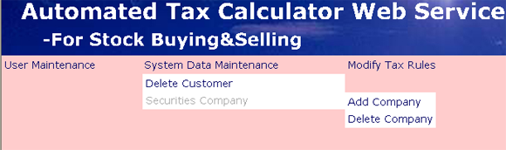

Reference:
- Understanding Object-Oriented Software Engineering, Stefan Sigfried, February 1996 ISBN 0-7803-1095-0
- C# and the .NET Platform, Second Edition, Andrew Troelsen, 2003 ISBN 1-59059-055-4
- Using HTML, Fourth Edition, Lee Anne Phillips, 1998 ISBN 0-7897-1562-7
- Sql Server 7: CompleteReference, Gayle Coffman, 1999 ISBN 0-07-882494-x
- http://www.irs.gov
- http://msdn.microsoft.com/library/
- http://msdn.microsoft.com/library/default.asp?url=/library/en-us/tsqlref/ts_tsqlcon_6lyk.asp
- http://www.ilook.fsnet.co.uk/ora_sql/sqlmain.htm
- http://www.businessobjects.com/

