Reply to "Re: Divide the triangle to four equal area triangles" by Steve Brian
reply to this message
post a message on a new topic
Back to messages on this topic
Back to geometry-puzzles
<< previous |

Subject: Reply to "Re: Divide the triangle to four equal area triangles"
Author: Steve Brian <sbrian@sbcglobal.net>
Date: 6 Dec 01 00:31:47 -0500 (EST)

>Subject: Re: Divide the triangle to four equal area triangles
>Author: Zakir Seidov <seidovzf@yahoo.com>
>Date: Wed, 5 Dec 2001 05:36:26 -0800 (PST)

(snip)

>The case of the equilateral triangle is also at:
>http://www.geocities.com/zseidov/eq.html

(snip)

>ZFS

I added a few lines to your drawing, showing both mirror images at
once (sort of). The lines are (intended to be) parallel to the
nearest side of triangle ABC at a distance of 1/4 of the length of an
altitude to that side. The bold portions divide the quarter size
triangle into quarters. You might find my modified picture at
http://www.geocities.com/steve_brian2001/images/image002.jpg unless
geocities starts acting funny again.

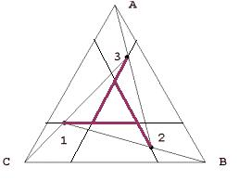
I just find the patterns interesting.

