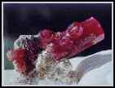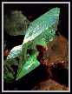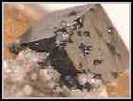

Creating a Power Point Project on Minerals

You will be creating a Power Point presentation that includes 5 slides. To start Power Point, click on Start at the bottom left of your screen in the taskbar. Select the New Office document. Select the Blank Presentation. You will see samples of 12 slide templates. For your first and last slide you will use the first template in the upper left hand corner. For slide two you will use the second template on the bottom row. For slide three you will use the third slide on the top row. For the fourth slide you will use the first template on the bottom row.
Let’s begin. Click on the first template on the top row. Insert information as shown on the back. Use the picture from the digital camera in place of the mice on slide two. Use your text to get the information for slide three. Use the sites below to get information for slide four. Use the web sites and information about your text to create slide five on credits and references.

Web Pages for images and information:

Great Picture Resource
http://www.asahi-net.or.jp/~UG7S-KTU/e_miner2.htm

Athena Mineral Pictures Index
http://un2sg4.unige.ch/athena/mineral/images/minpic_frame0.html

Alphabetical Mineral Reference
http://www.geology.wisc.edu/~jill/glossary2.html - k

Rock Hound Home
http://www.ghgcorp.com/gpenning/

Bob’s Rock Shop
http://www.rockhounds.com/rockshop/table.html

